

<Name of the project>

User Manual

Project Code: <Code of the project>

Document Code: <Code of the document >– v<x.x>

**<Location, issued date of the Document>**

Record of change

*A - Added M - Modified D - Deleted

|  |  |  |  |  |
| --- | --- | --- | --- | --- |
| Effective Date | Changed Items | A* M, D | Change Description | New Version |
|  |  |  |  |  |
|  |  |  |  |  |
|  |  |  |  |  |
|  |  |  |  |  |
|  |  |  |  |  |
|  |  |  |  |  |
|  |  |  |  |  |
|  |  |  |  |  |
|  |  |  |  |  |
|  |  |  |  |  |
|  |  |  |  |  |
|  |  |  |  |  |
|  |  |  |  |  |
|  |  |  |  |  |
|  |  |  |  |  |
|  |  |  |  |  |
|  |  |  |  |  |
|  |  |  |  |  |
|  |  |  |  |  |
|  |  |  |  |  |
|  |  |  |  |  |

SIGNATURE PAGE

ORIGINATOR: <Name> <Date>

<Position>

REVIEWERS: <Name> <Date>

<Position>

<Name, if it’s needed> <Date>

<Position>

APPROVAL: <Name> <Date>

<Position>

<Name, if it’s needed> <Date>

<Position>

TABLE OF CONTENTS

1. Quick start 5

1.1. How to use this manual 5

1.2. Typography convention 5

1.3. Term and abbreviation 5

2. Introduction and overview 6

3. Installation guide 7

3.1. Introduction 7

3.2. Environment 7

3.3. Application Installation 7

4. System Functional description 22

4.1. Overview 22

4.2. Details guidelines 22

5. Appendix 99

# Quick start

## How to use this manual

Describe here the structure of the manual and suggested reading sequence.

## Typography convention

Describe each type faces used in the manual and their meaning

## Term and abbreviation

# Introduction and overview

Give the context description of the system and describe some technical concepts used in system so that may help better system usage

# Installation guide

## Introduction

This document contains guide-lines step by step to use UJD_VN website, and set up its own database.

## Environment

Following are the software required to start the UJD_VN System:

* Operating System: Windows 7, WinXP, Win8
* Browsers: Firefox 20, Chrome 36 or higher.
* Database: MySQL 5.6.16 or higher
* Xampp 1.8.3/ PHP 5.5.11
* Tool: Sublime Text 3

## Application Installation

### Set up Environments:

* Web: If users want to use UJD_VN system on personal computer, users need to install Chrome36 /Firefox 20 or higher version and MySQL to create and store database.
* Tool development: Sublime Text 3
* Server: Xampp 1.8.3

### Set up Xampp 1.8.3

* Go to link https://www.apachefriends.org/download.html

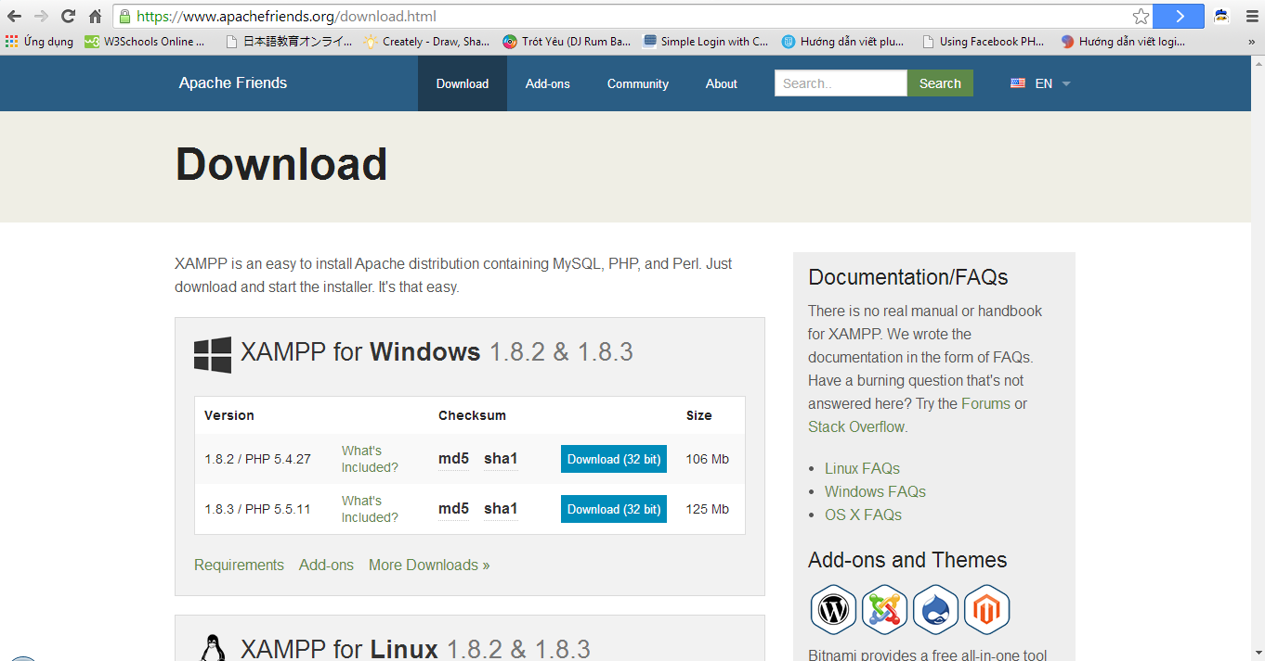

* Select download version 1.8.3/PHP 5.5.11(size 125Mb)
* Click double on file xampp-win32-1.8.3-VC11-installer.exe and click “Run”

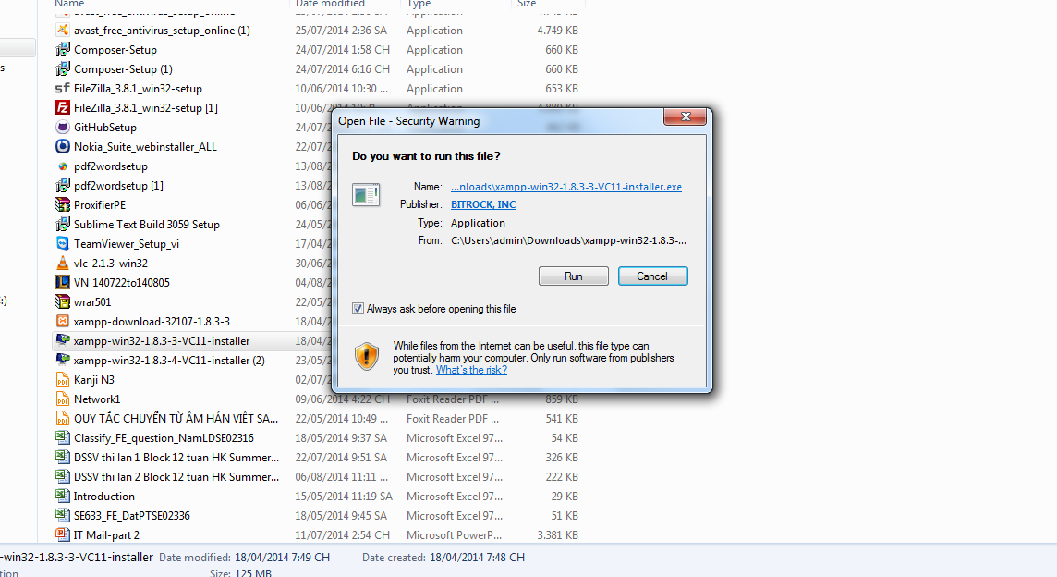

* After, click “Next”:

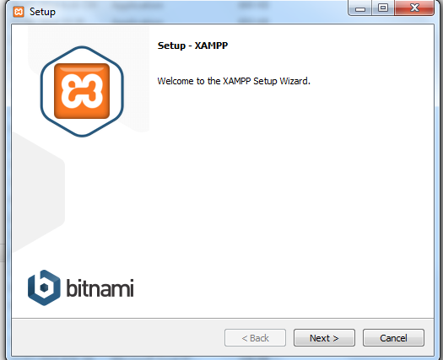

* Click “Next”

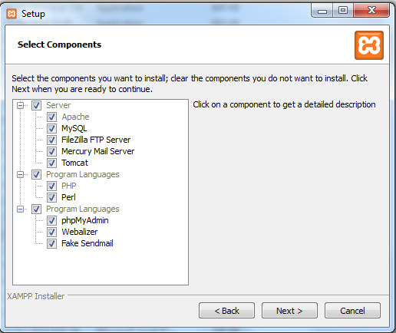

* Select a folder to install xampp (default C:\xampp) and click “Next”

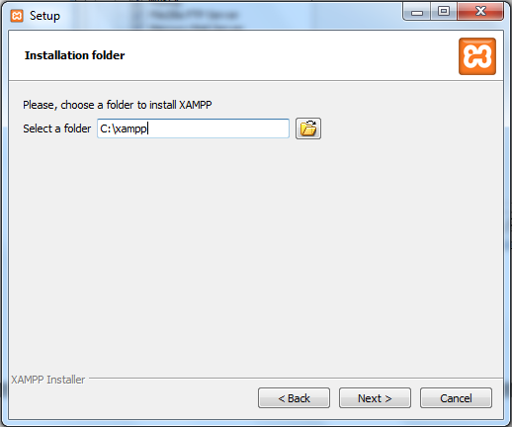

* Click “Next”:

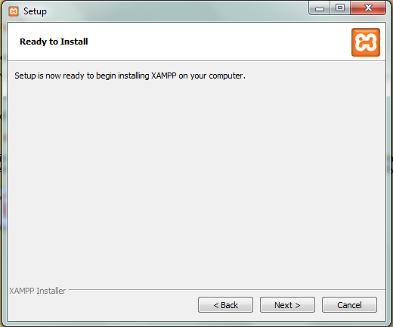

### Create Database

* After set up Xampp 1.8.3, start XAMPP Control Panel :

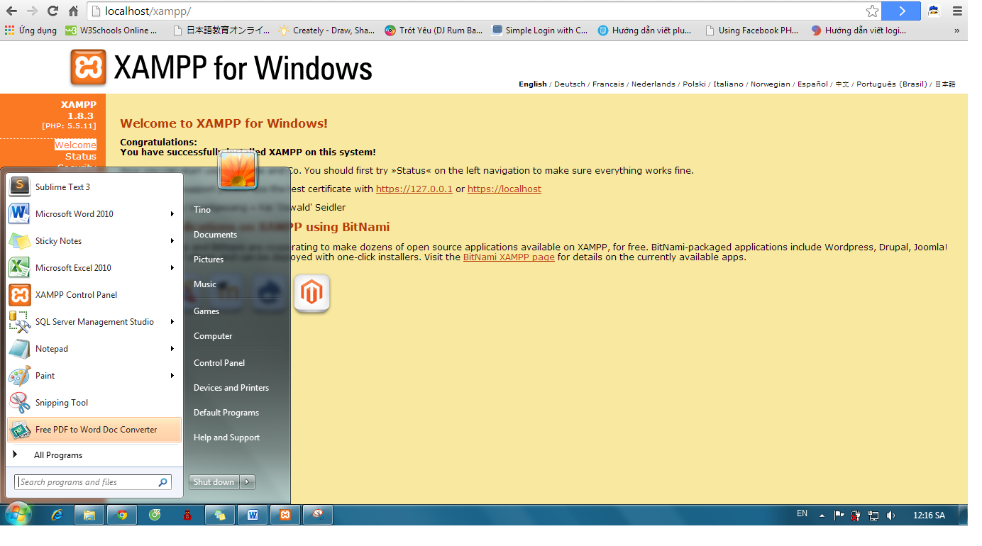

* Click “Start”of Apache and MySQL:

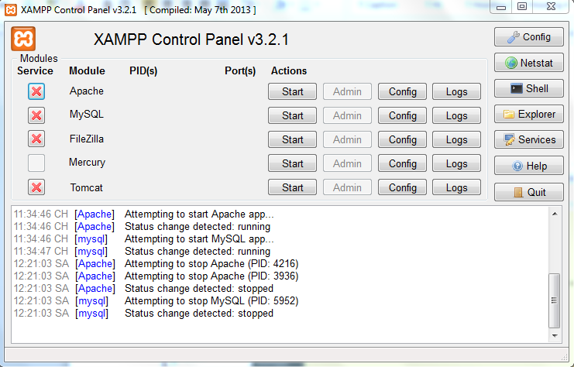

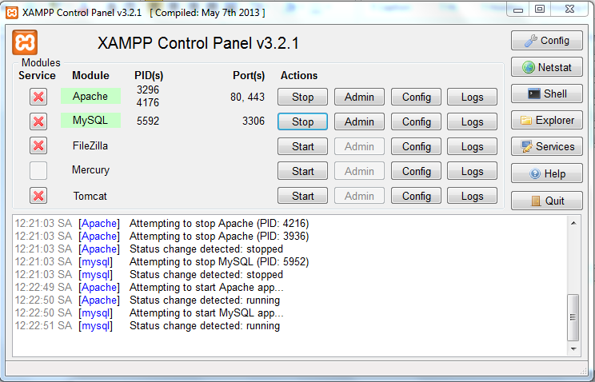

* Go to link: http://localhost/xampp/ and click on phpMyAdmin

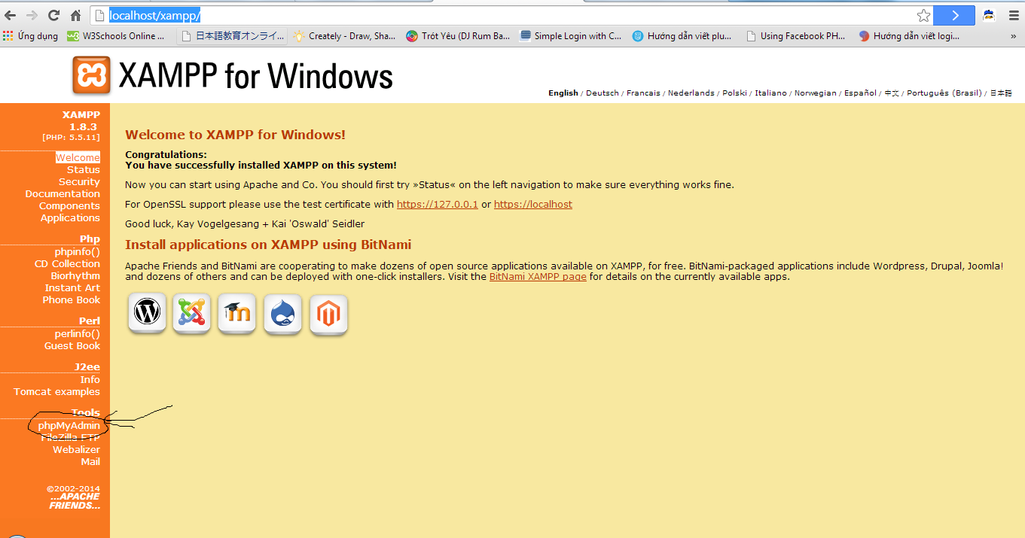

* Click on “New” to create a new database with name as “japanesedictionary” and collation “utf8_general_ci”. After click “Create”

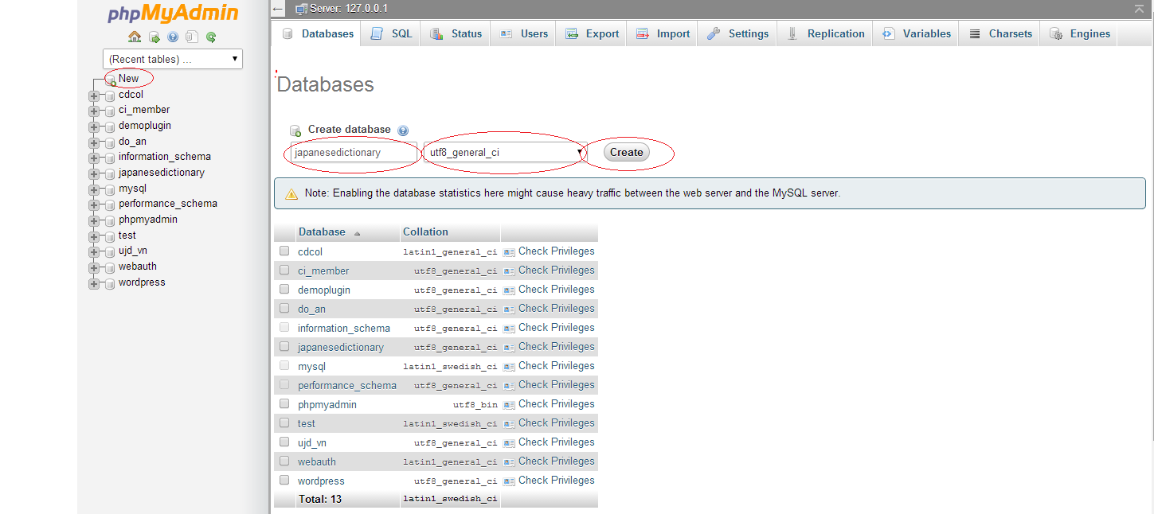

* After click “Create”, a new database were created with name as “japanesedictionary”

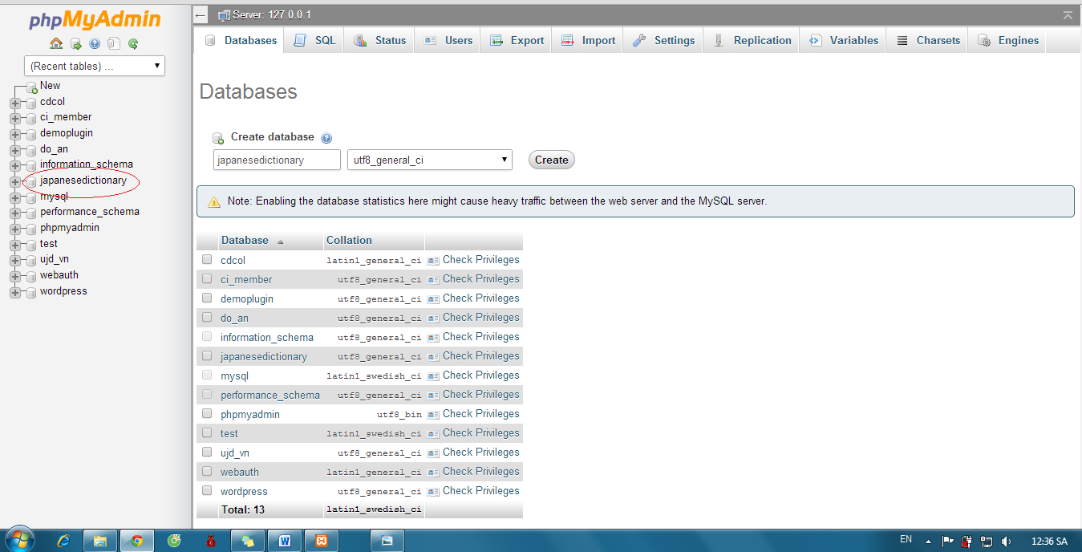

* Click “japanesedictionary” and “Import” :

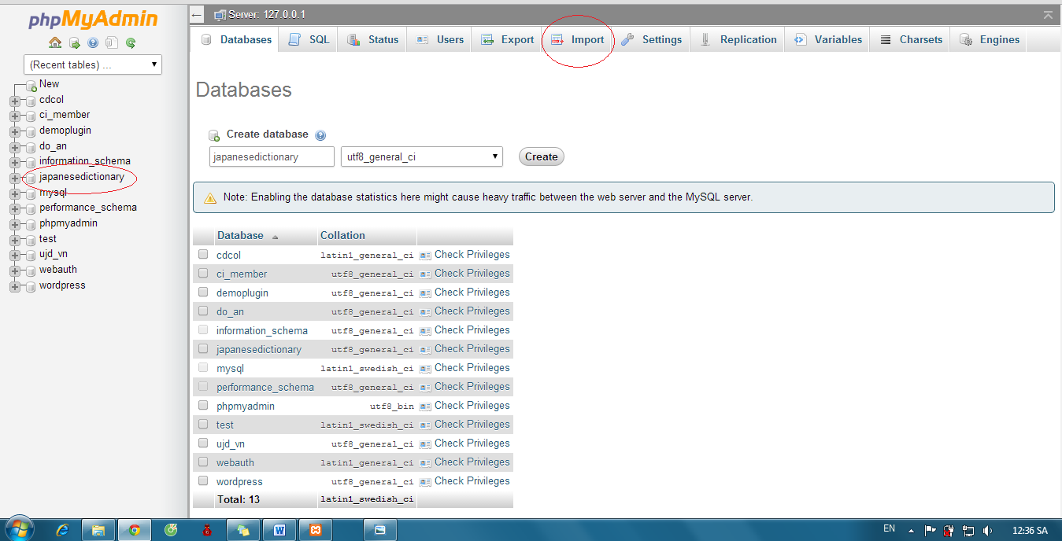

* Click “Chọn tệp” button:

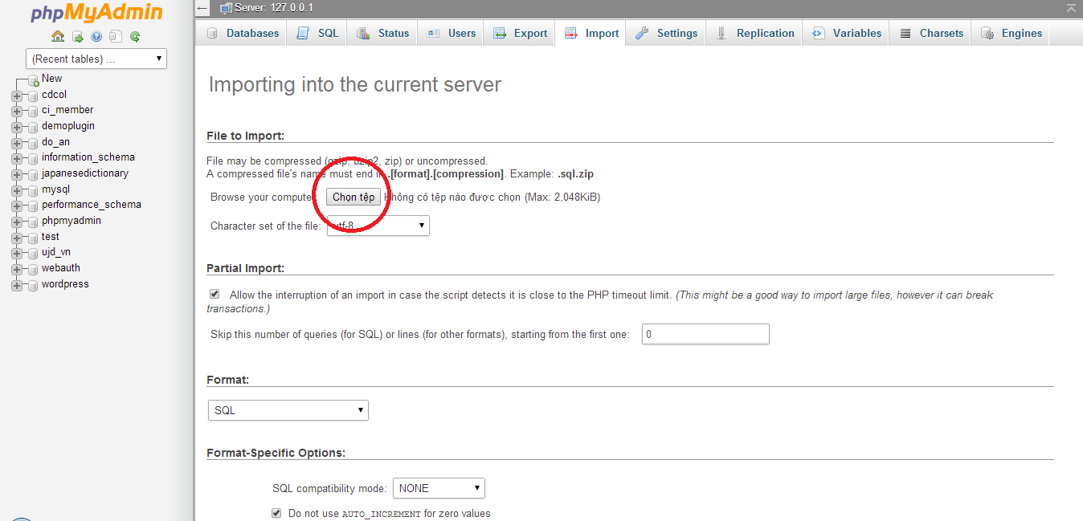

* Select file “japanesedictionary.sql”

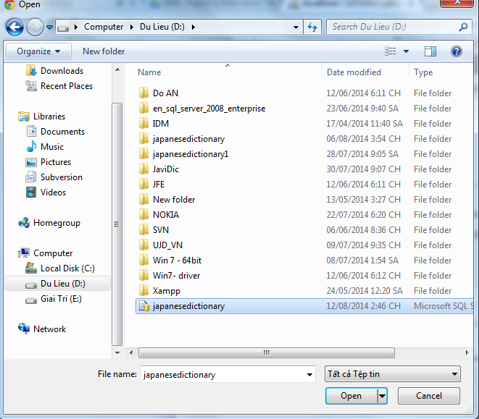

* Click “Go”

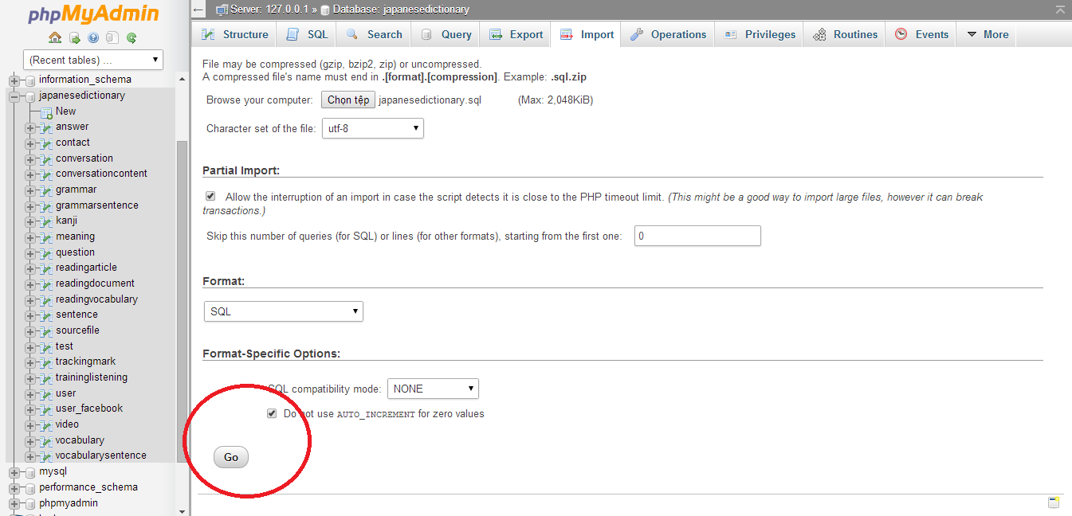

* Database was created with some table that contained data

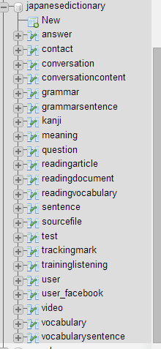

# System Functional description

## Overview

This user's manual has been developed to help users better understand the requirements that may apply to use this website by providing them simple step by step tutorials. This manual is intended to help make website's functions more accessible and their associated requirements more understandable to users.

## Details guidelines

### Homepage

The first page which user will see is the homepage. From this page the user can go to every page they want.

Open browser and enter to the address bar: http://localhost/japanesedictionary/index.php/Home/verify/login

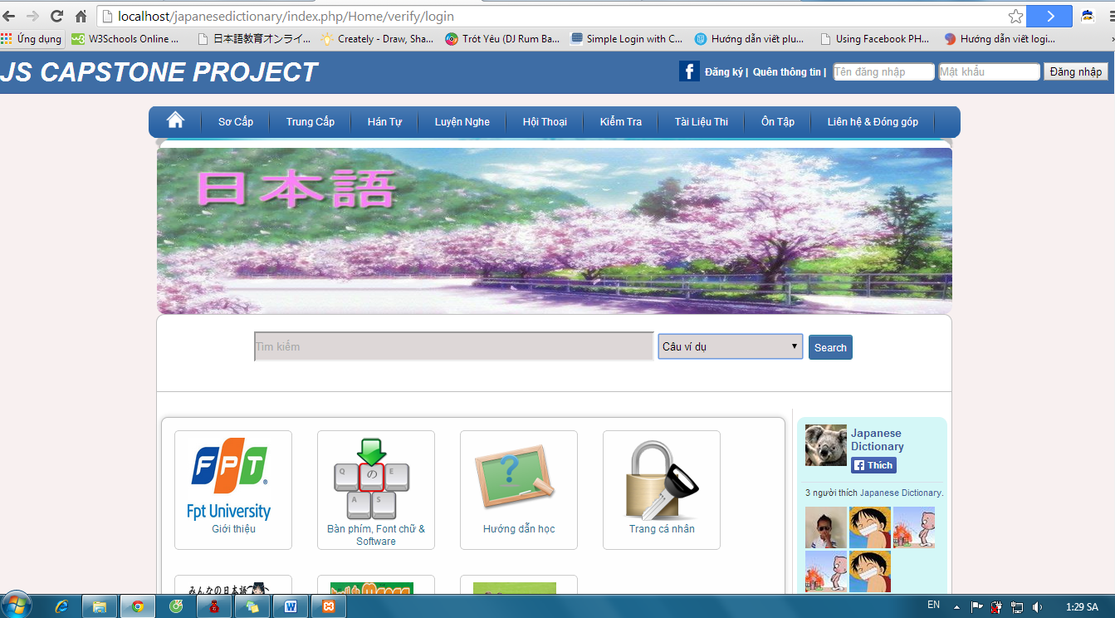

### Search sentences

To use search sentences function on website, the users do the steps below:

Step 1: Choose option search “Câu ví dụ”

Step 2: Type vocabulary’s hiragana or vocabulary’s romaji into search box on Home page

Step 3: Click “Search” button. Display result list of found.

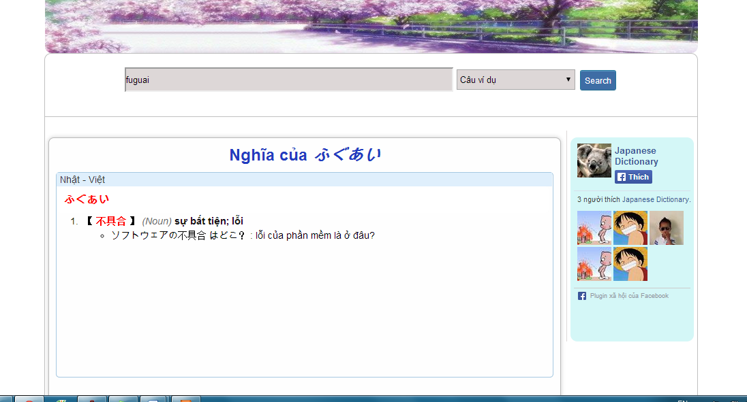

### Search conversation

To use search conversation function on website, the users do the steps below:

Step 1: Choose option search “Hội thoại”

Step 2: Type conversation’s title into search box on Home page

Step 3: Click “Search” button. Display result list of found.

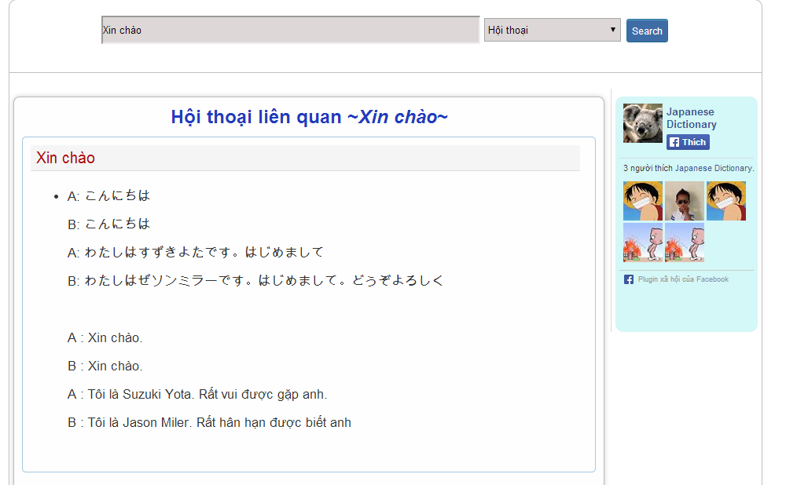

### Search grammar

To use search grammar function on website, the users do the steps below:

Step 1: Choose option search “Ngữ pháp”

Step 2: Type grammar’s hiragana or grammar’s romaji into search box on Home page

Step 3: Click “Search” button. Display result list of found.

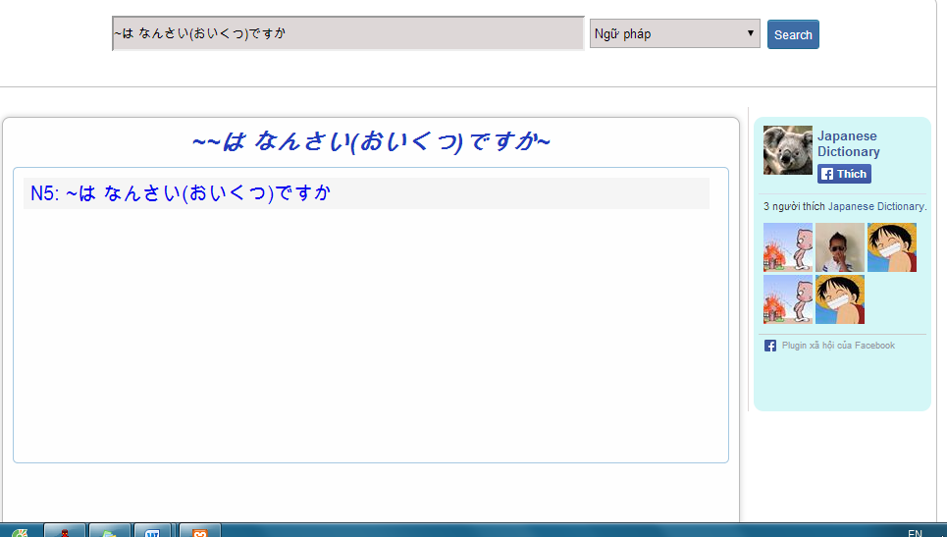

Step 4: Click title of grammar that was found to view detail.

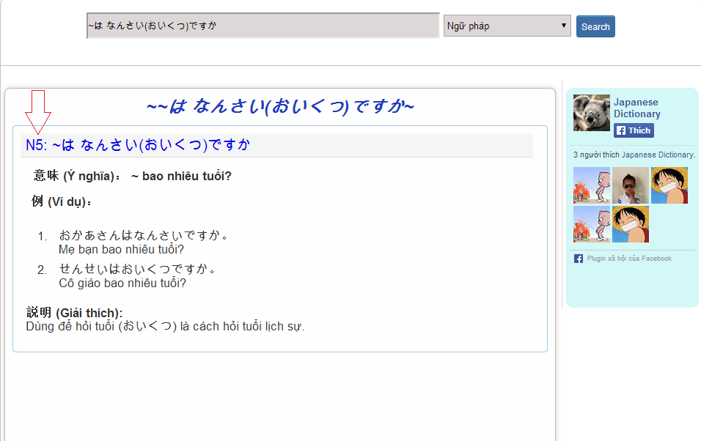

### Search video

To use search conversation function on website, the users do the steps below:

Step 1: Choose option search “Video”

Step 2: Type video’s title into search box on Home page

Step 3: Click “Search” button. Display result list of found.

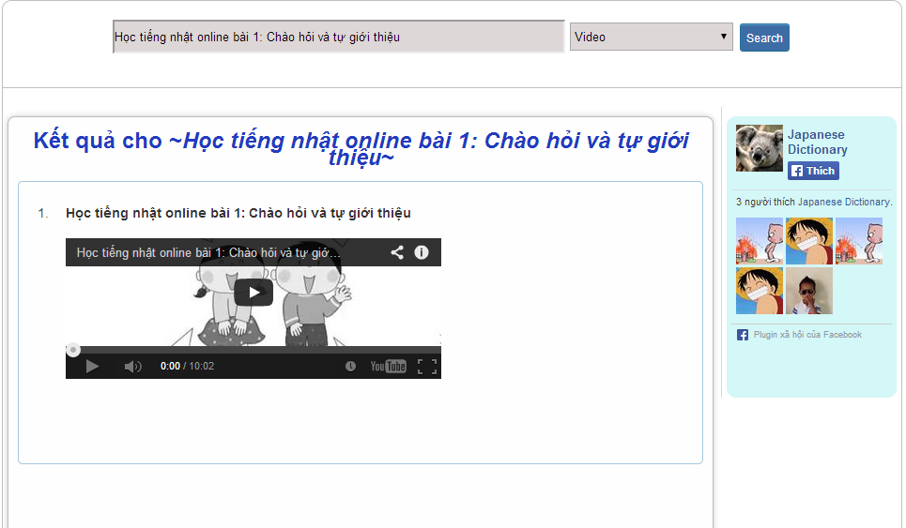

### Login

#### Login by facebook

To use login by facebook function on website, the users do the steps below:

Step 1: Click icon Facebook on Homepage

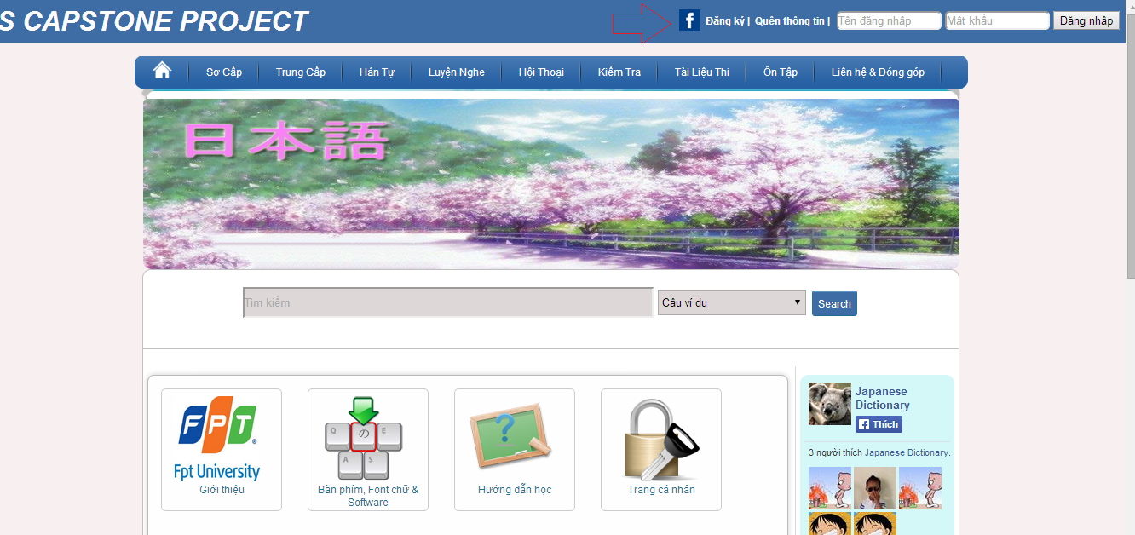

Step 2: If you not login facebook, user need input username and password of facebook account and login.

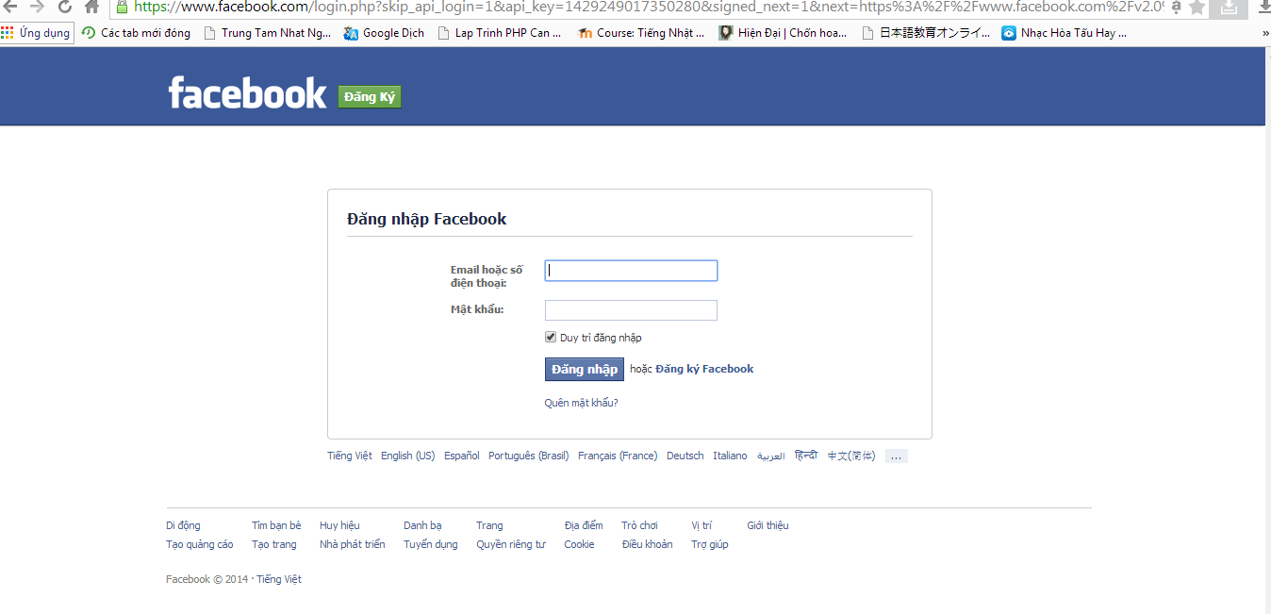

Step 3: Click “Đồng ý” to login by facebook.

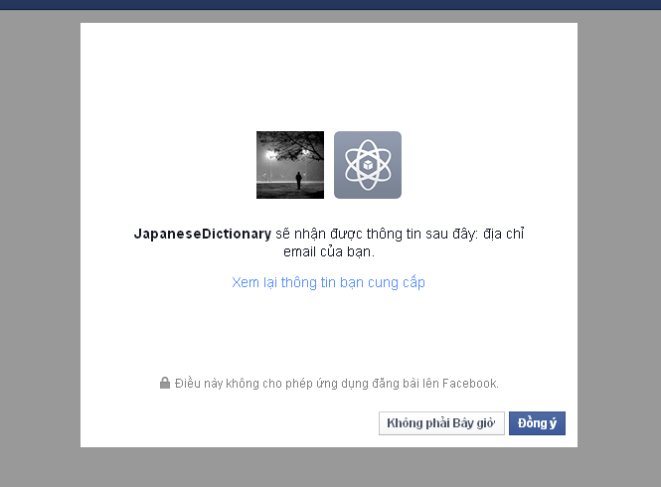

Step 4: System will redirect to homepage if login successful.

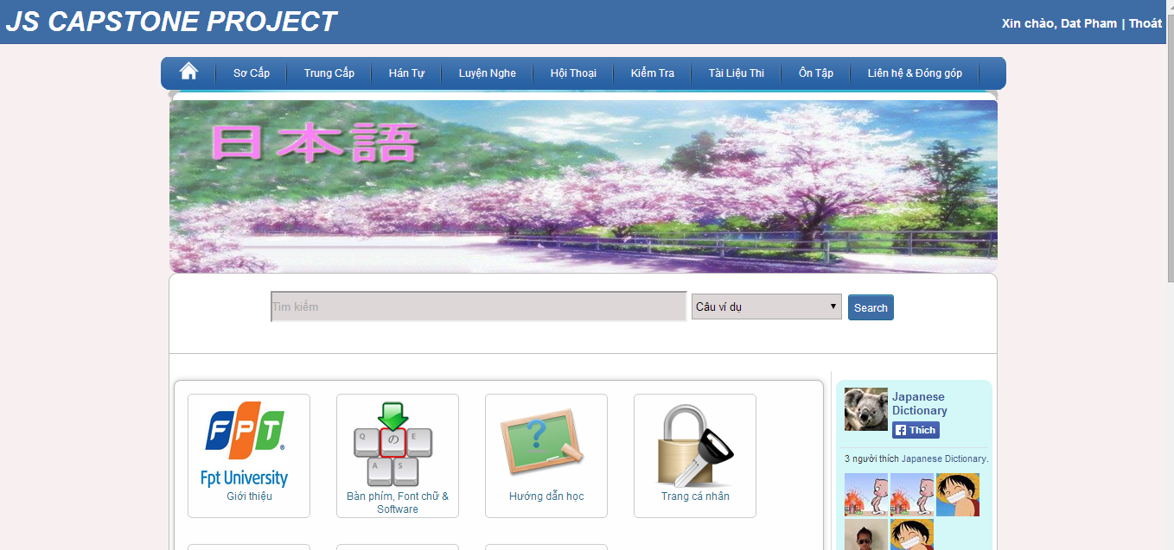

#### Login by registered account

To use login by register account function on website, the users do the steps below:

Step 1: Go to homepage

Step 2: Input correct username and password

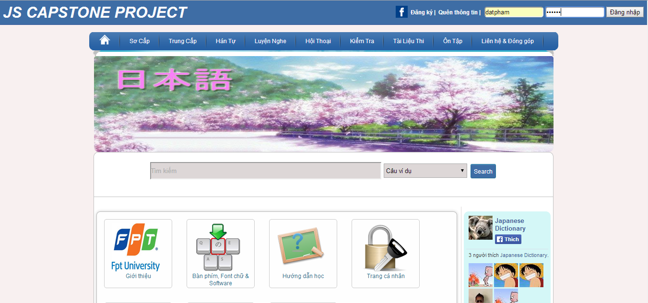

Step 3: Click “Đăng nhập” button

* Success:



* Fails: Error message will notify. You must be try again.

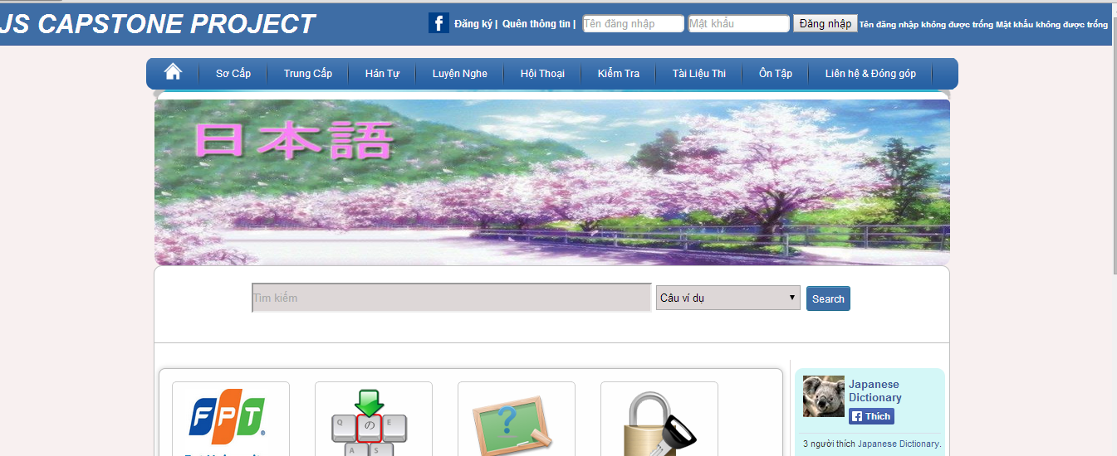

### Logout

To use logout function on website, the users do the steps below:

Step 1: Login with facebook account or registered account as 4.2.6

Step 2: Click “Thoát” link.

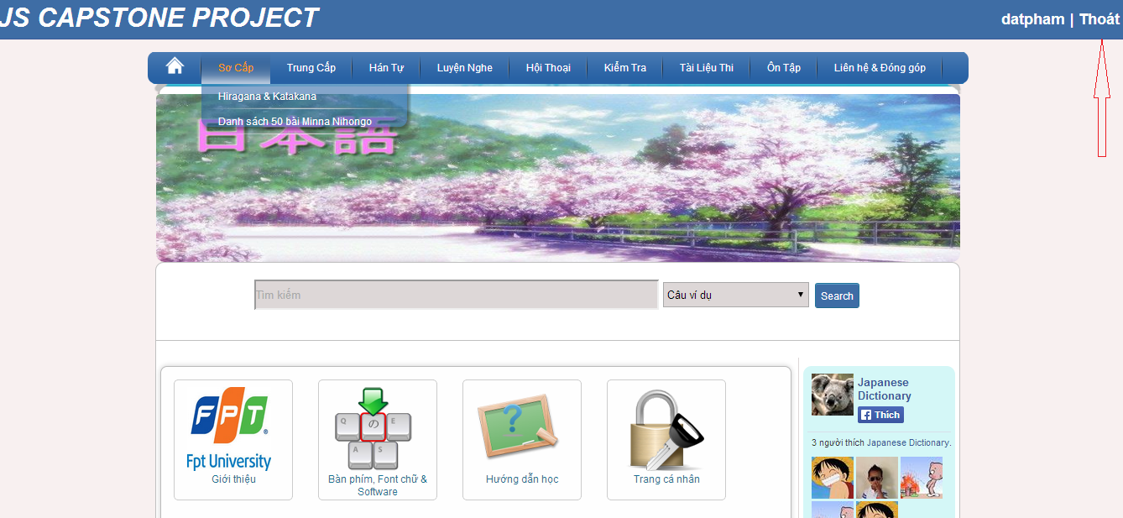

### Register

To use register function on website, the users do the steps below:

Step 1: Go to homepage

Step 2: Click “Đăng ký” link.

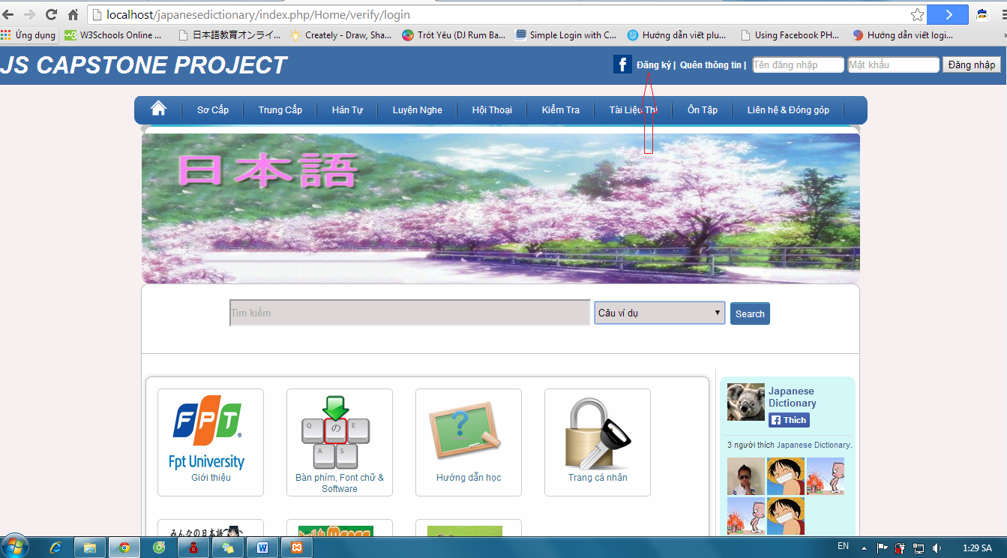

Step 3: Fill full your information to textbox. (*) is required.

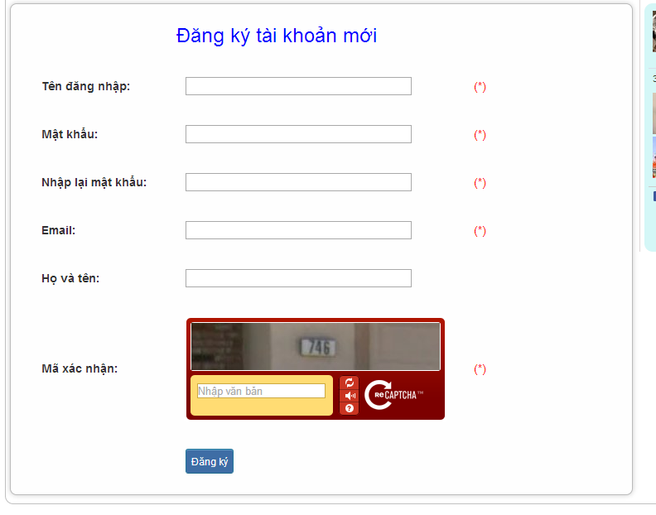

Step 4: Click “Đăng ký” button. System will check your information.

* If it suitable, a new account will create.

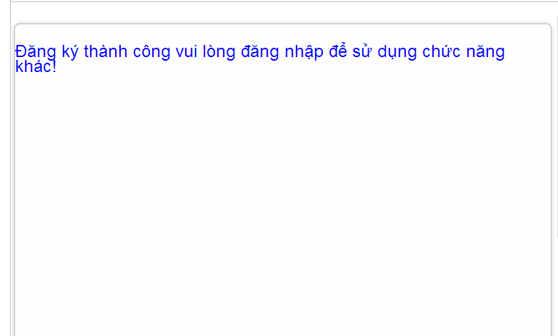

* If it unsuitable, error message will notify. You must be try again.

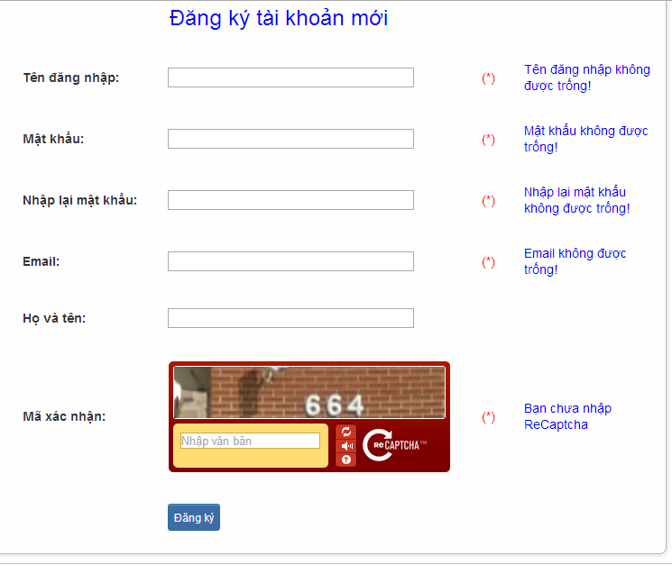

### Edit profile

To use edit profile function on website, the users do the steps below:

Step 1: Login with Facebook account or registered account as 4.2.6

Step 2:

* Method 1: Click “username” link.

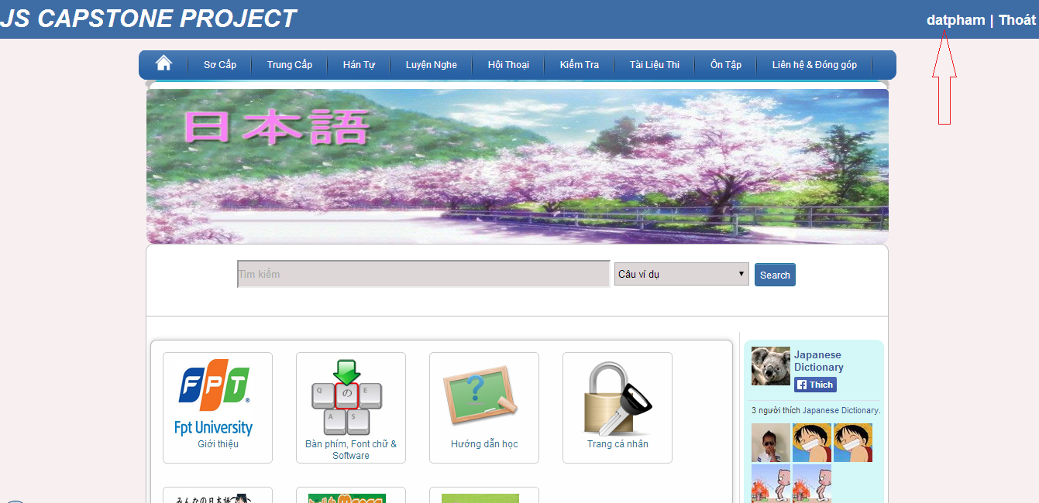

* Method 2:

+ Click “Trang cá nhân” link.

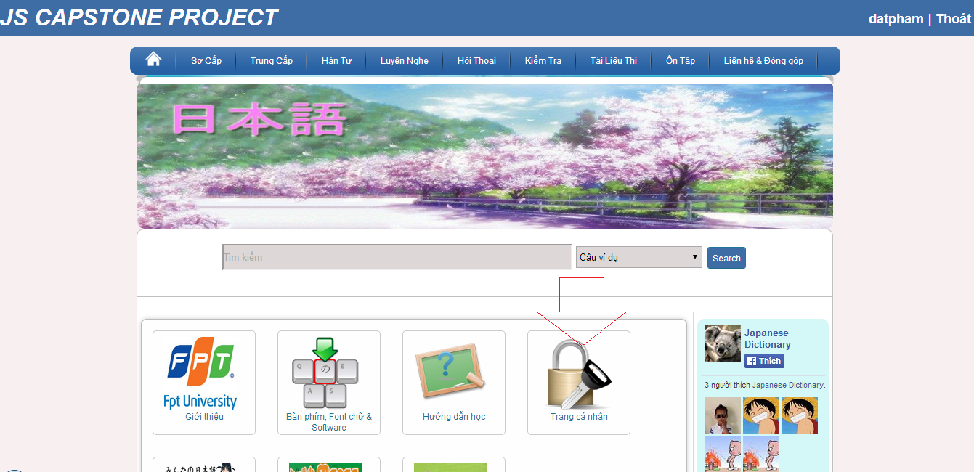

+ Click “Thay đổi thông tin” button

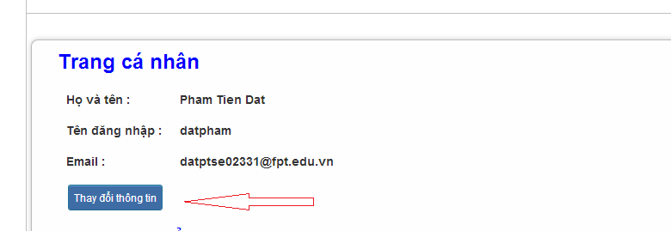

Step 3: Input correct information that you want change (email, họ tên, mật khẩu).

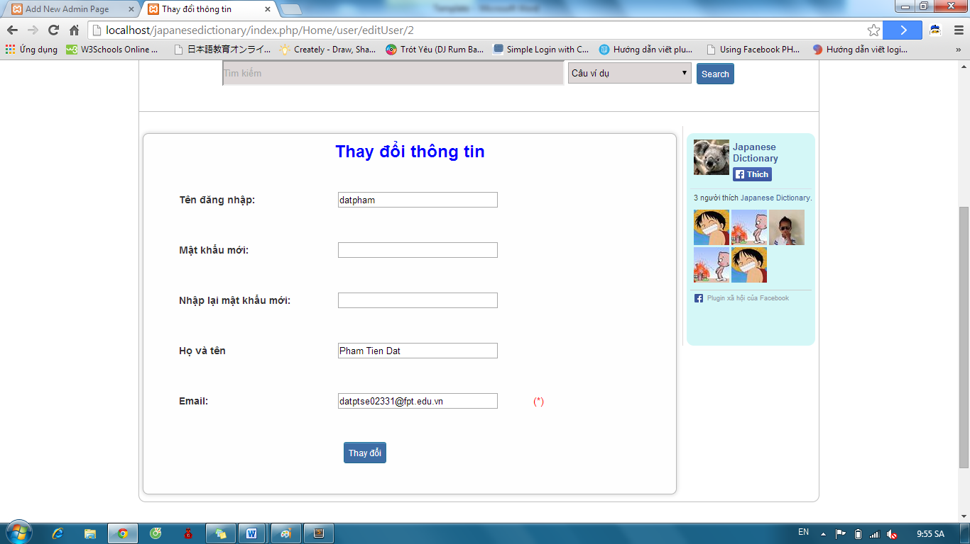

Step 4 : Click “Thay đổi” button.

* Success: System redirect to homepage

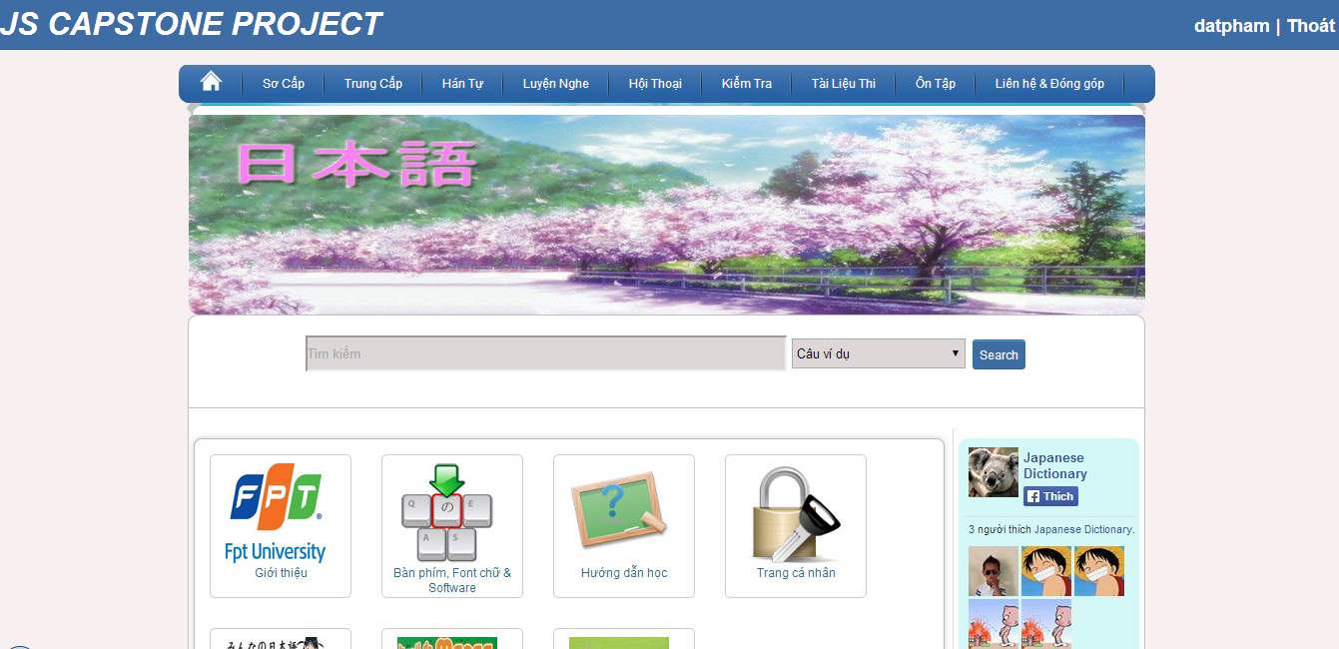

* Fails: Error message will notify. You must be try again.

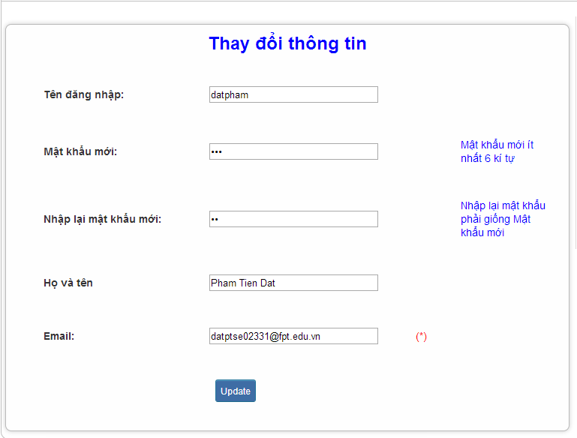

### Forgot Password

To use forgot password function on website, the users do the steps below:

Step 1: Go to homepage.

Step 2: Click “Quên thông tin” link.

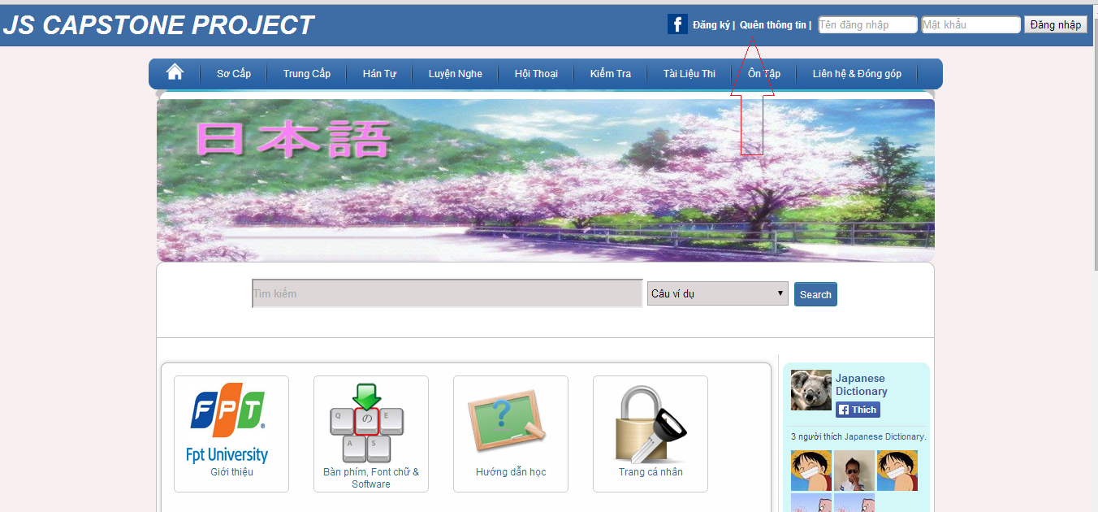

Step 3: Input email that use to register your account.

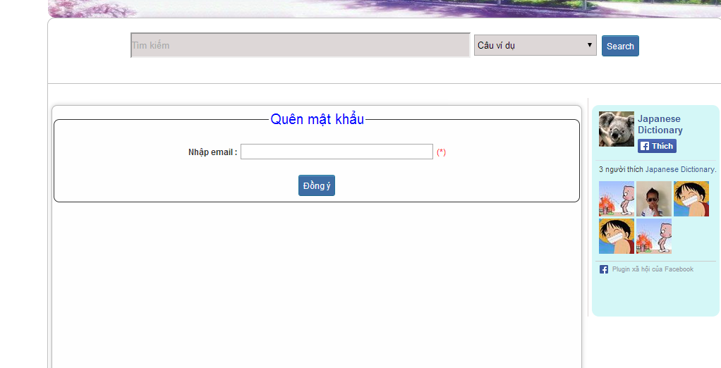

Step 4: Click “Đồng ý” button

* Success: Password will reset and send to your email

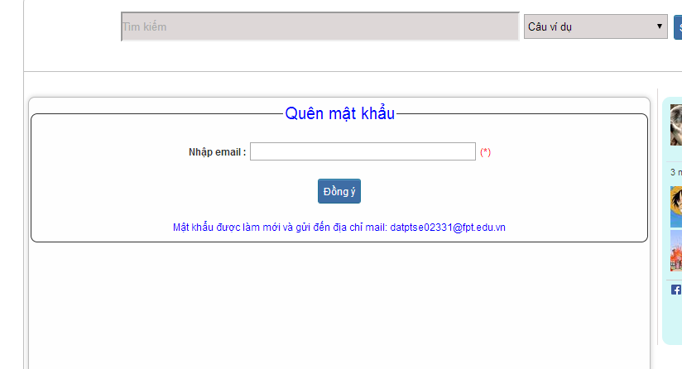

* Fails: Error message will notify. You must be try again.

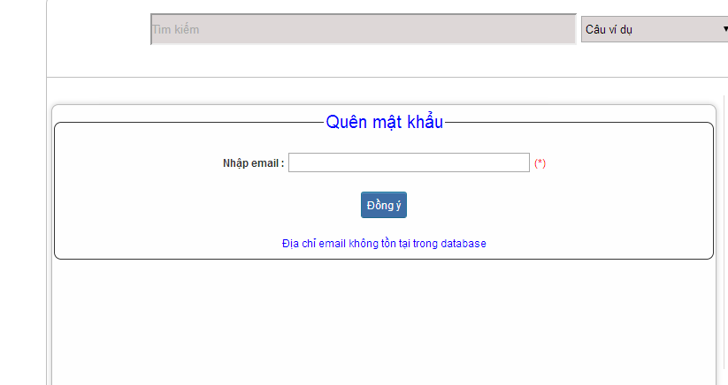

### Contribute content

To use contribute content function on website, the users do the steps below:

Step 1**:** Go to homepage.

Step 2**:** Hover on “Liên hệ & Đóng góp” and click “Đóng góp database”.

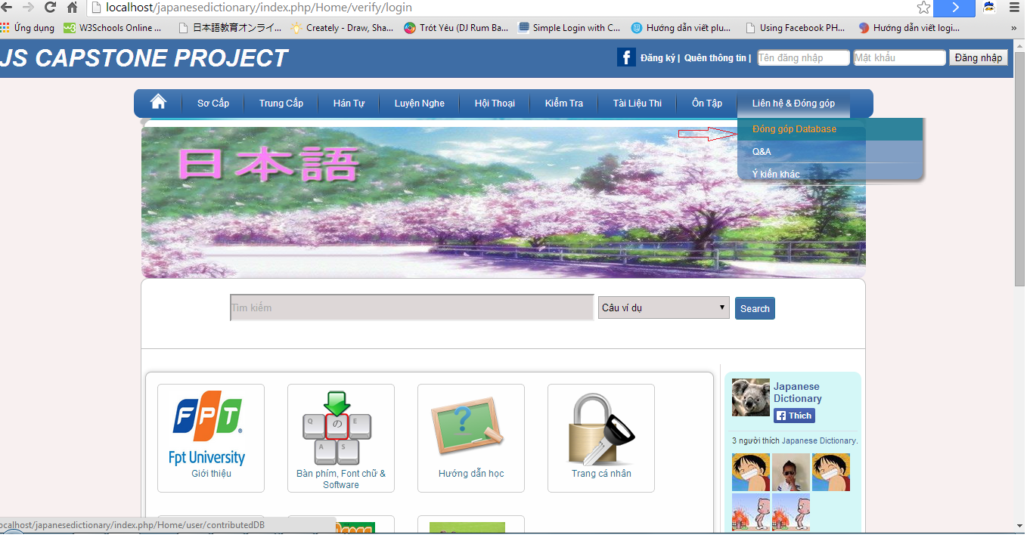

Step 3**:** Choose 1 of 3 type contribute

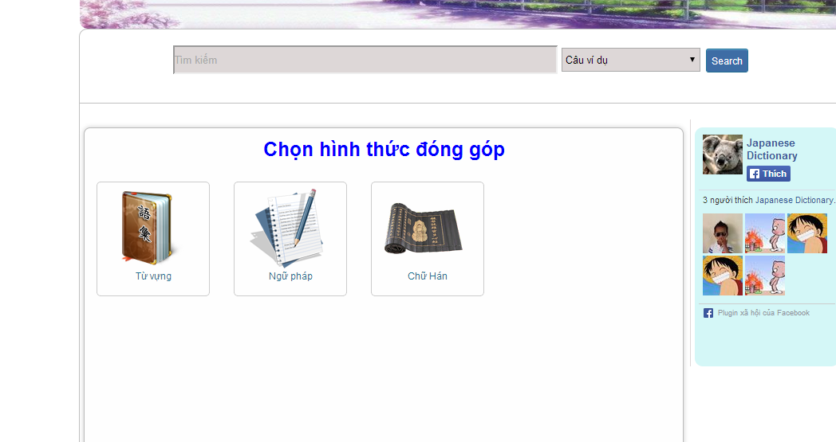

Step 4**:** Input correct information that you want contributed.

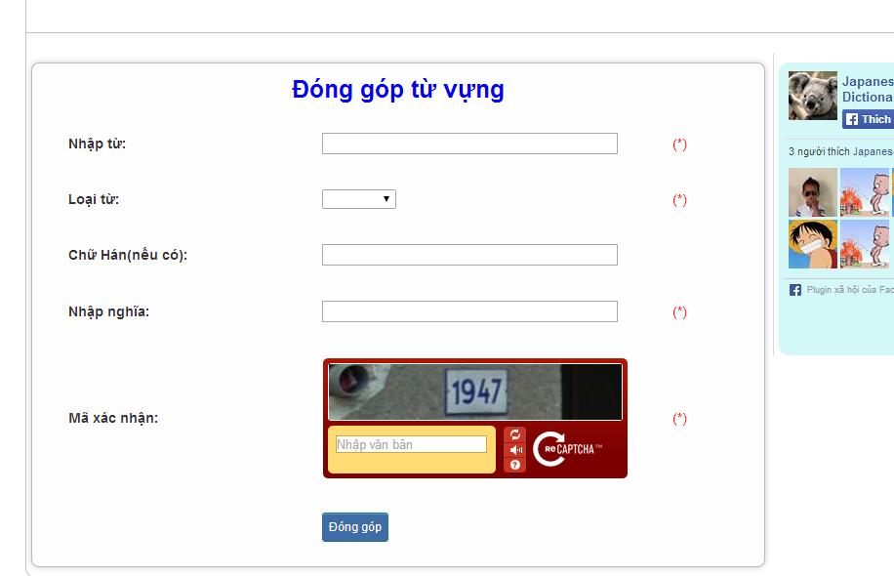

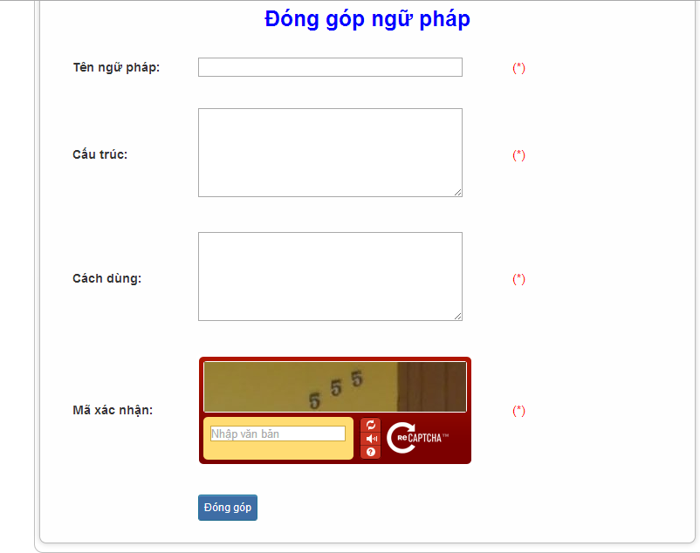

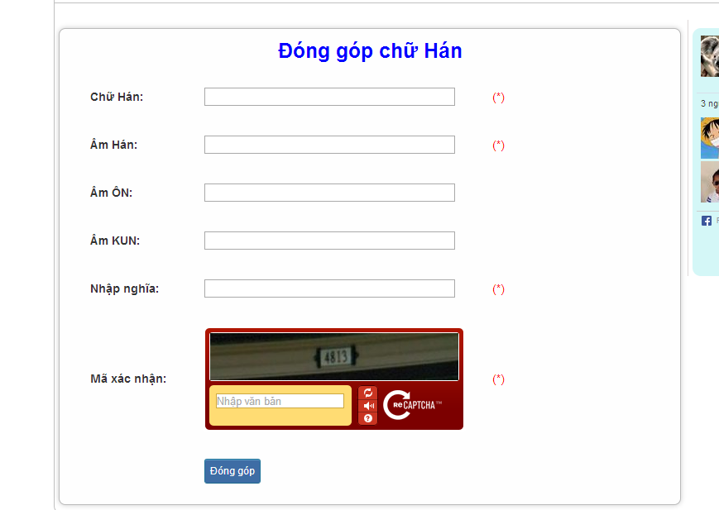

Step 5: Click “Đóng góp” button

* Success:

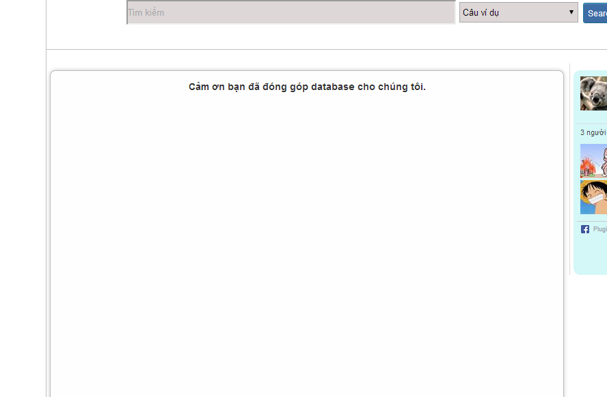

* Fails: Error message will notify. You must be try again.

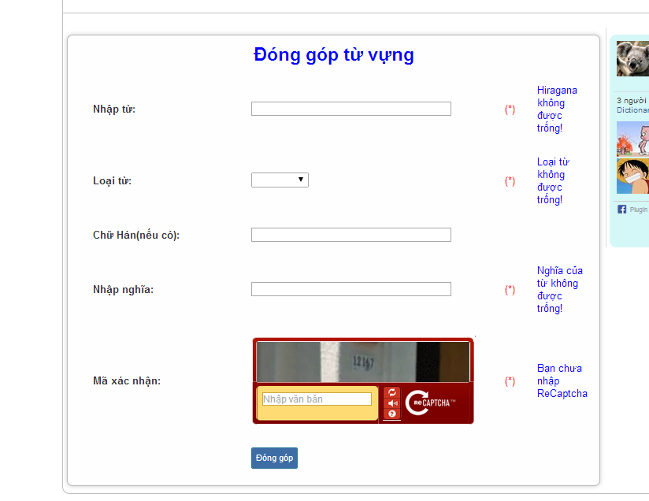

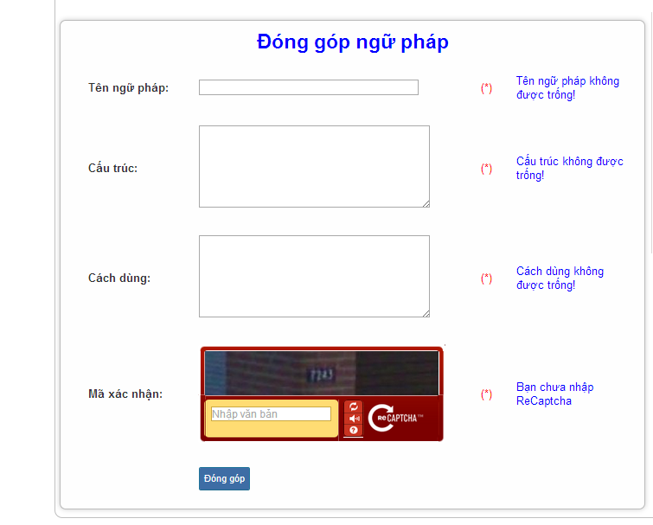

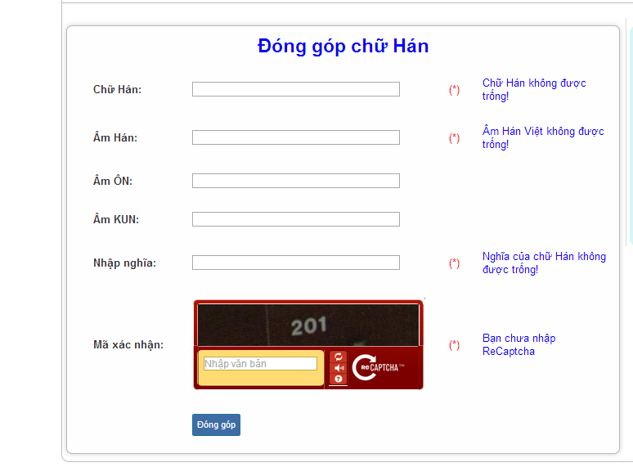

### Contribute opinion

To use contribute opinion function on website, the users do the steps below:

Step 1**:** Go to homepage.

Step 2**:** Hover on “Liên hệ & Đóng góp” and click “Ý kiến khác”.

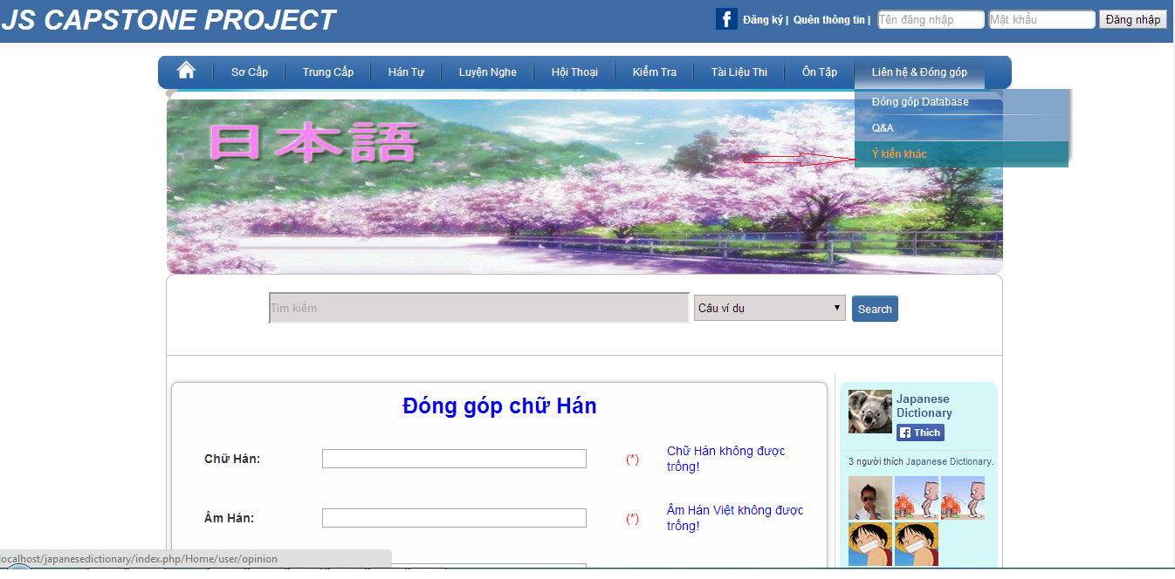

Step 3: Input correct opinion’s information that you want contributed.

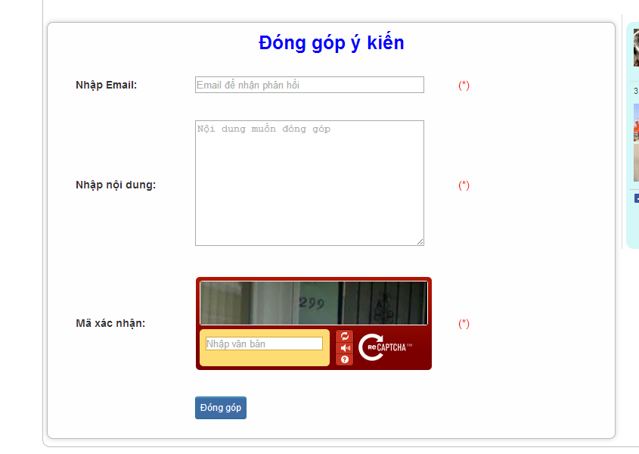

Step 4: Click “Đóng góp” button

* Success :

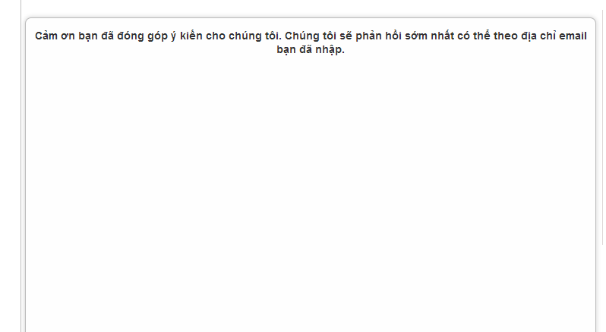

* Fails: Error message will notify. You must be try again.

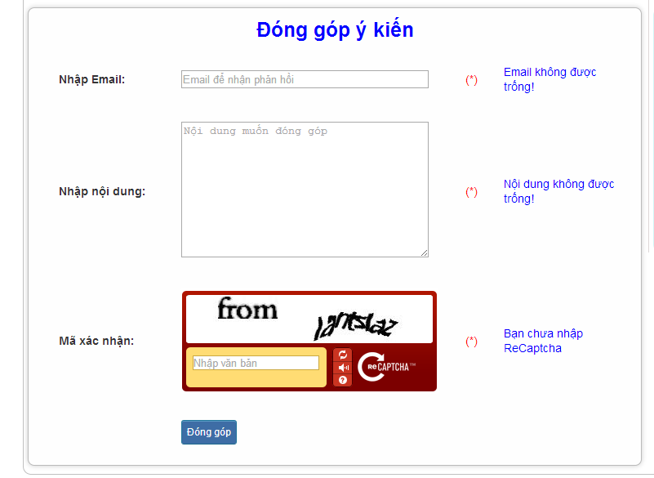

### Send Q & A

To use Send Q&A function on website, the users do the steps below:

Step 1**:** Go to homepage.

Step 2**:** Hover on “Liên hệ & Đóng góp” and click “Q&A”.

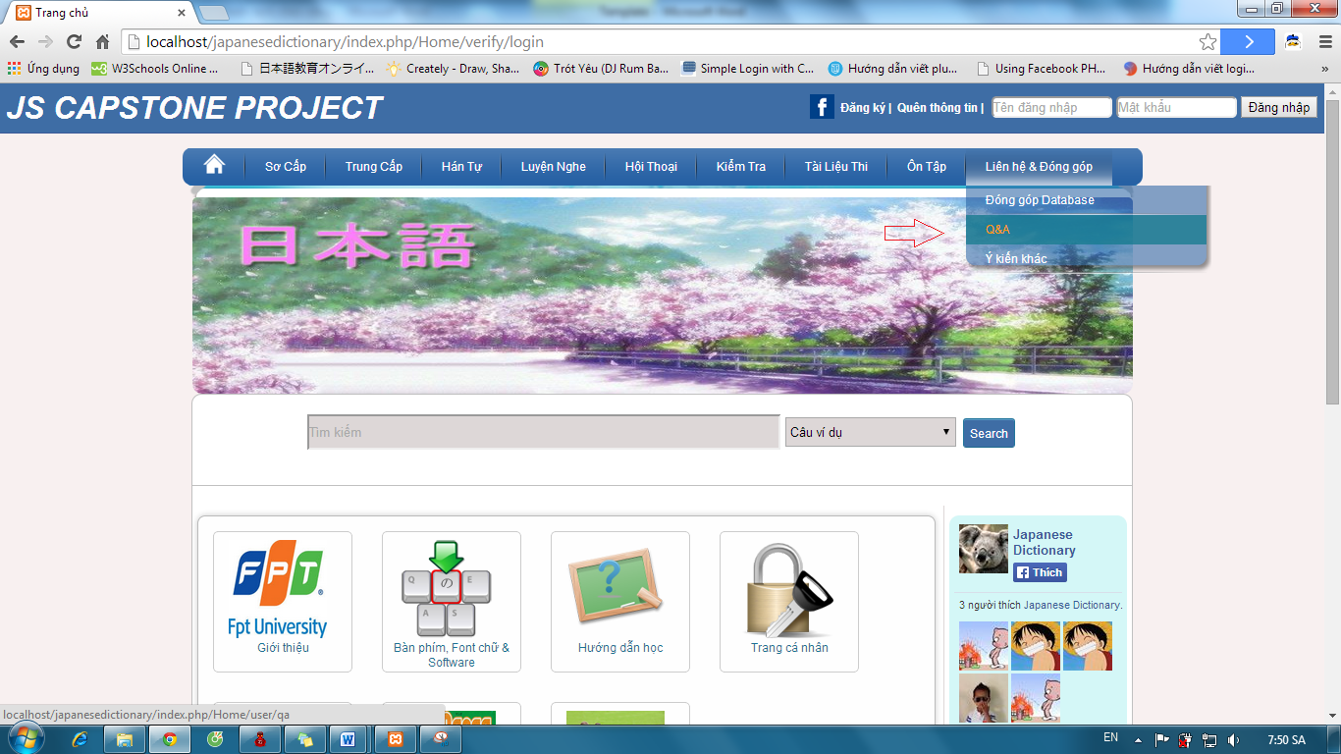

Step 3: Input correct opinion’s information that you want contributed.



Step 4: Click “Đóng góp” button

* Success :



* Fails: Error message will notify. You must be try again.



### Test

To use test function on website, the users do the steps below:

Step 1: Login with facebook account or registered account as 4.2.6

Step 2:Hover on “Kiểm tra” and click 1 of 3 level to test.

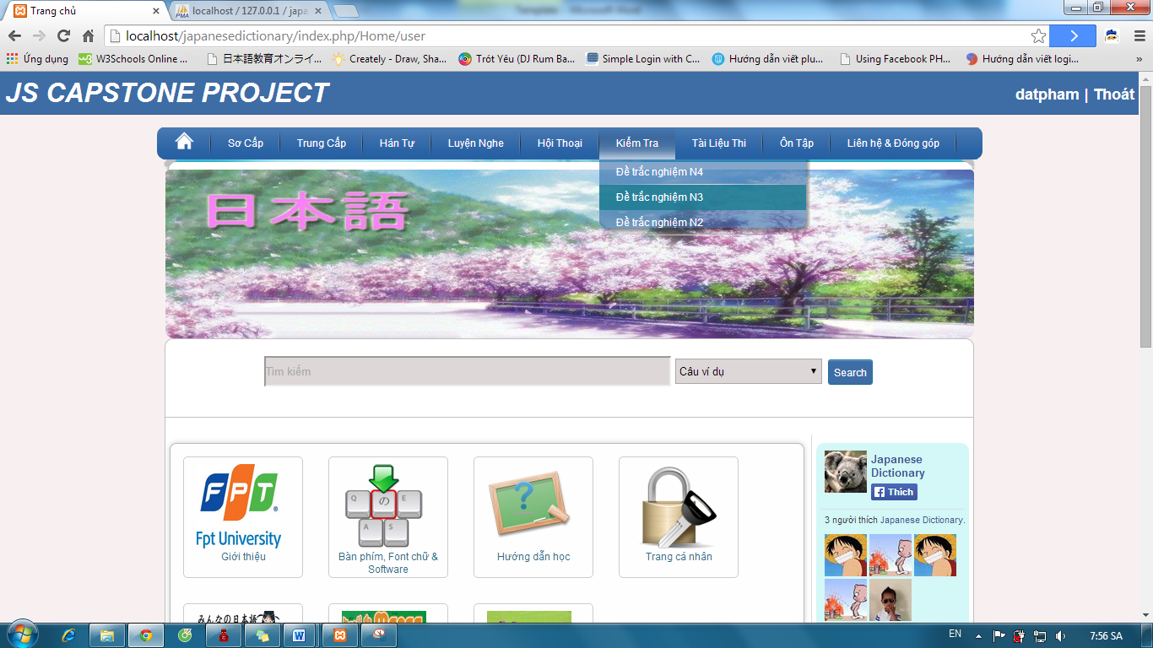

Step 3:Click one of the test link

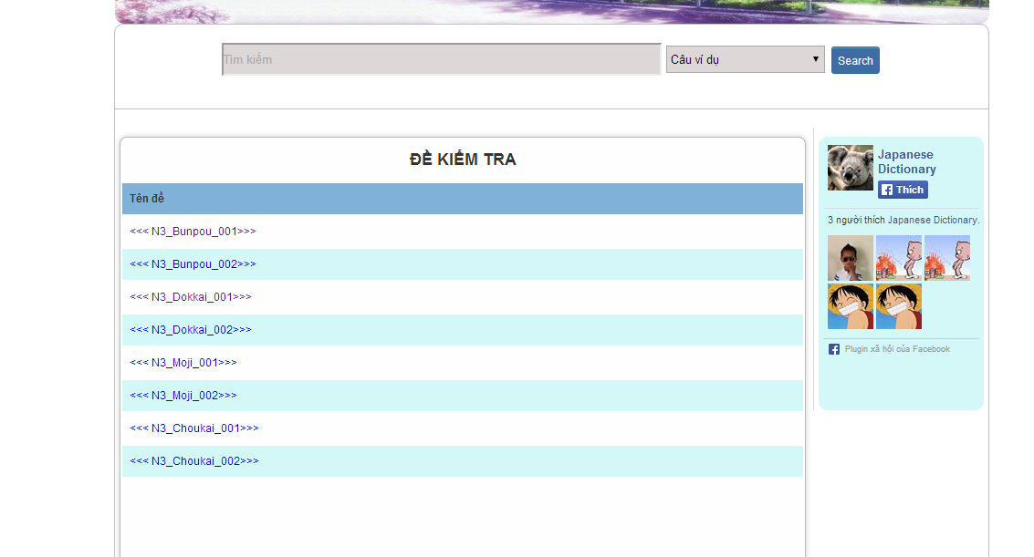

Step 4: Tick on your answer and click “Hoàn thành” button

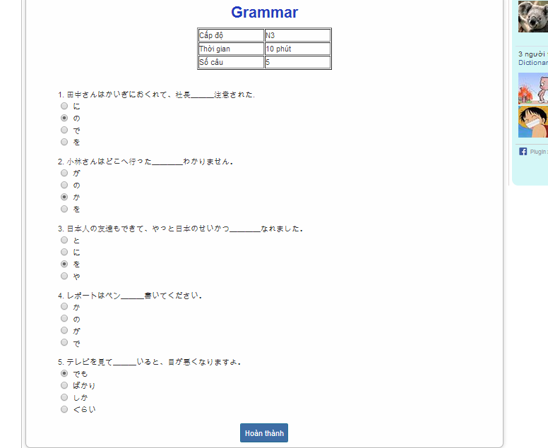

Step 5: Click “đây” link to view correct answer

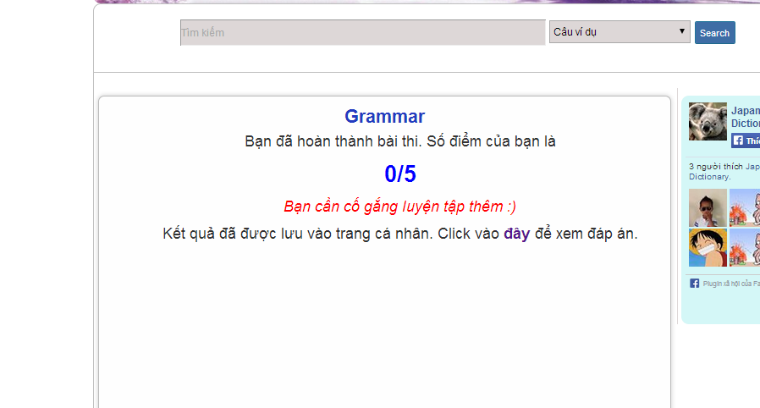

Step 6: Click “Quay lại” button after view correct answer

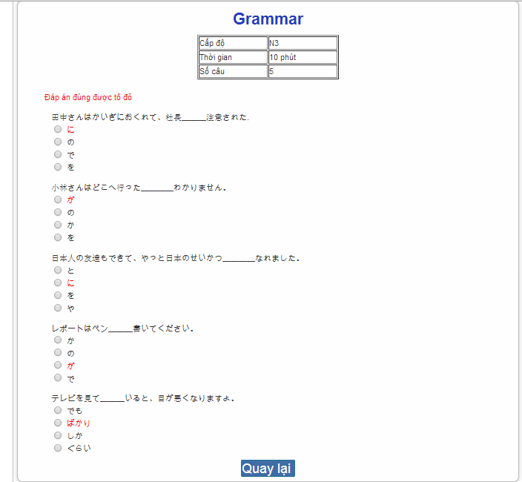

### Tracking mark

To use tracking mark function on website, the users do the steps below:

Step 1: Login with facebook account or registered account as 4.2.6

Step 2: Click “Trang cá nhân” link on homepage



Step 3: View your mark.

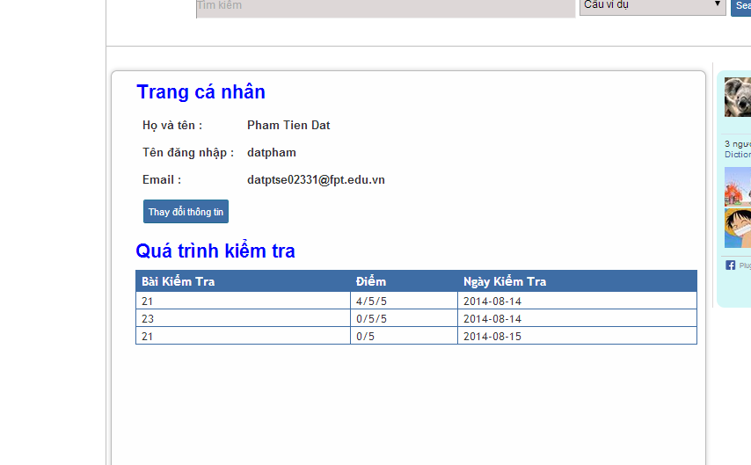

### Training Listening

To use training listening function on website, the users do the steps below:

Step 1: Go to homepage

Step 2: Hover on “Luyện nghe” and click 1 of 2 levels to listen.

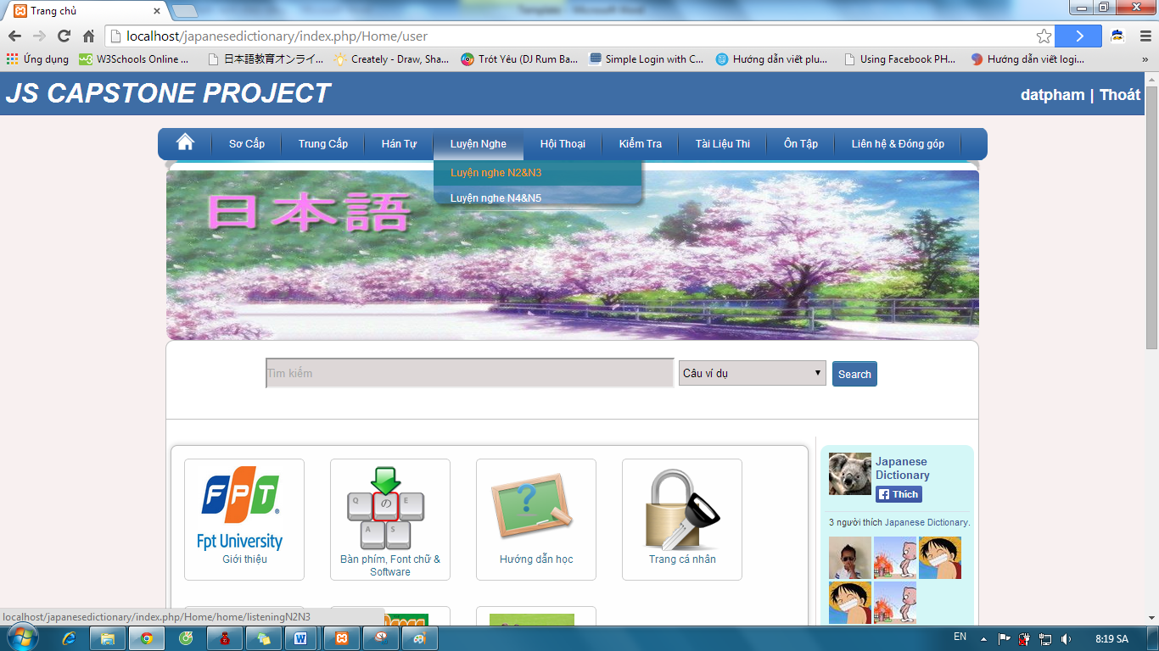

Step 3: Click one of the lesson listening links.

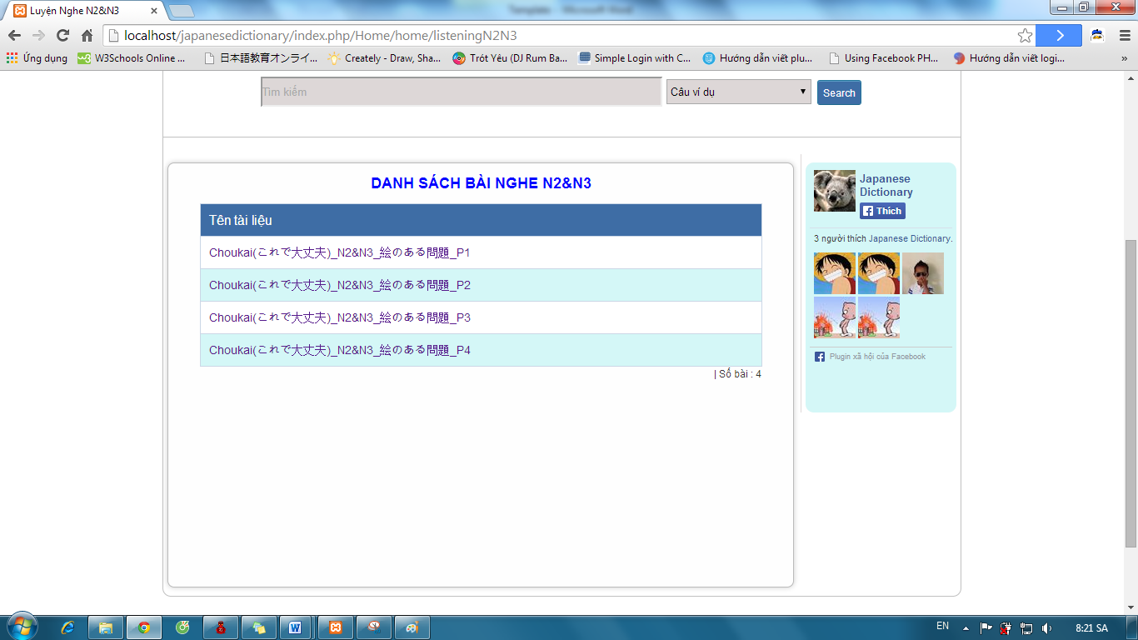

Step 4: Click play button to listen and click “Dịch&Đáp án” to view listening’s detail.

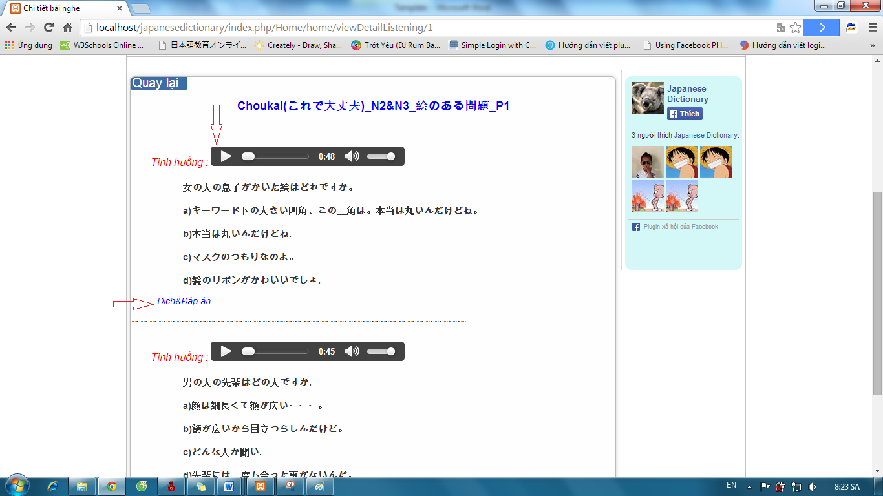

Step 5: Click “Quay lại” button after view listening’s detail.

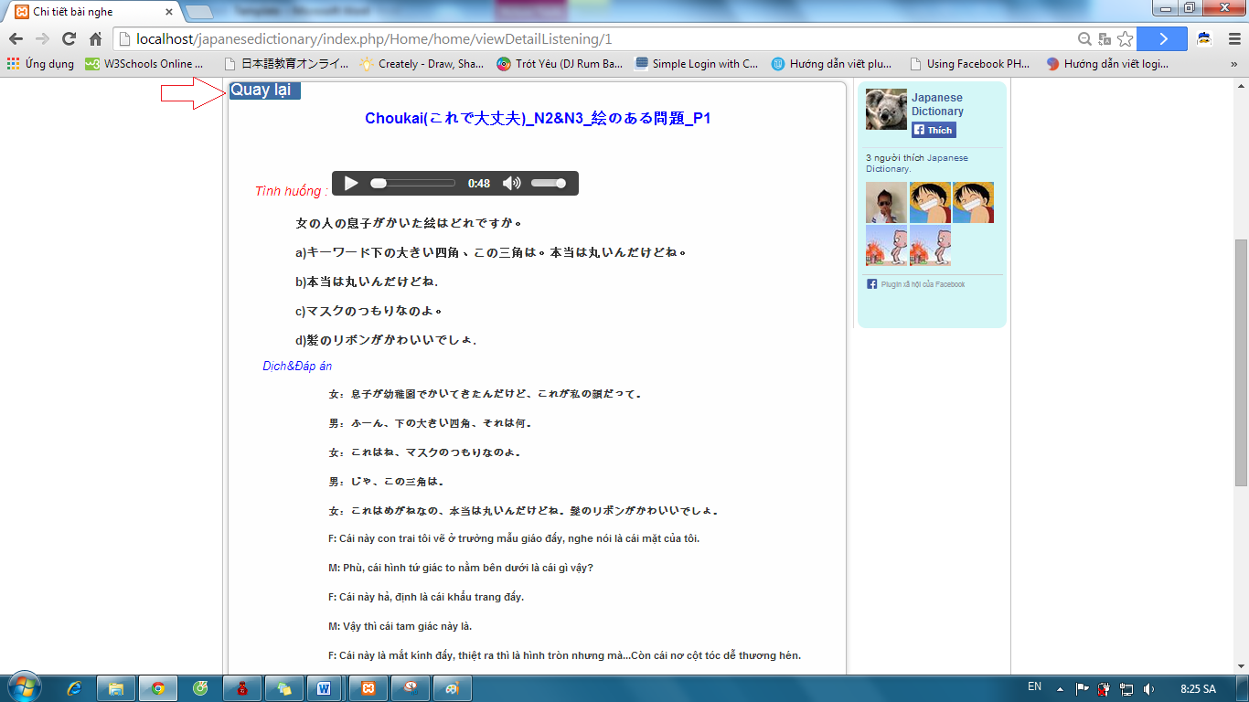

### Listening conversation

To use listening conversation function on website, the users do the steps below:

Step 1: Go to homepage

Step 2: Hover on “Hội thoại” and click 1 of 3 levels to listening conversation.

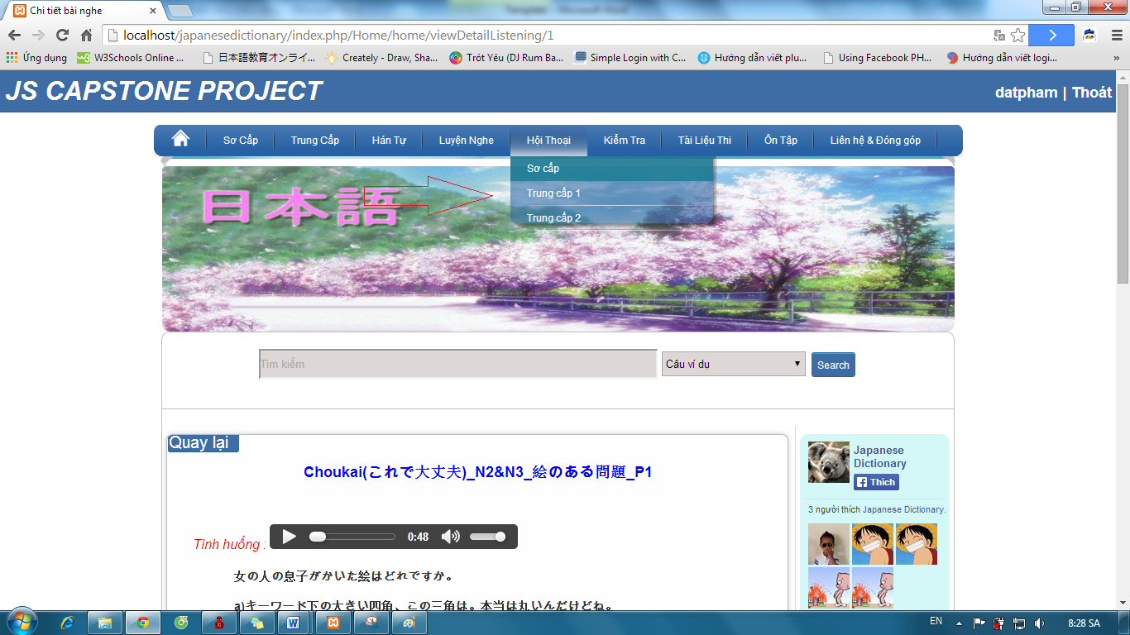

Step 3: Click one of the lesson of conversation links.

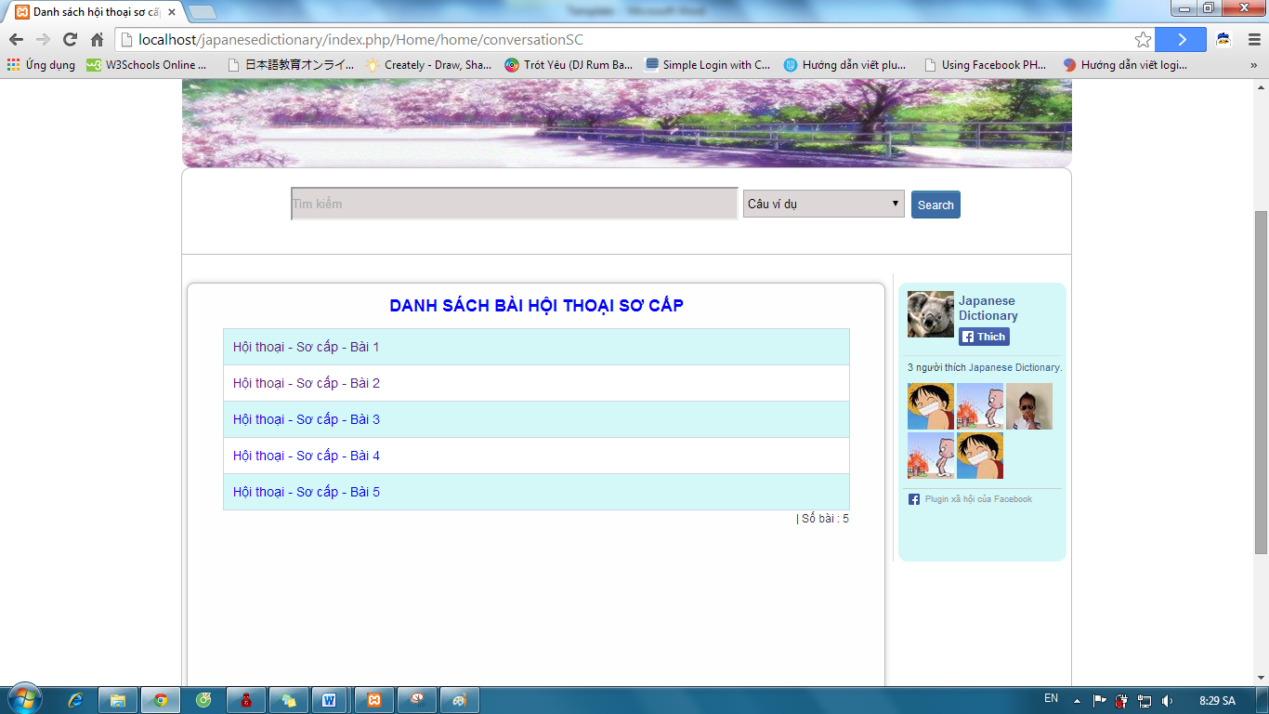

Step 4: Click play button to listen and click “Dịch” to view conversation’s content.

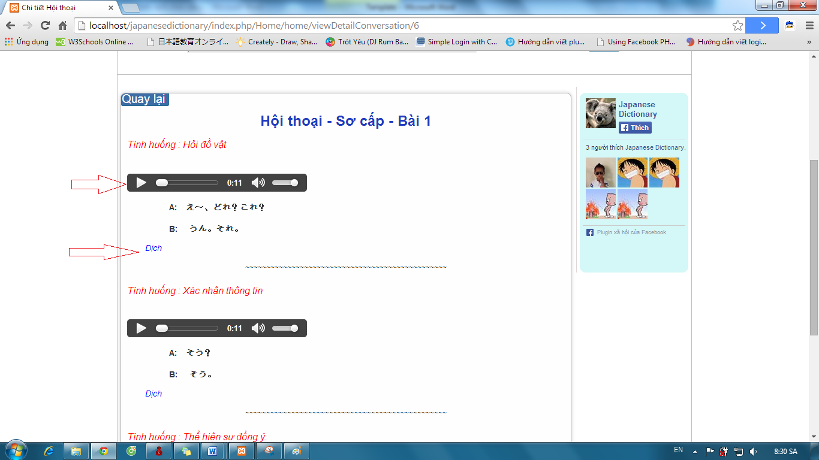

Step 5: Click “Quay lại” button after view conversation’s content 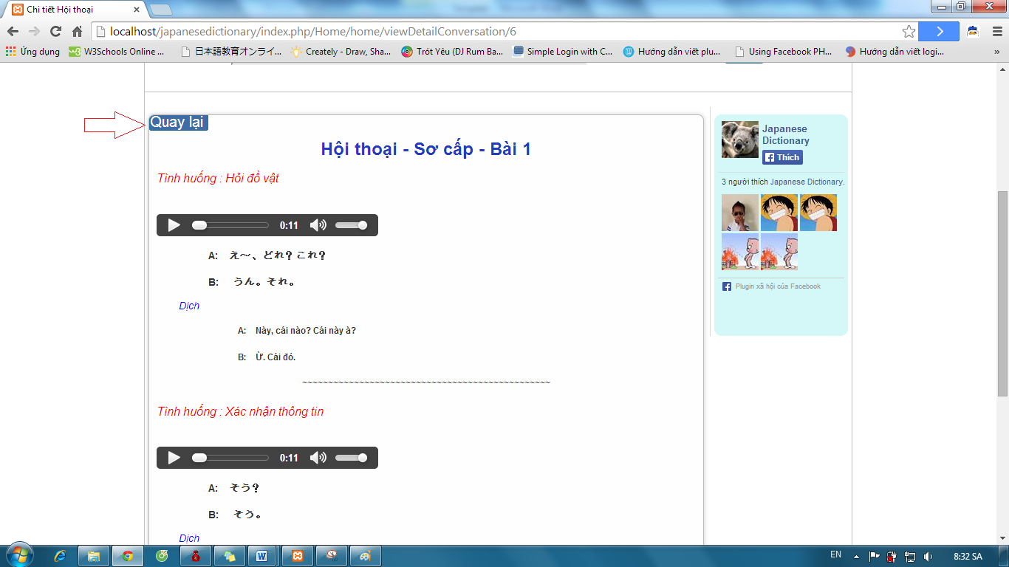

### Reading Document

To use reading document function on website, the users do the steps below:

#### View alphabet

Step 1: Go to homepage

Step 2: Hover on “Sơ cấp” and click “Hiragana & Katakana” to view alphabet.

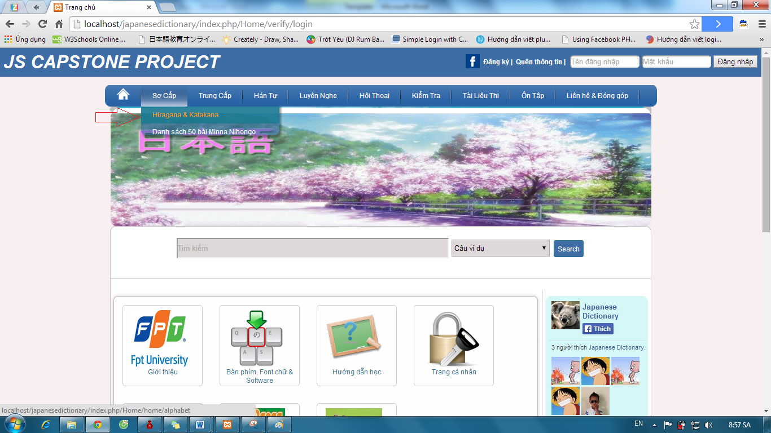

Step 3: Click “Bảng chữ cái Hiragana” link or “Bảng chữ cái Katakana” link to view alphabet.

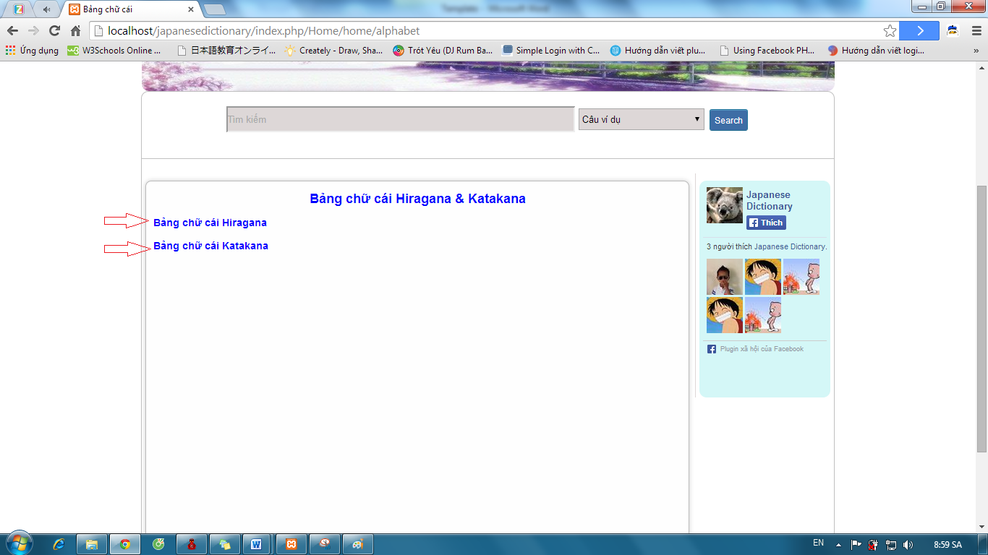

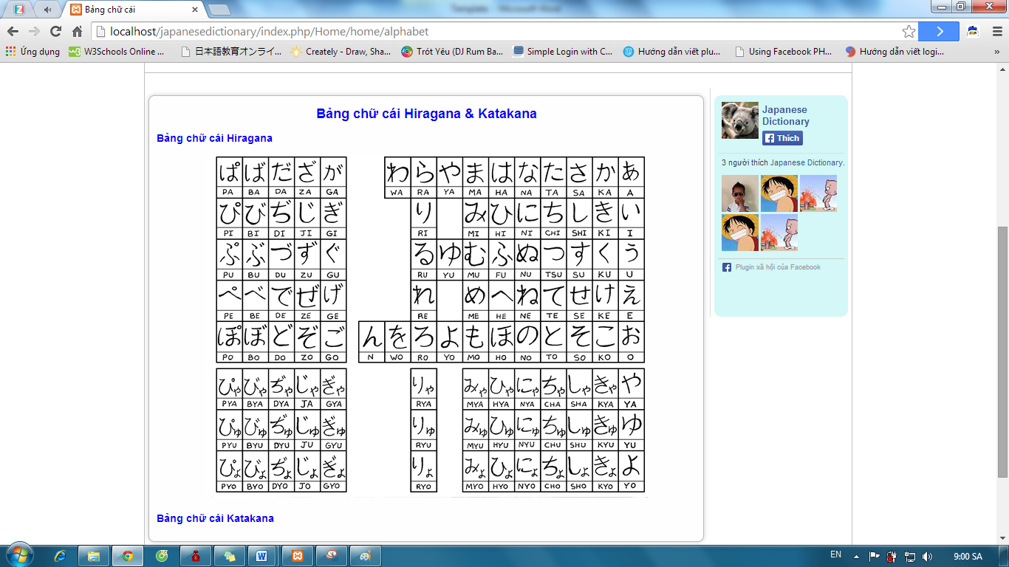

#### View document level Minna

Step 1: Go to homepage

Step 2: Hover on “Sơ cấp” and click “Danh sách 50 bài Minna Nihongo” link.

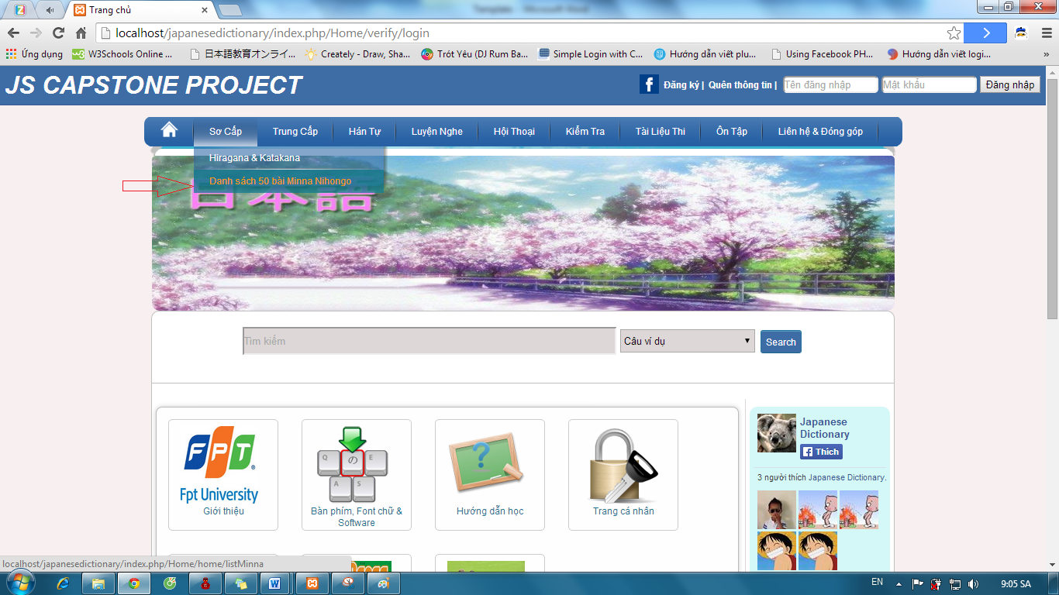

Step 3: Click one of the lessons.

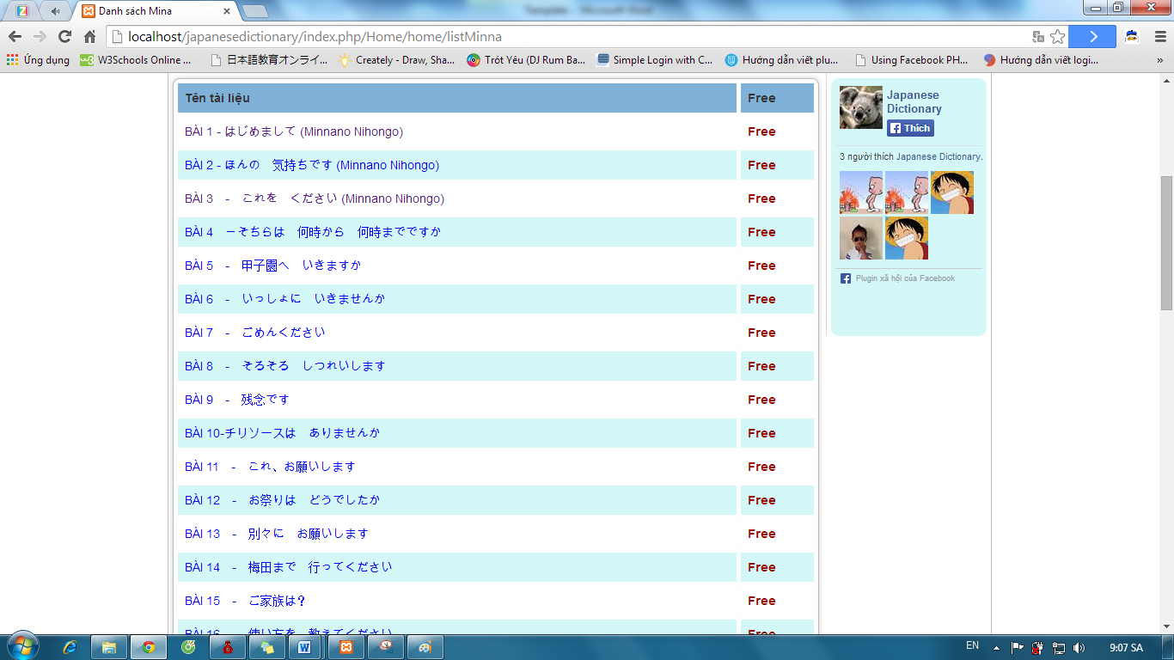

Step 4: Click one of the lesson’s content.

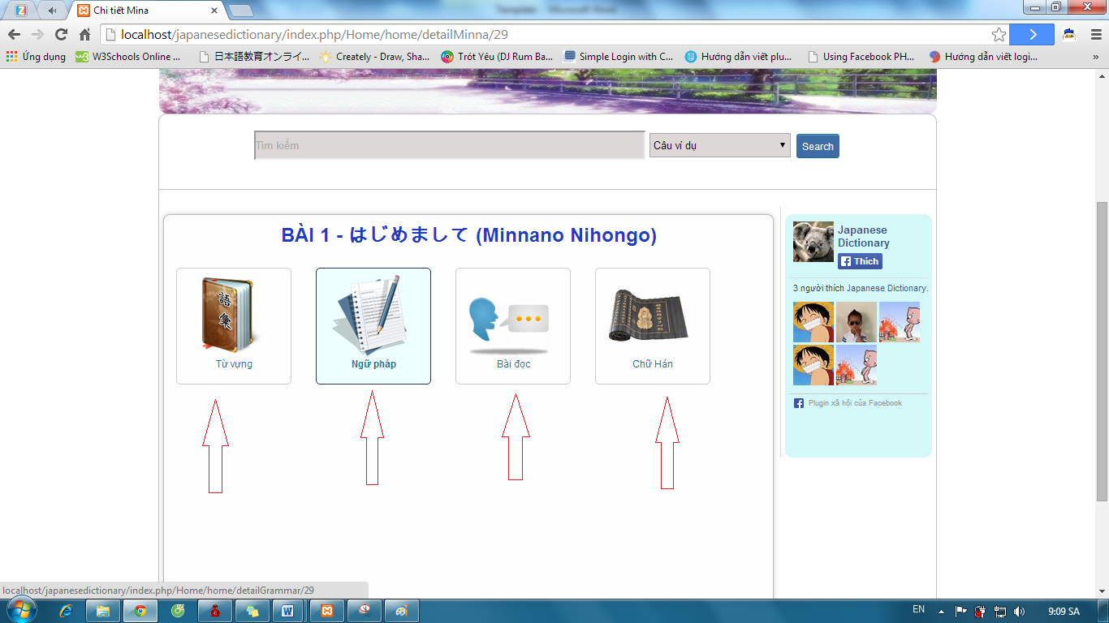

Step 5: Click “Quay lại” button after view content of lesson.

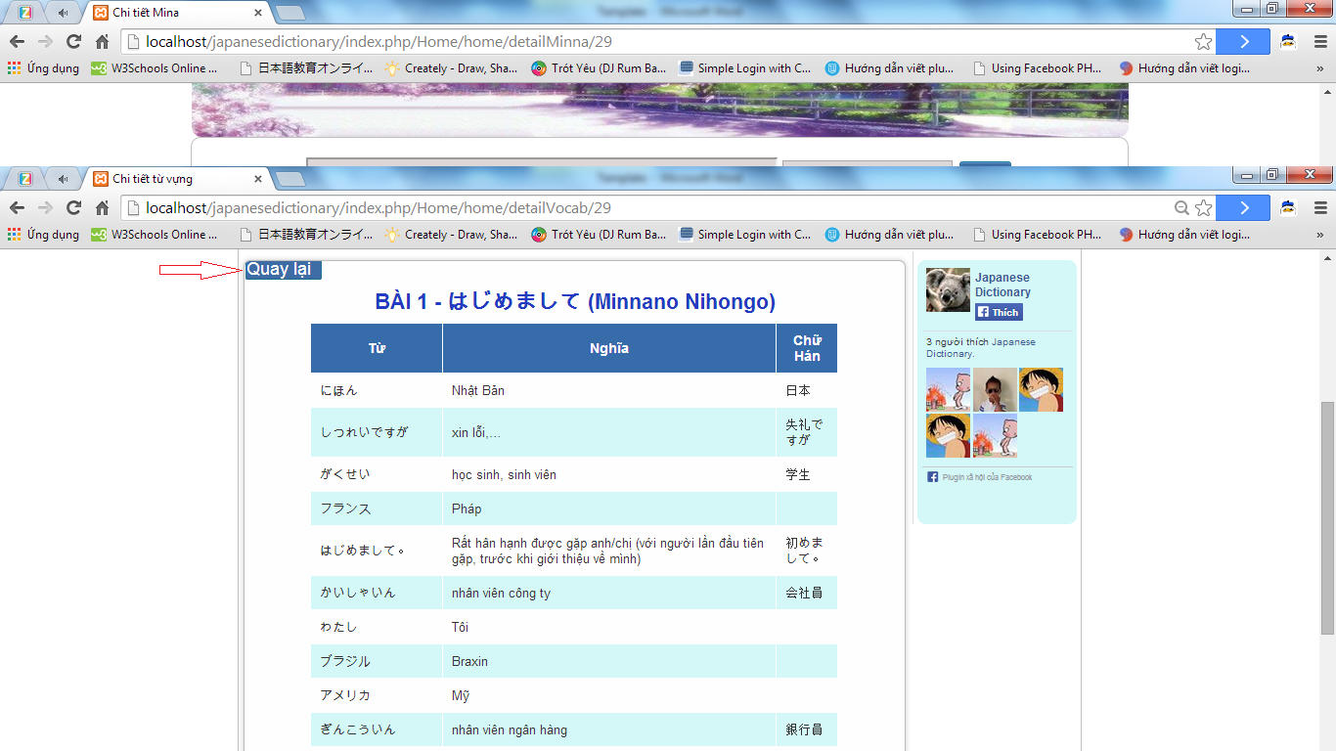

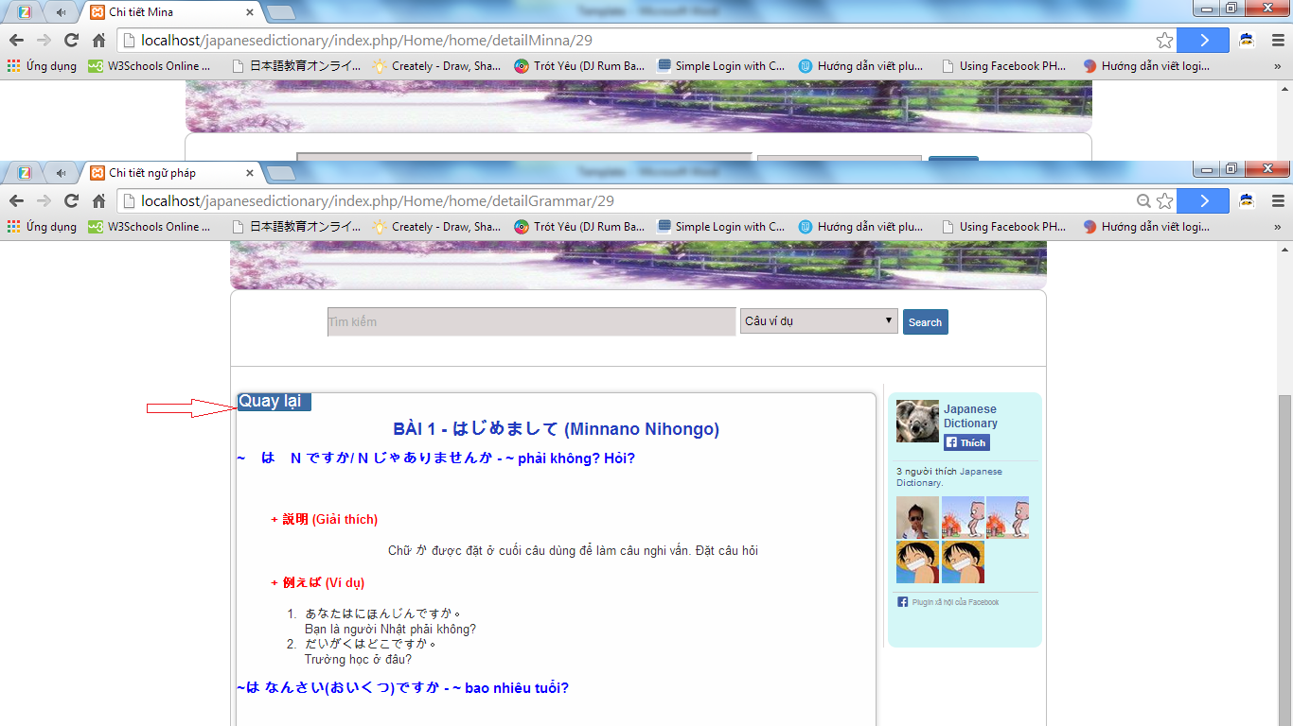

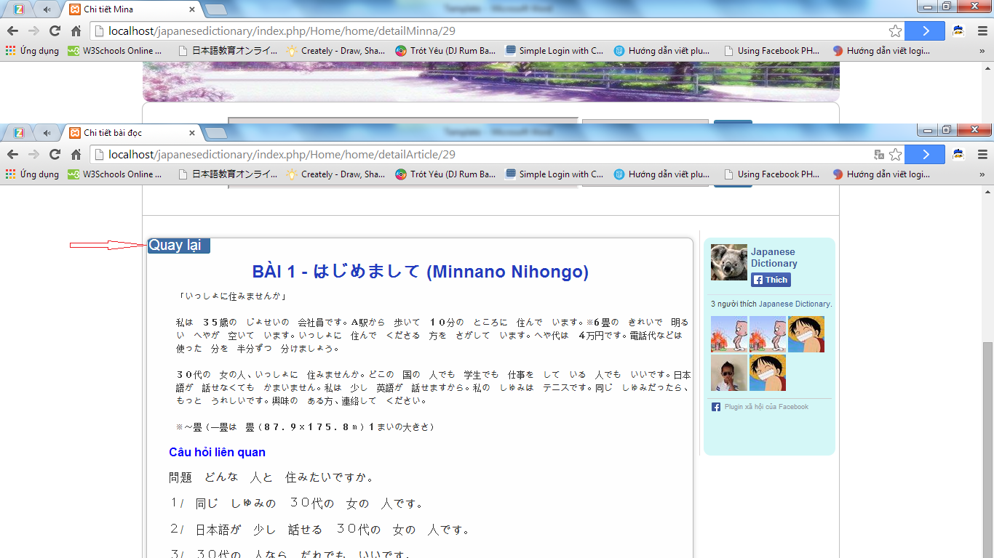

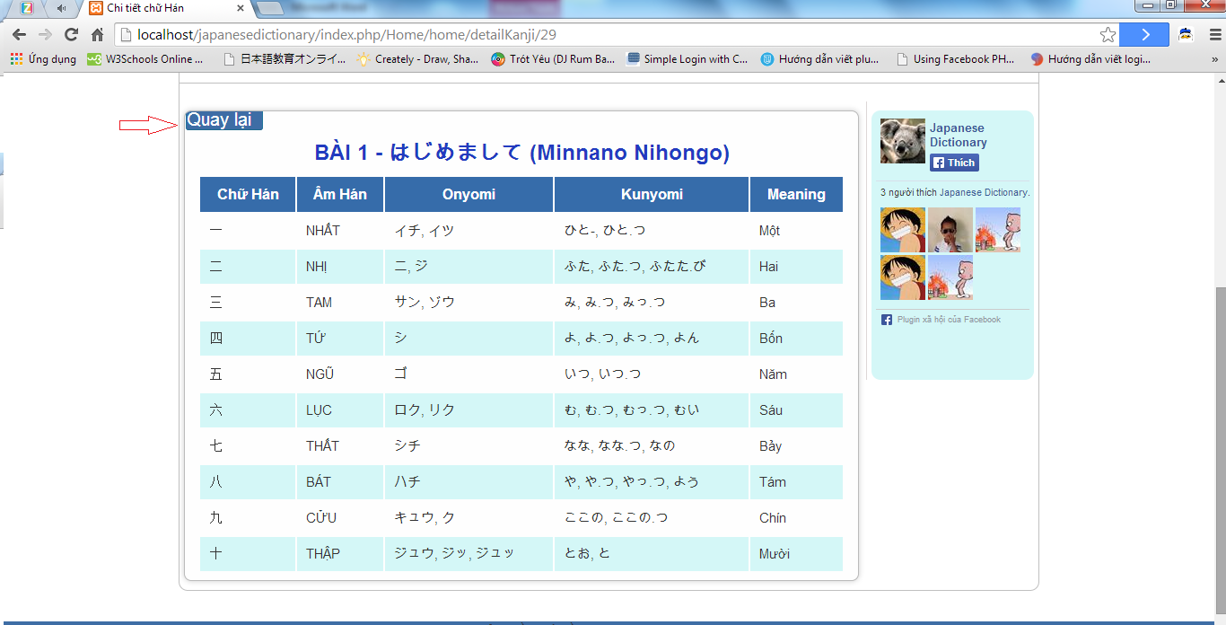

#### View document level intermediate

Step 1: Go to homepage

Step 2: Hover on “Trung cấp” and click one of the level links.

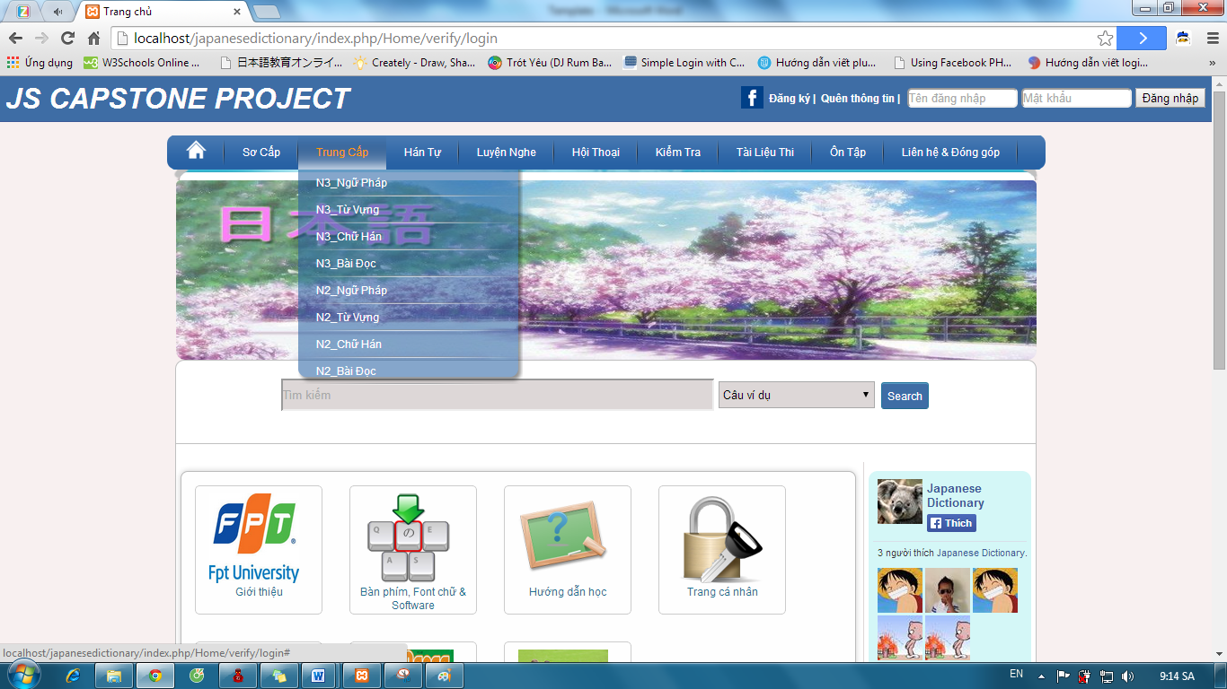

Step 3: Click one of the lesson links.

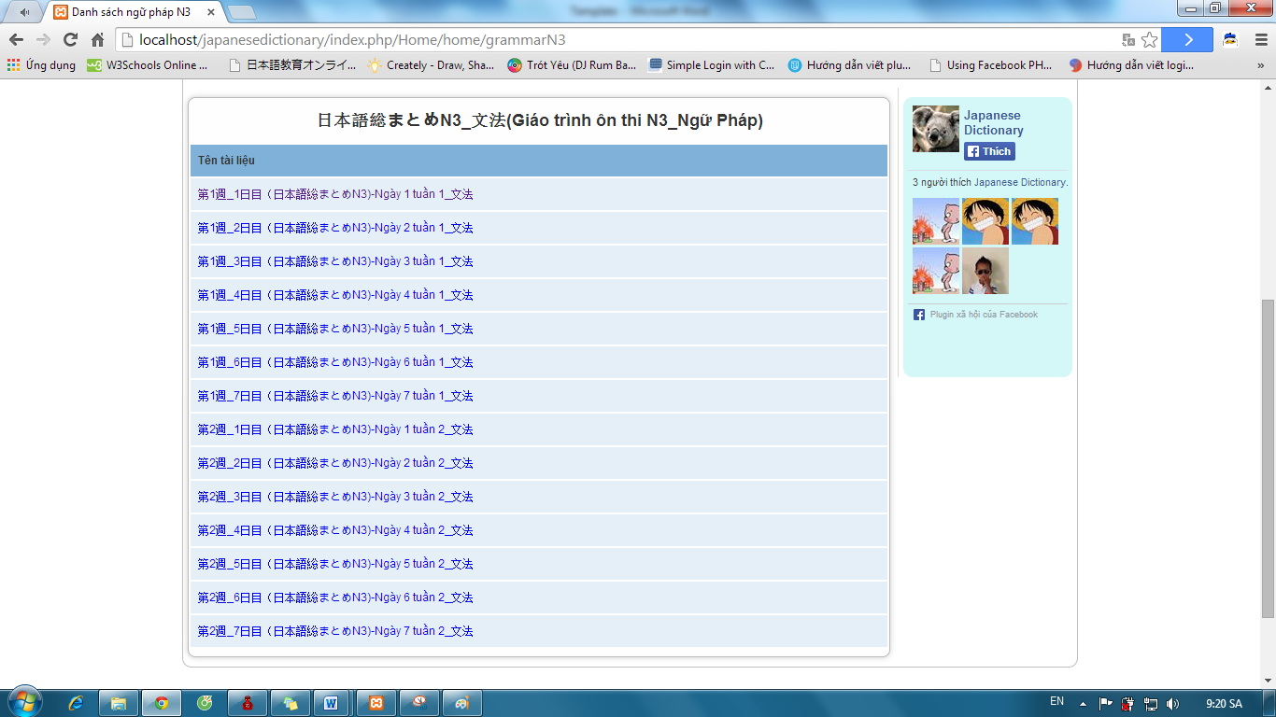

Step 4: Click “Quay lại” button after view lesson’s content.

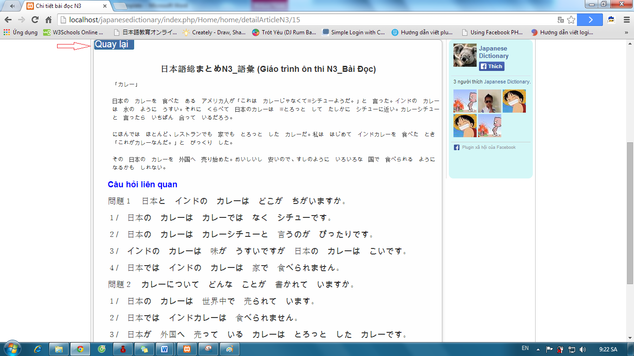

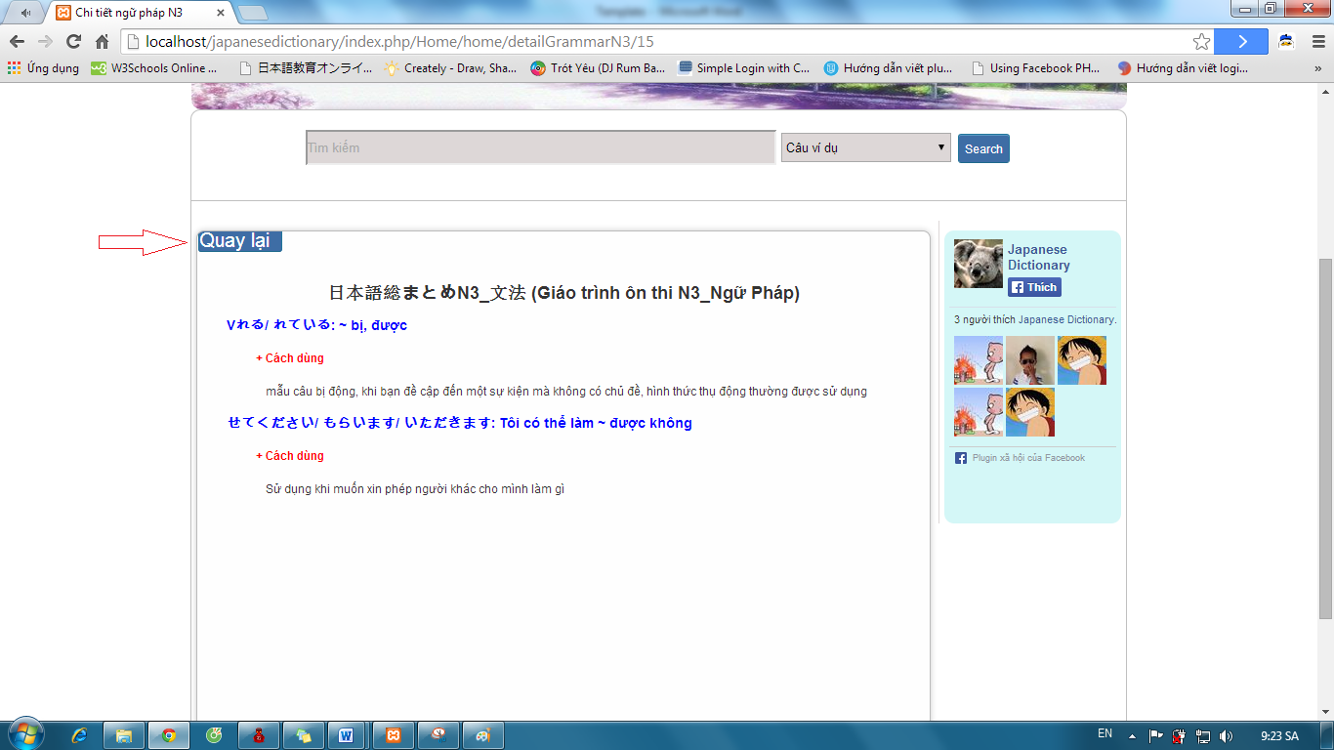

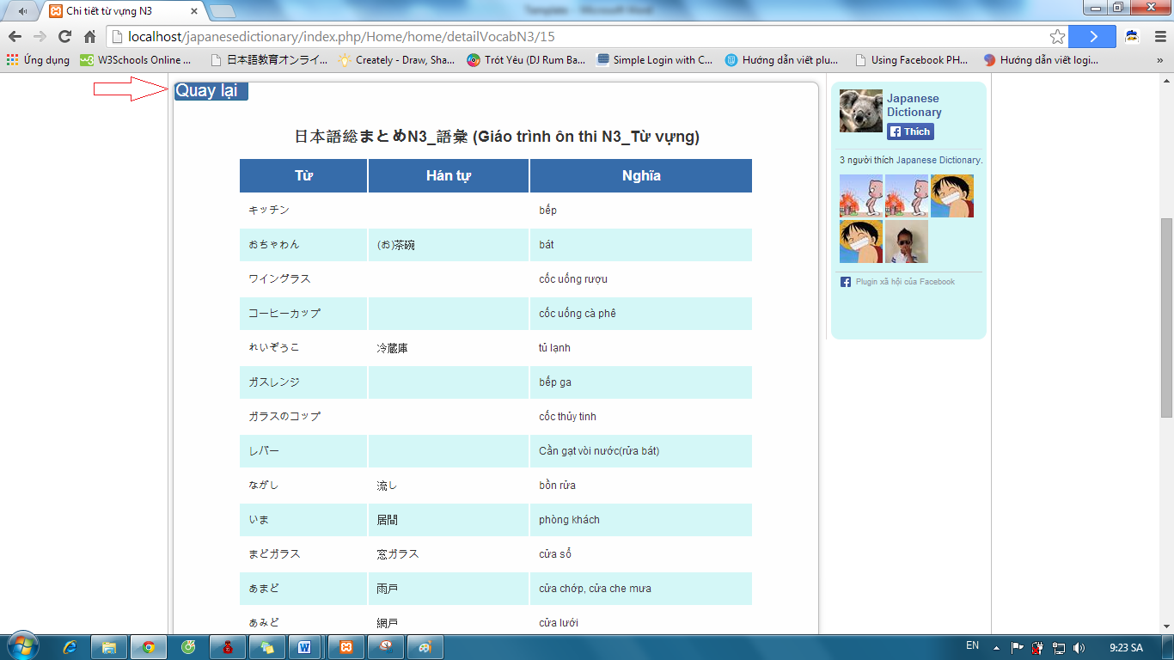

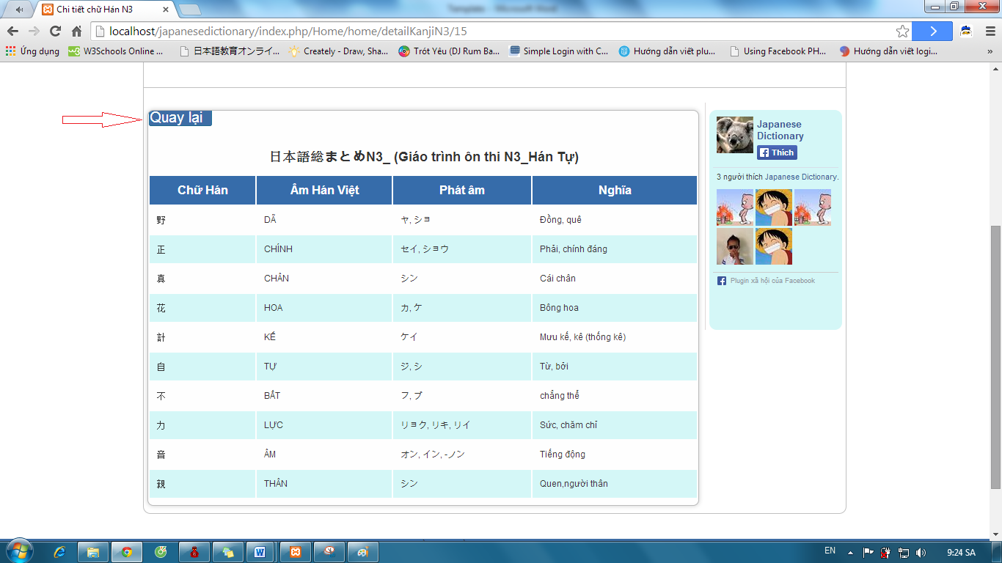

### Login with admin account

To use login with admin account function on website, the users do the steps below:

Step 1: Go to link http://localhost/japanesedictionary/index.php/admin/verify/login

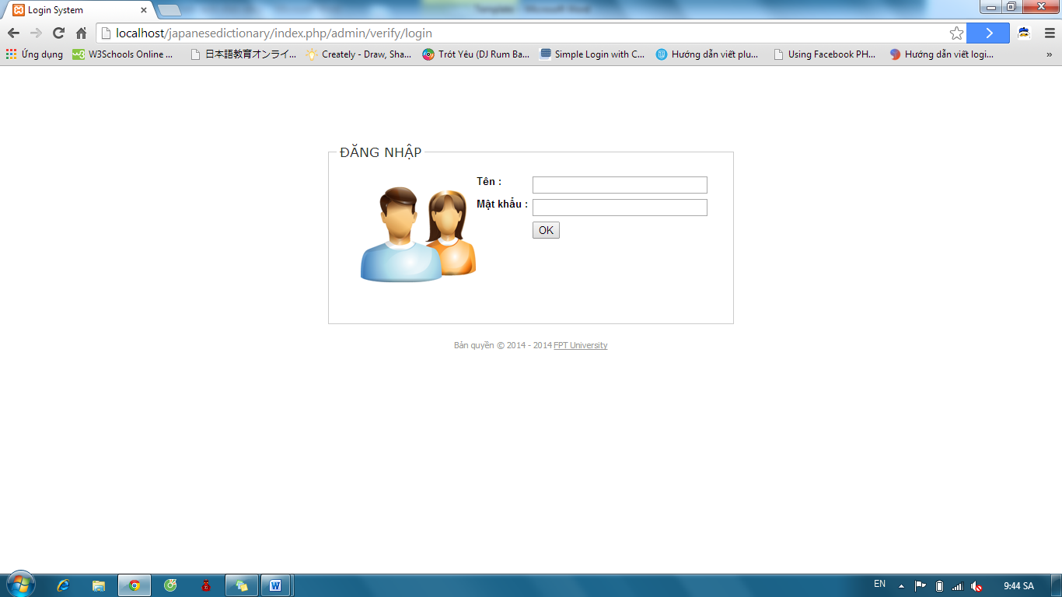

Step 2: Input correct username and password and click “OK” button.

* Success: Redirect to homepage admin.

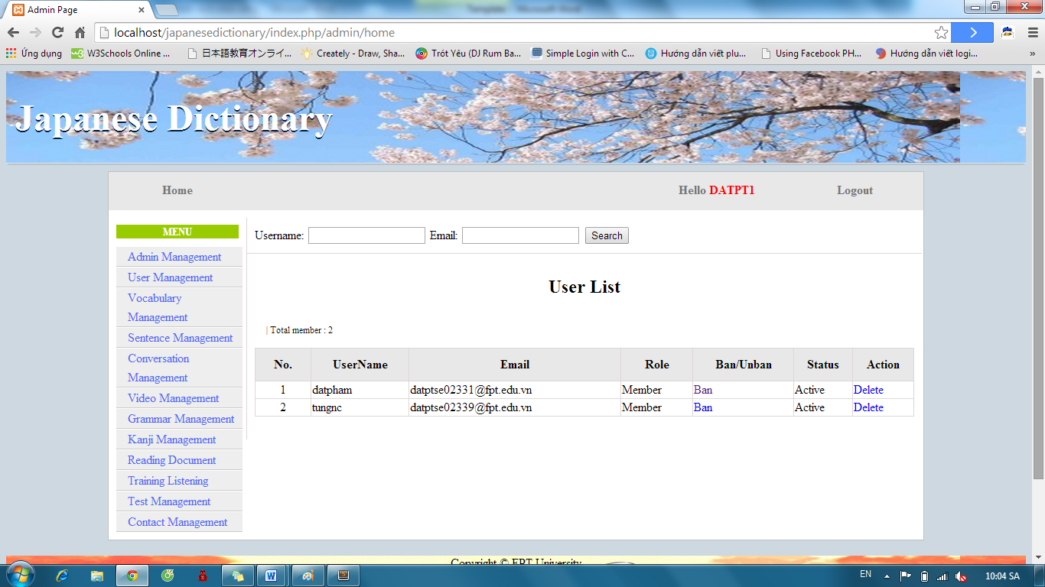

* Fails: Error message will notify. You must try again.

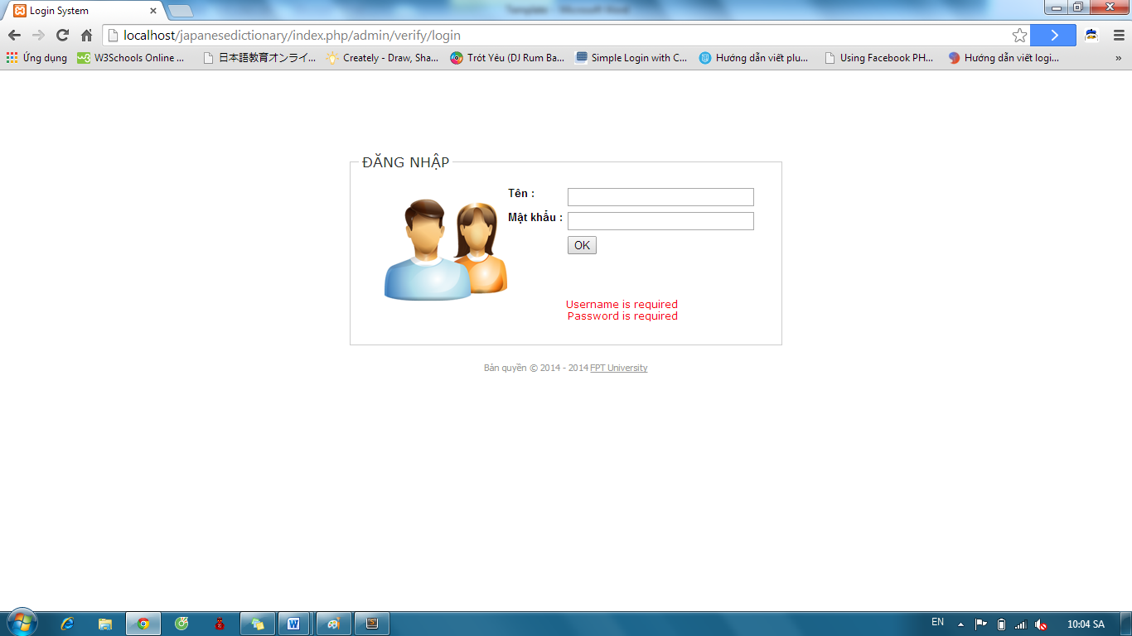

### Admin’s account management

#### Add new Admin

To use add new admin function on website, the users do the steps below:

Step 1: Login with supper admin account as 4.2.19.

Step 2: Click “Admin Management” link.

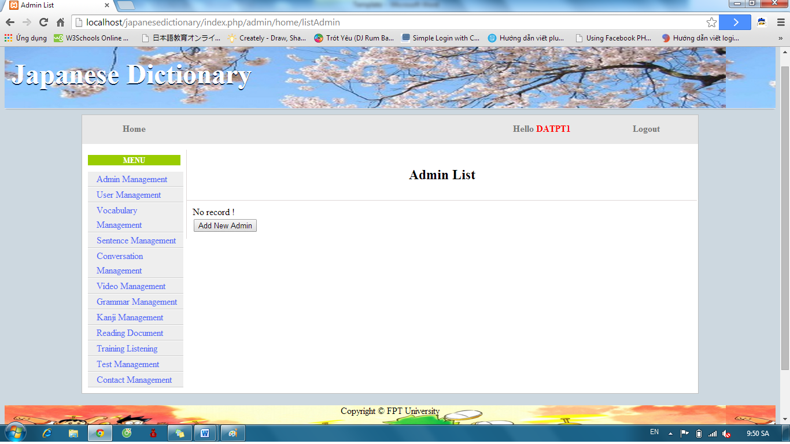

Step 3: Click “Add New Admin” button and input correct information that you want use to create a new account.

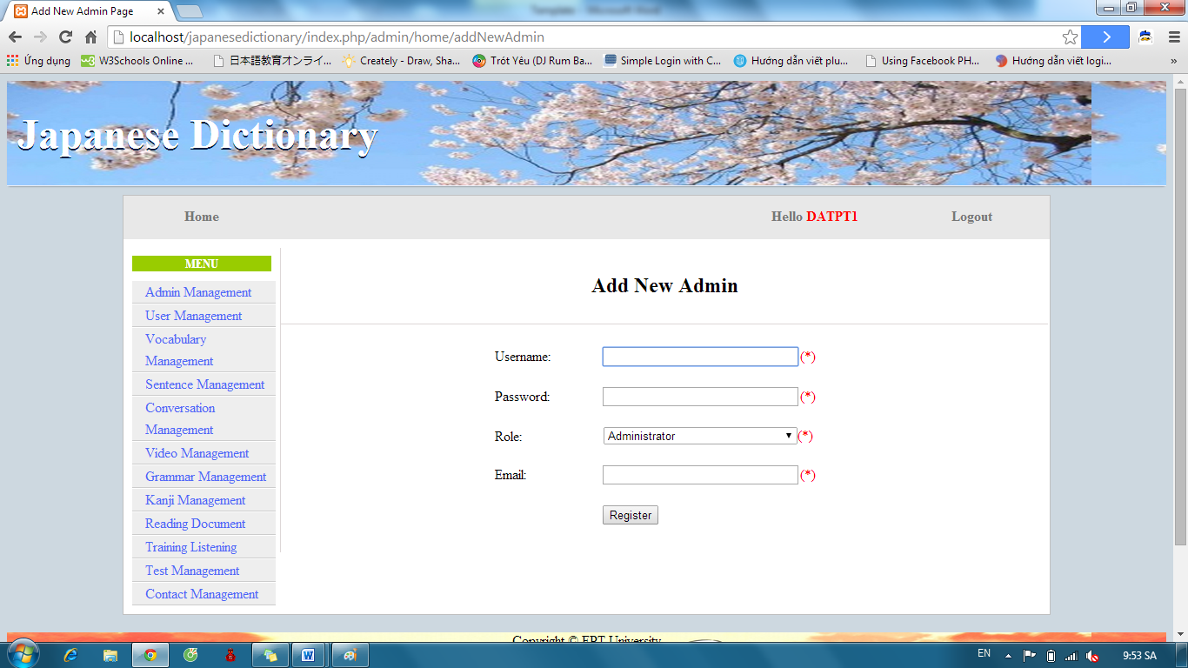

Step 4: Click “Register”

* Success: A new admin was created and system display admin list

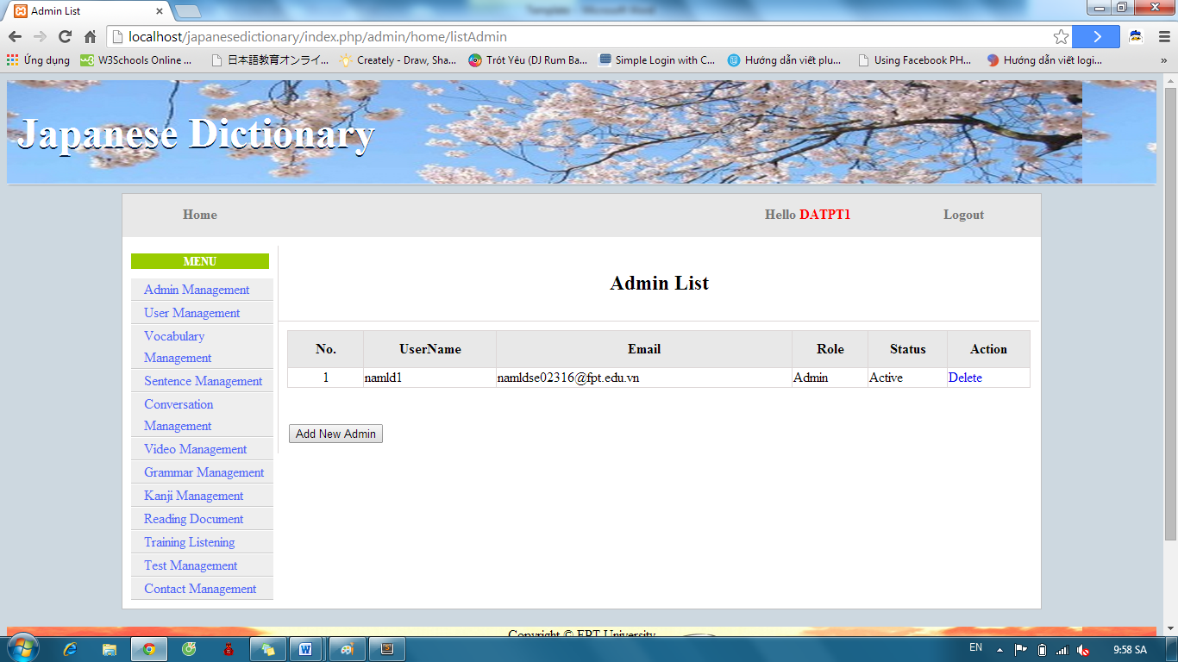

* Fails: Error message will notify. You must try again.

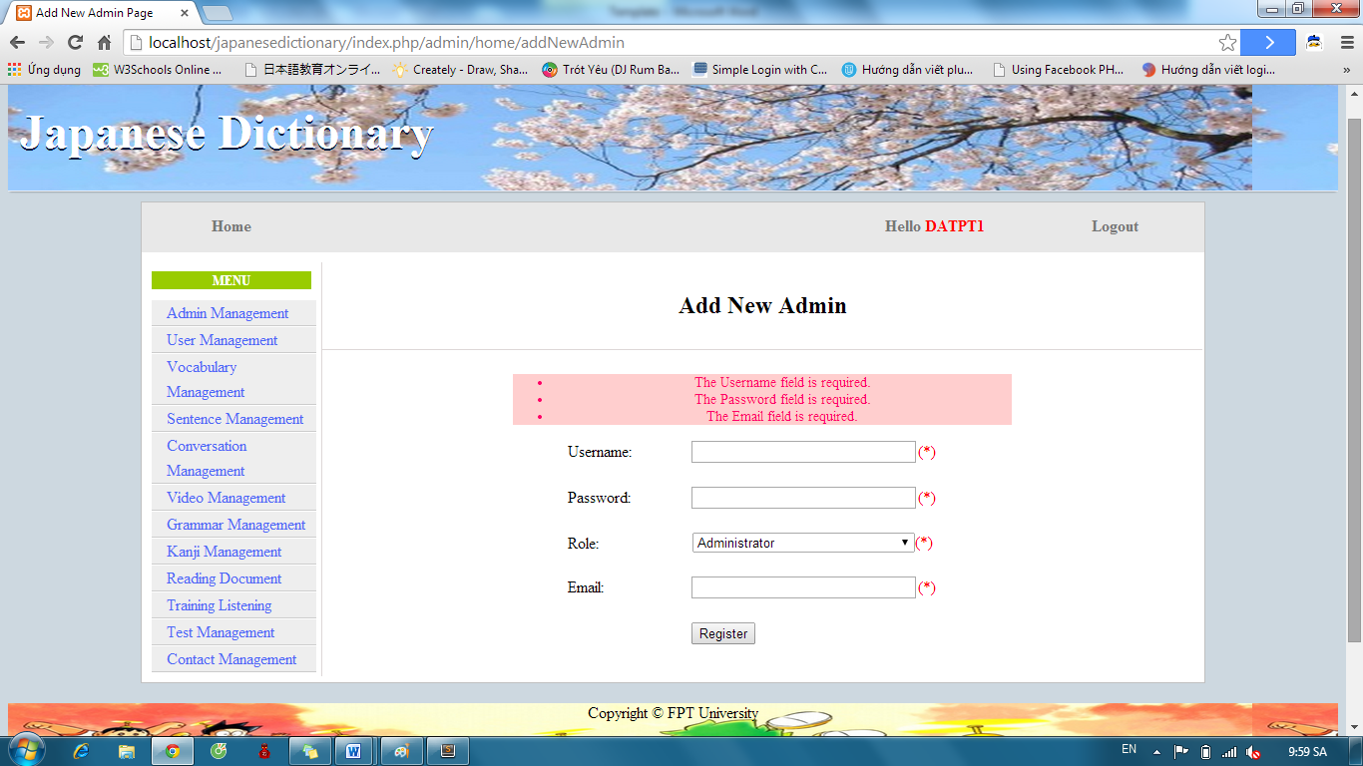

#### Edit profile

To use edit profile function on website, the users do the steps below:

Step 1: Login with admin account as 4.2.19.

Step 2: Click “username” link.

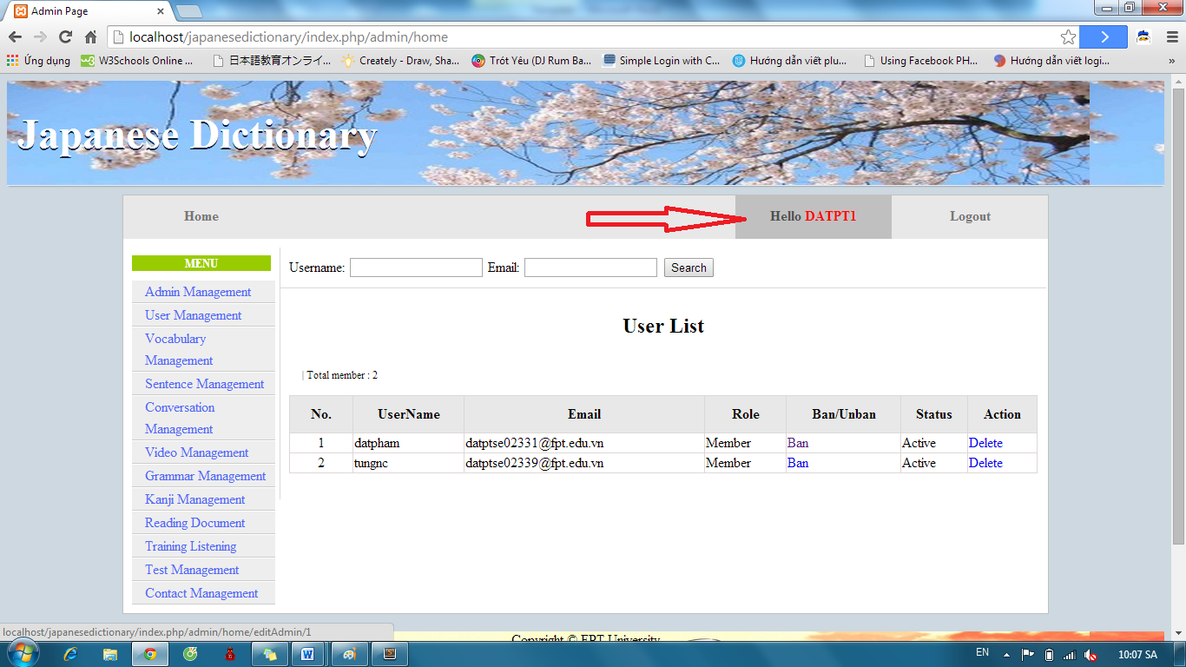

Step 3: Input correct information that you want change and click “Update” button.

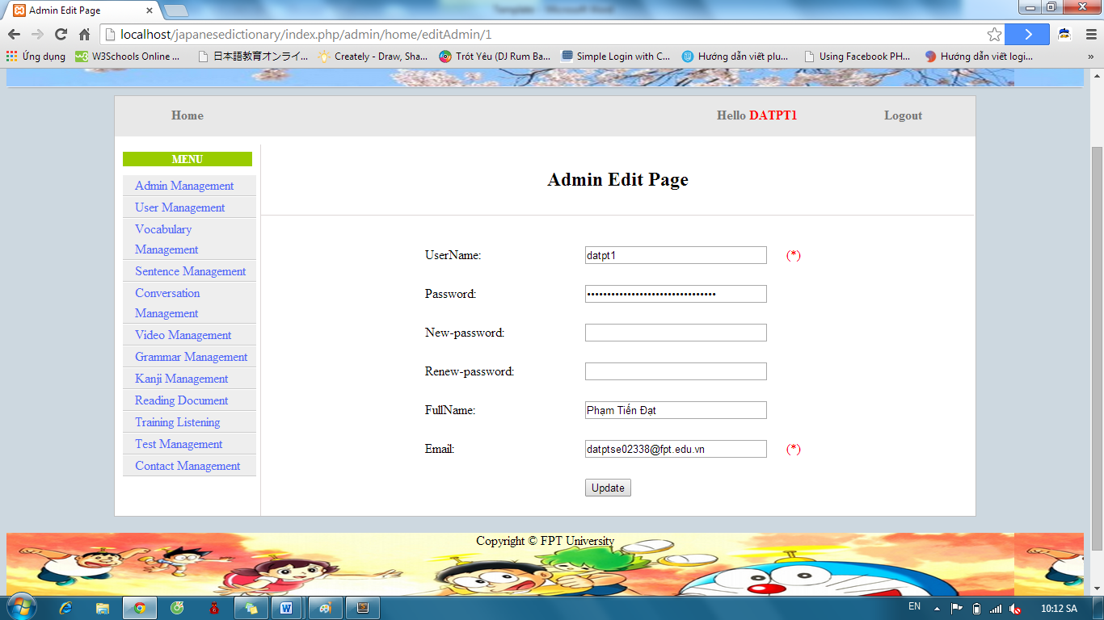

* Success: Redirect to homepage admin

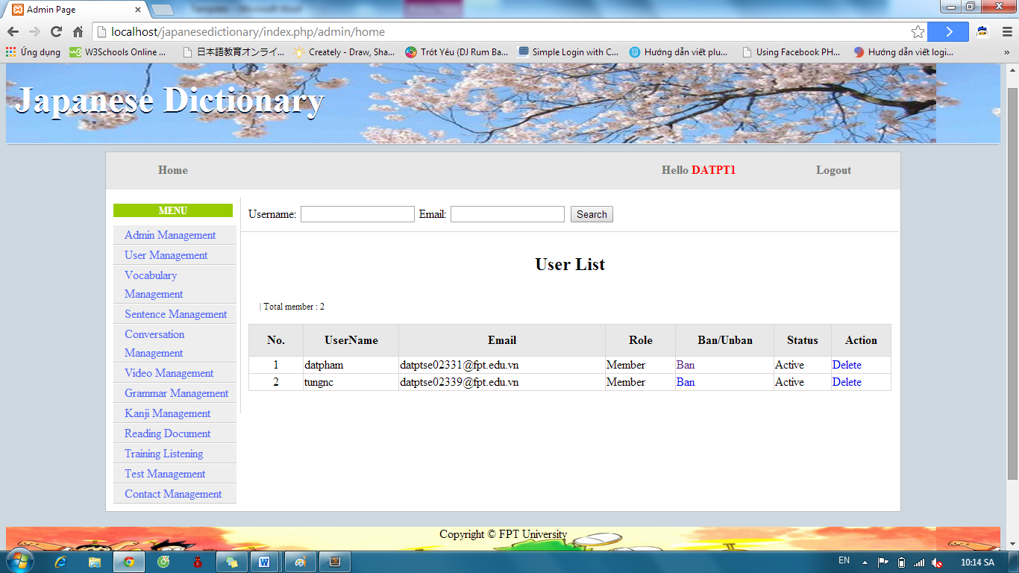

* Fails: Error message will notify. You must try again.

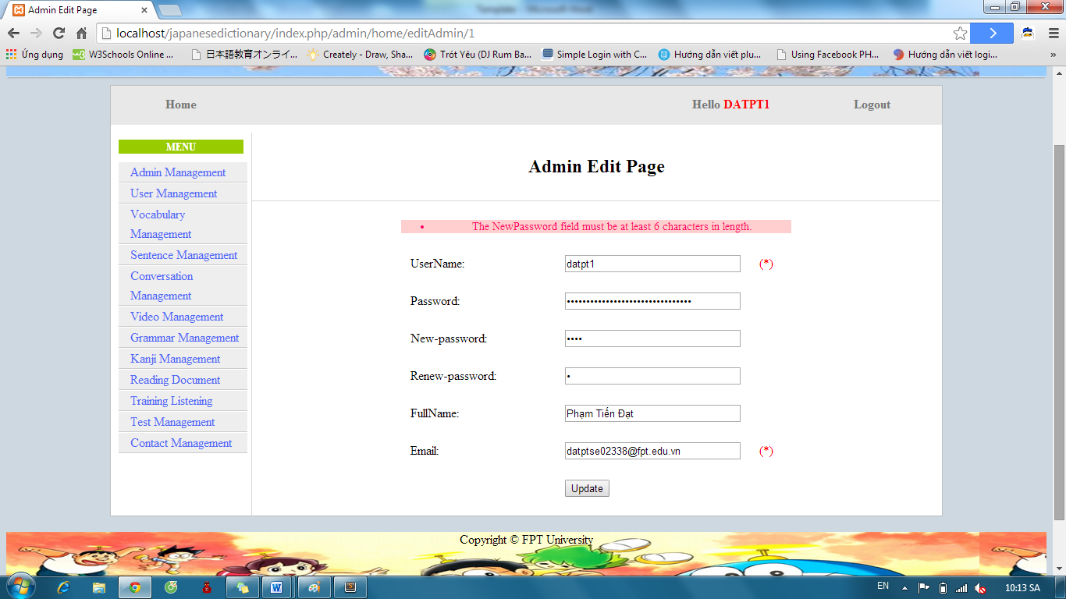

#### Delete Admin

To use delete admin function on website, the users do the steps below:

Step 1: Login with supper admin account as 4.2.19.

Step 2: Click “Admin Management” link. System will display list admin.

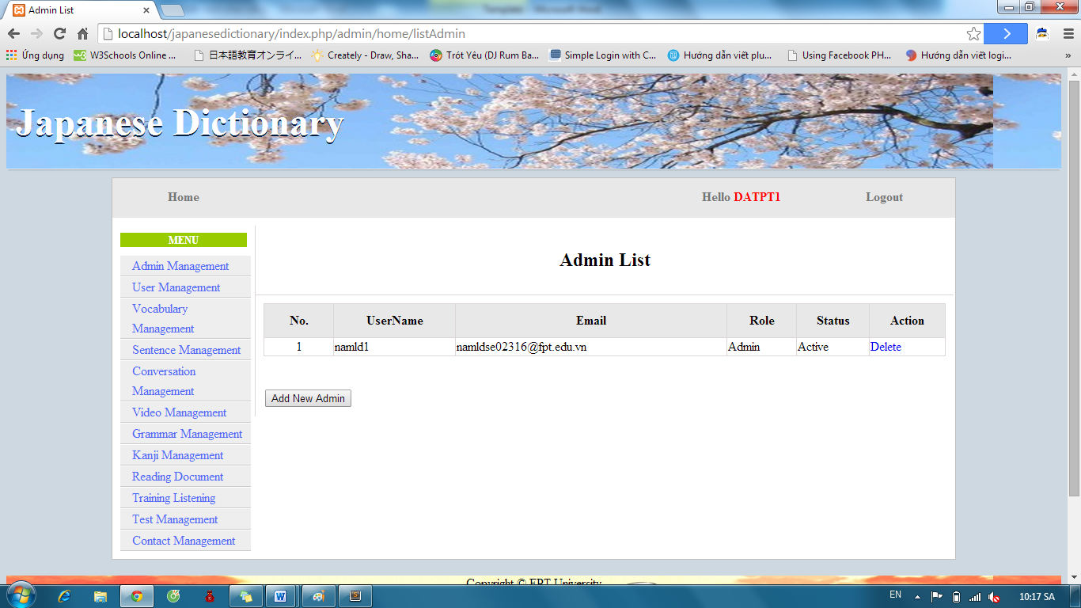

Step 3: Click “Delete” link. System will display list admin after delete a admin account.



### Management Member’s account

#### Search member

To use search member function on website, the users do the steps below:

Step 1: Login with admin account as 4.2.19. System will display list User.

Step 2: Input username or email that you want find. Click “Search” button.

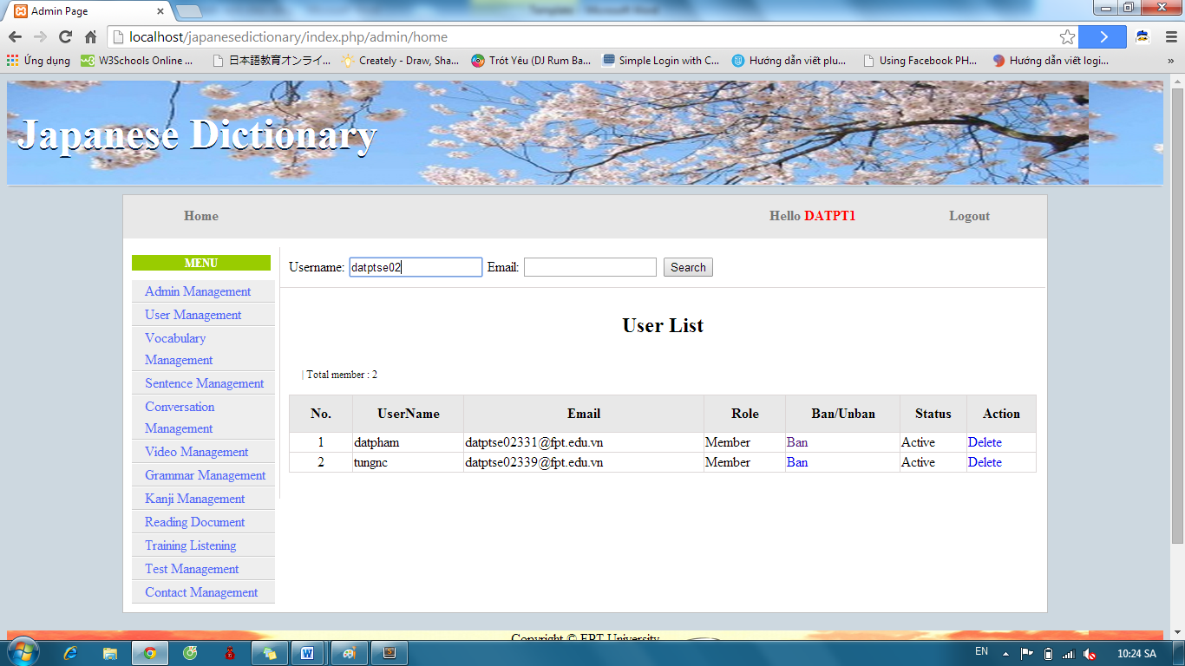

Step 3: View results found.

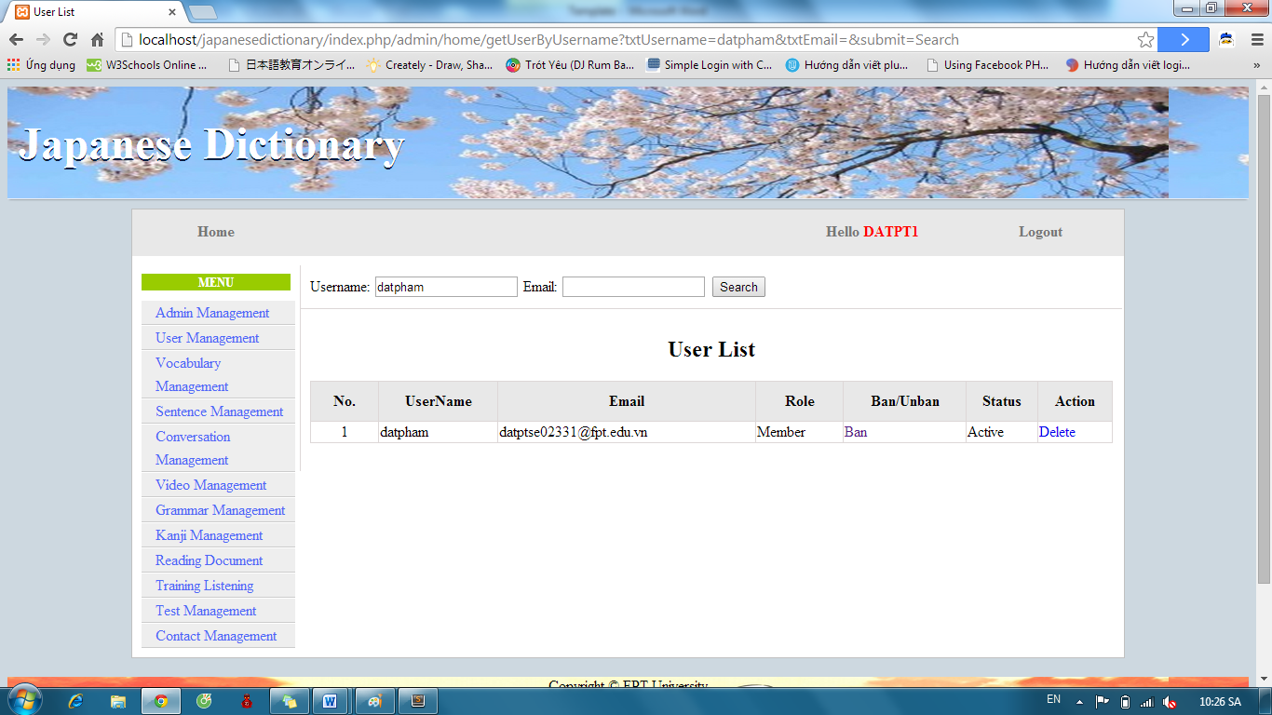

#### Ban/Unban member’s account.

To use ban/unban member’s account function on website, the users do the steps below:

Step 1: Login with admin account as 4.2.19. System will display list User.

Step 2: Click “Ban” or “Unban” link.

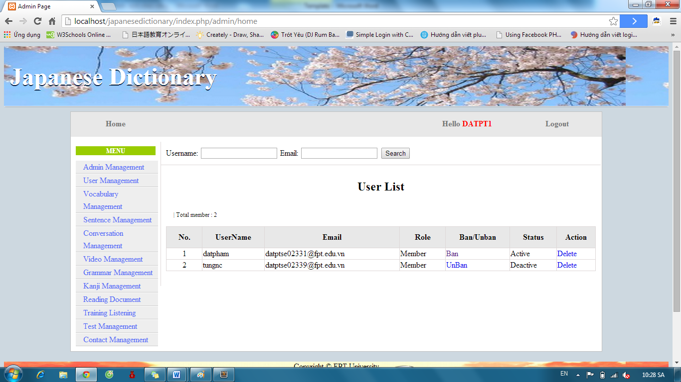

#### Delete member

To use delete member function on website, the users do the steps below:

Step 1: Login with admin account as 4.2.19. System will display list User.

Step 2: Click “Delete” link.



### Vocabulary Management

#### Search Vocabulary

To use search vocabulary function on website, the users do the steps below:

Step 1: Login with admin account as 4.2.19. System will display list User.

Step 2: Click “Vocabulary management” link. System will display list Vocabulary.

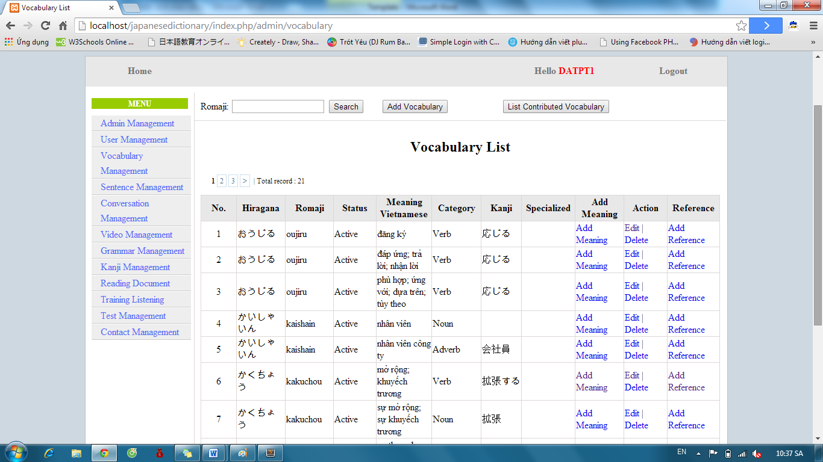

Step 3: Input vocabulary’s romaji and click “Search” button. Display results found.

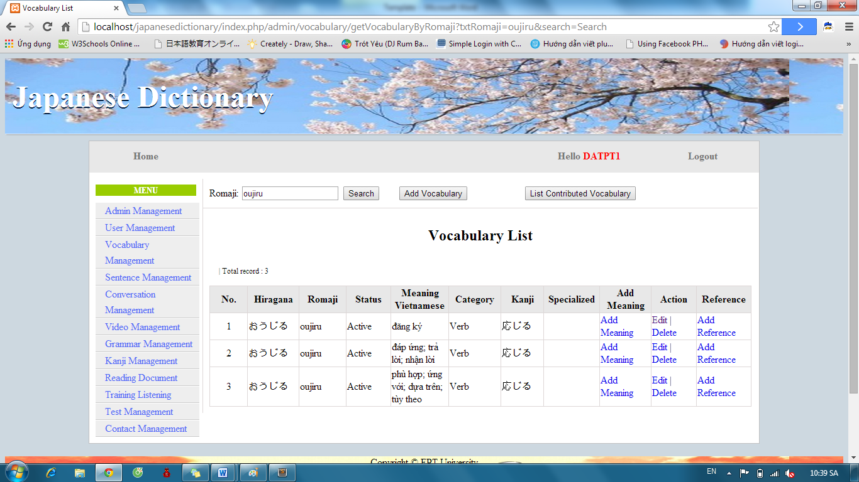

#### Add Vocabulary

To use add vocabulary function on website, the users do the steps below:

Step 1: Login with admin account as 4.2.19. System will display list User.

Step 2: Click “Vocabulary management” link. System will display list Vocabulary.



Step 3: Click “Add Vocabulary” button and input correct information of vocabulary that you want add.

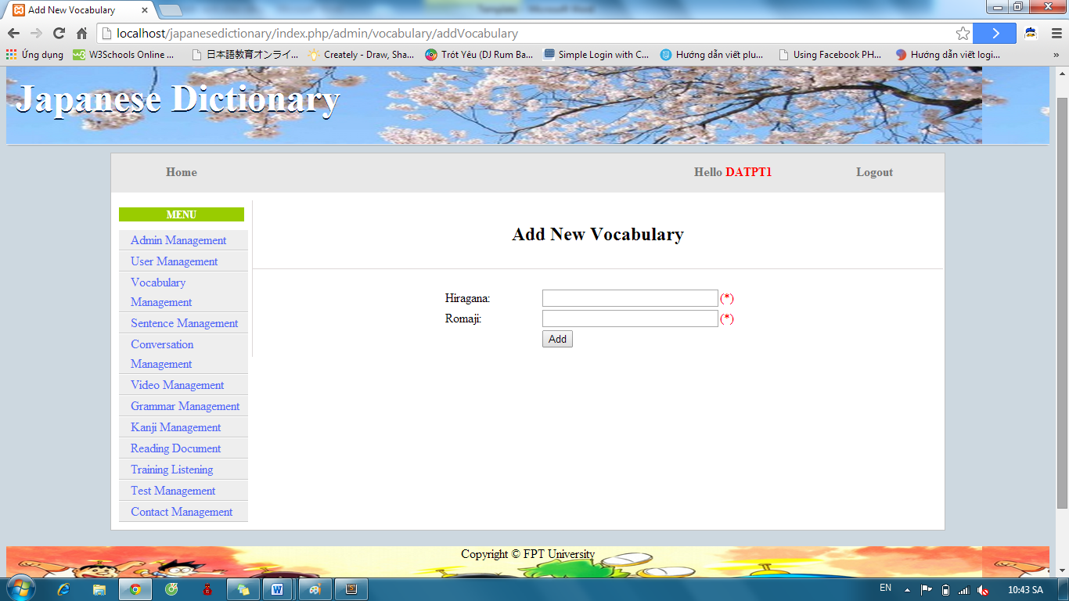

Step 4: After input, click “Add” button.

* Success: System display list Vocabulary with new vocabulary



* Fails: Error message will notify. You must try again.

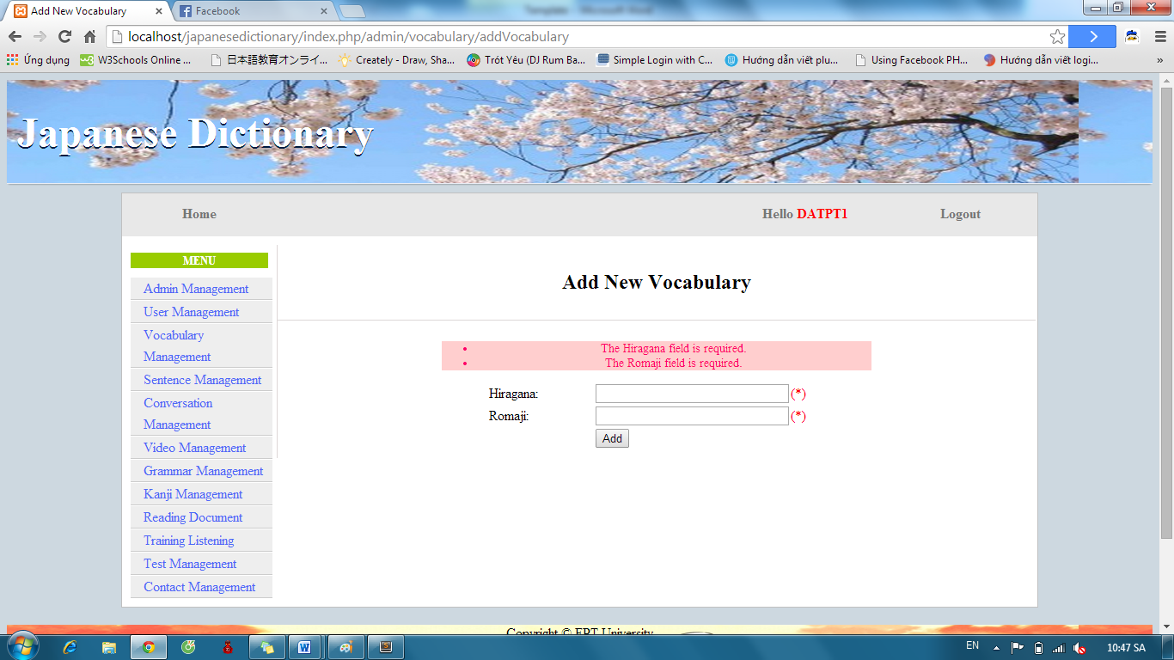

Step 5: After add vocabulary successful, click “Add Meaning” of corresponding Vocabulary.

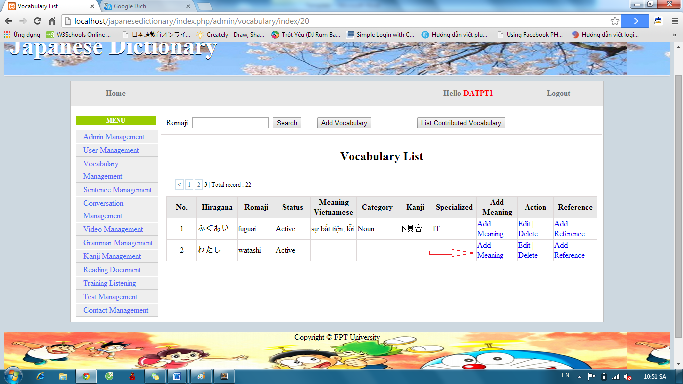

Step 6: Input correct information of vocabulary and click “Add” button

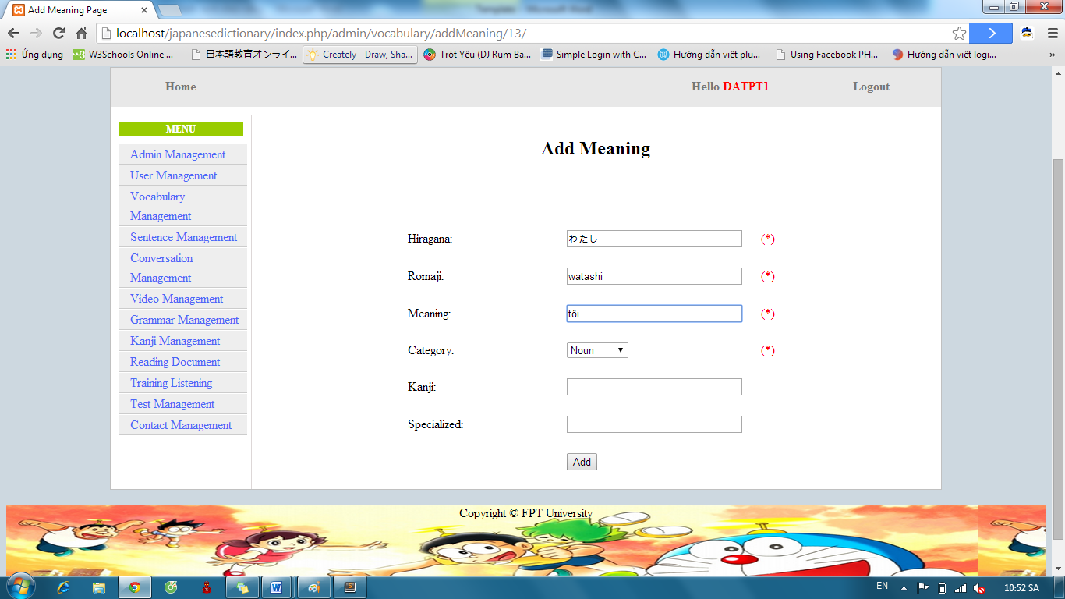

* Success : Display list Vocabulary



* Fails: Error message will notify. You must try again.

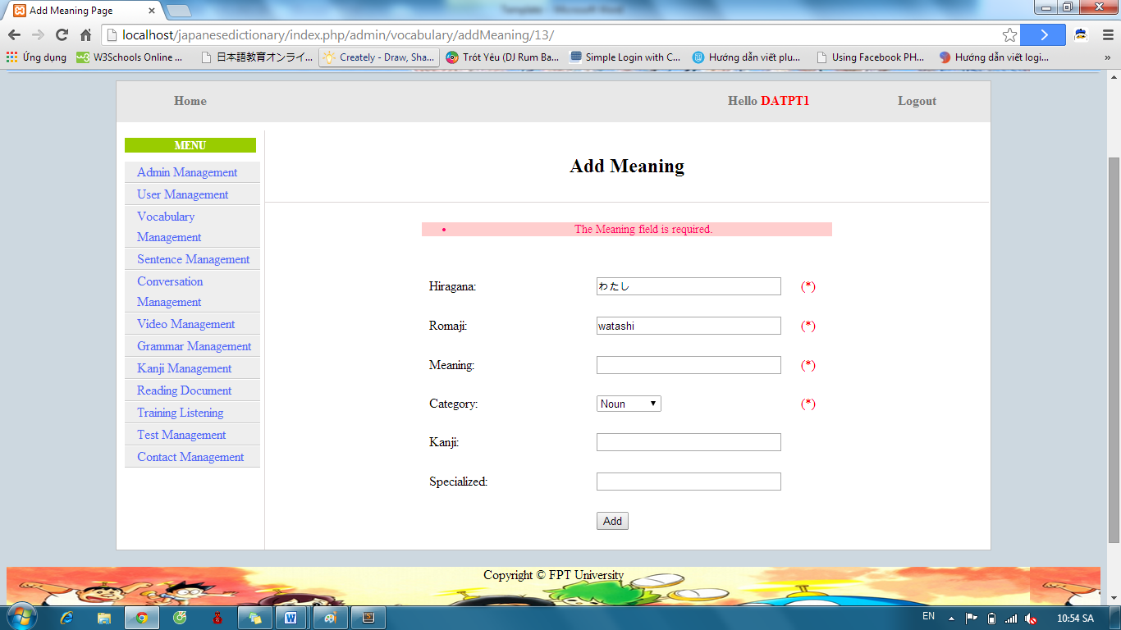

#### Edit Vocabulary

To use edit vocabulary function on website, the users do the steps below:

Step 1: Login with admin account as 4.2.19. System will display list User.

Step 2: Click “Vocabulary management” link. System will display list Vocabulary. After that, click “Edit” link.



Step 3: Input correct information of vocabulary that you want change and click “Edit” button.

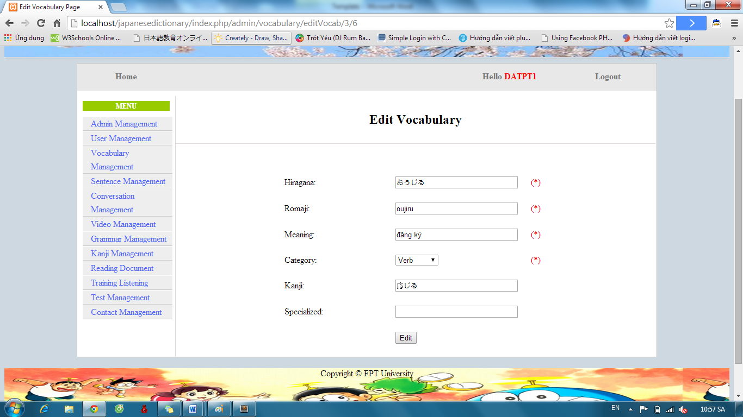

* Success : Display list vocabulary



* Fails: Error message will notify. You must try again.

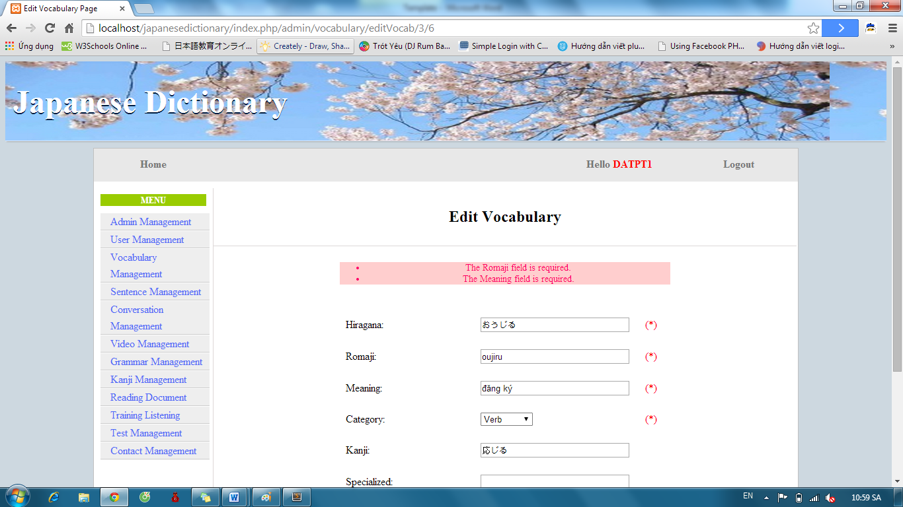

#### Delete Vocabulary

To use delete vocabulary function on website, the users do the steps below:

Step 1: Login with admin account as 4.2.19. System will display list User.

Step 2: Click “Vocabulary management” link. System will display list Vocabulary. After that, click “Delete” link.



If vocabulary has one meaning, it deleted. If vocabulary has many meaning, corresponding meaning with “Delete” link deleted.

### Grammar Management

#### Search grammar

To use search grammar function on website, the users do the steps below:

Step 1: Login with admin account as 4.2.19. System will display list User.

Step 2: Click “Grammar management” link. System will display list Grammar.

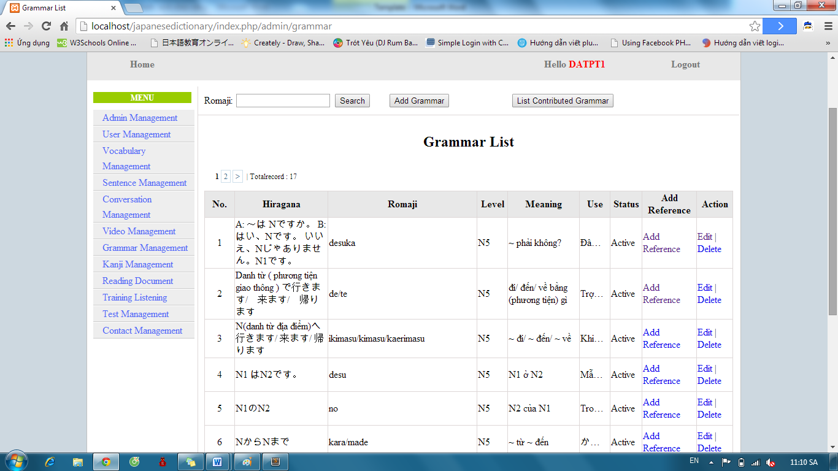

Step 3: Input grammar’s romaji and click “Search” button. Display results found.

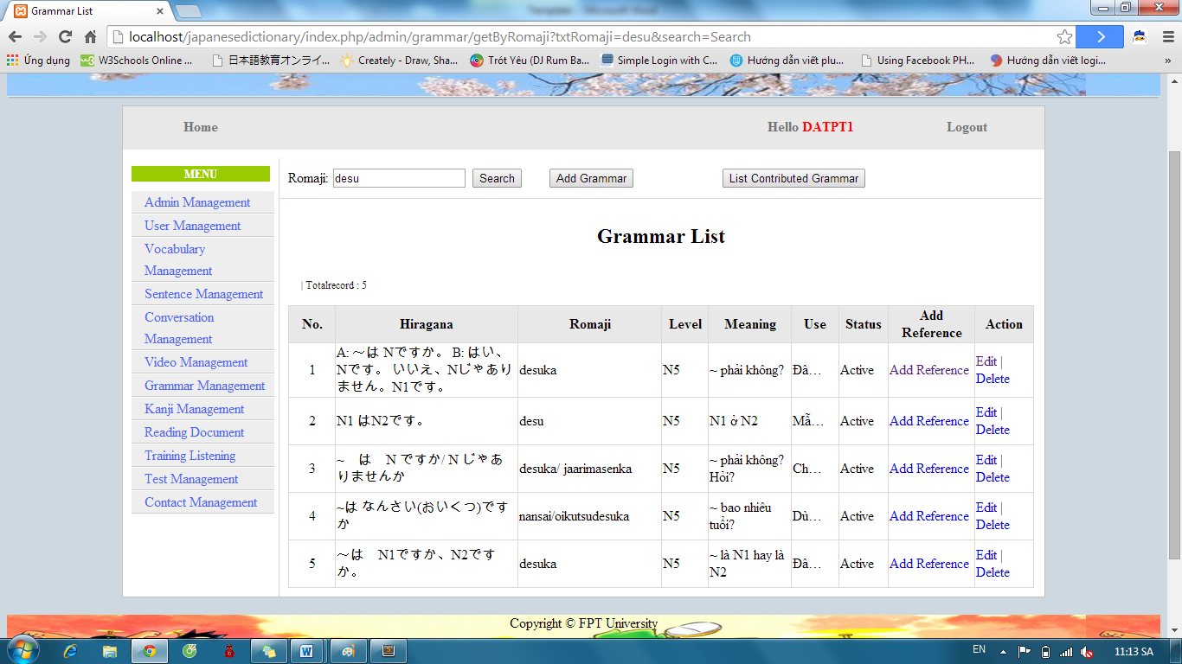

#### Add Grammar

To use add grammar function on website, the users do the steps below:

Step 1: Login with admin account as 4.2.19. System will display list User.

Step 2: Click “Grammar management” link. System will display list Grammar.



Step 3: Click “Add Grammar” button and input correct information of grammar that you want add.

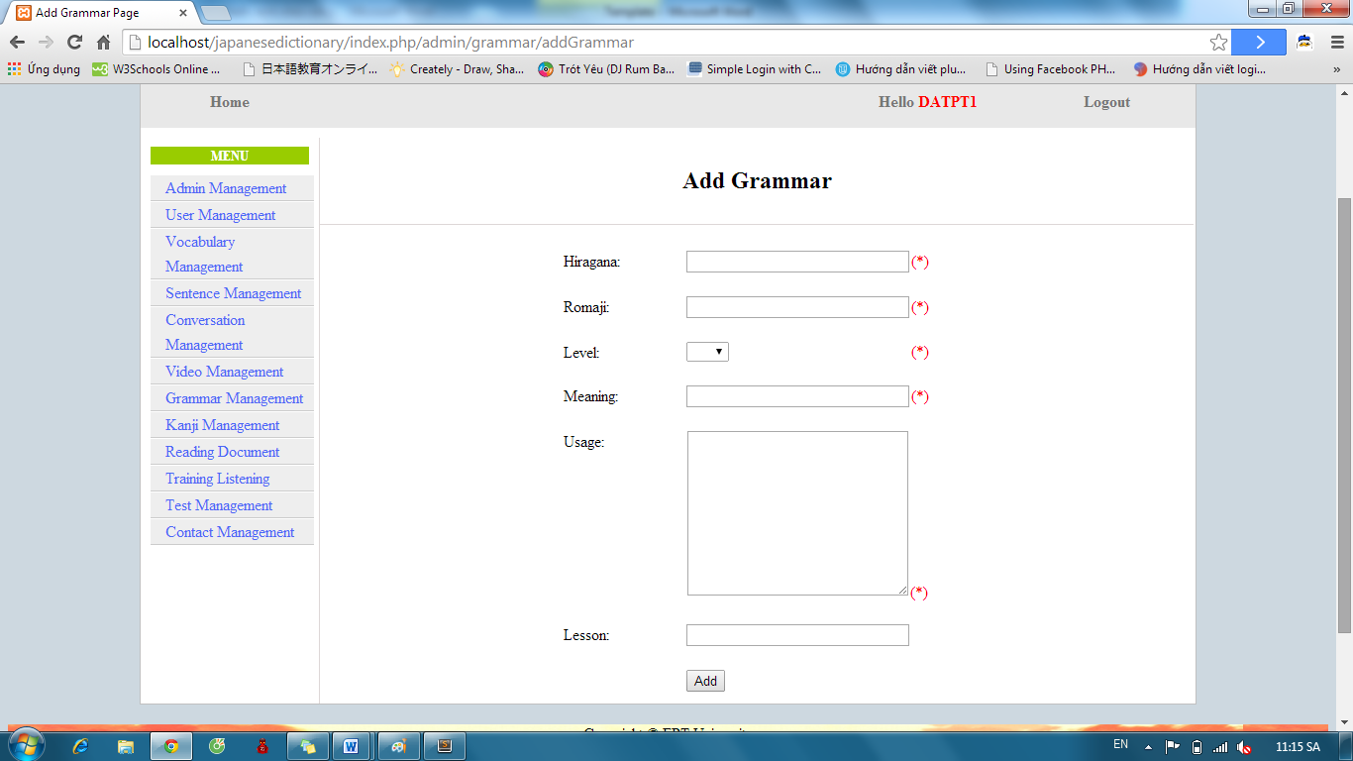

Step 4: After input, click “Add” button.

* Success: System display list Grammar with new grammar



* Fails: Error message will notify. You must try again.

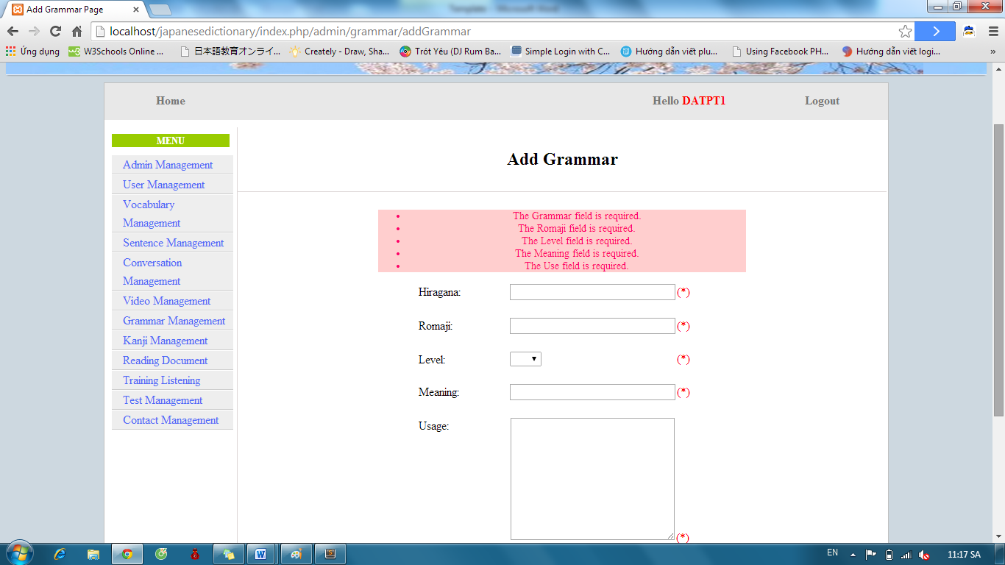

#### Edit Grammar

To use edit grammar function on website, the users do the steps below:

Step 1: Login with admin account as 4.2.19. System will display list User.

Step 2: Click “Grammar management” link. System will display list Grammar. After that, click “Edit” link.



Step 3: Input correct information of grammar that you want change and click “Edit” button.

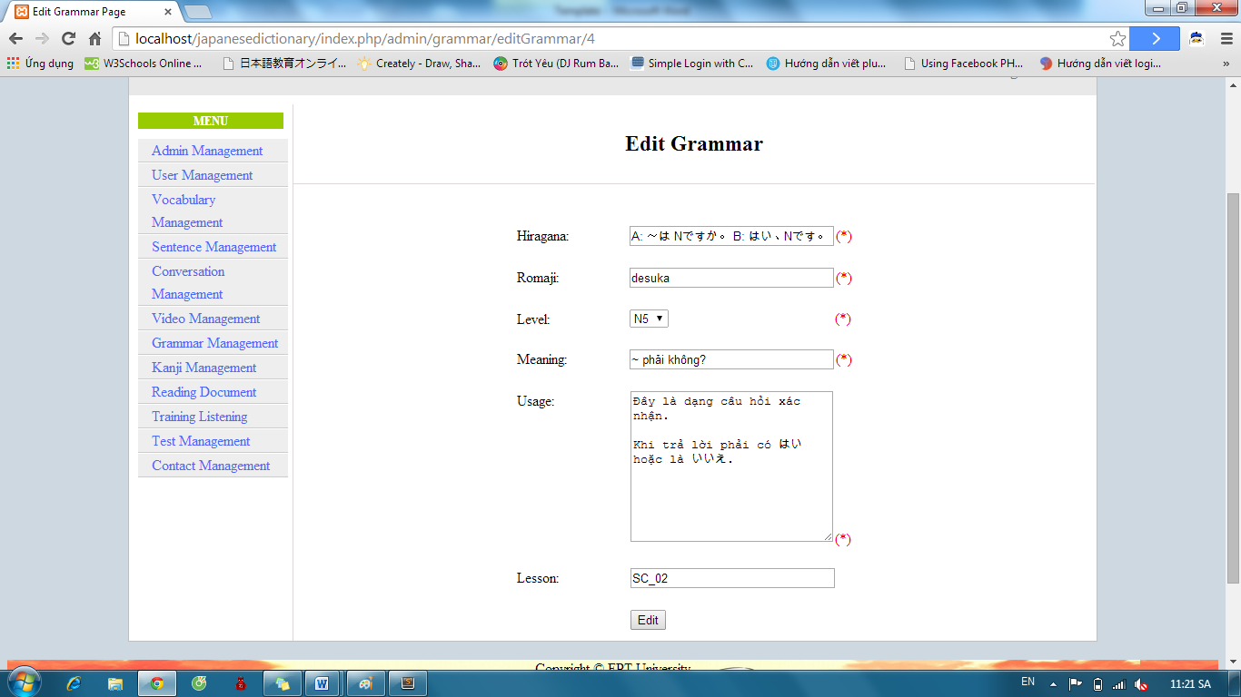

* Success : Display list Grammar.



* Fails: Error message will notify. You must try again.

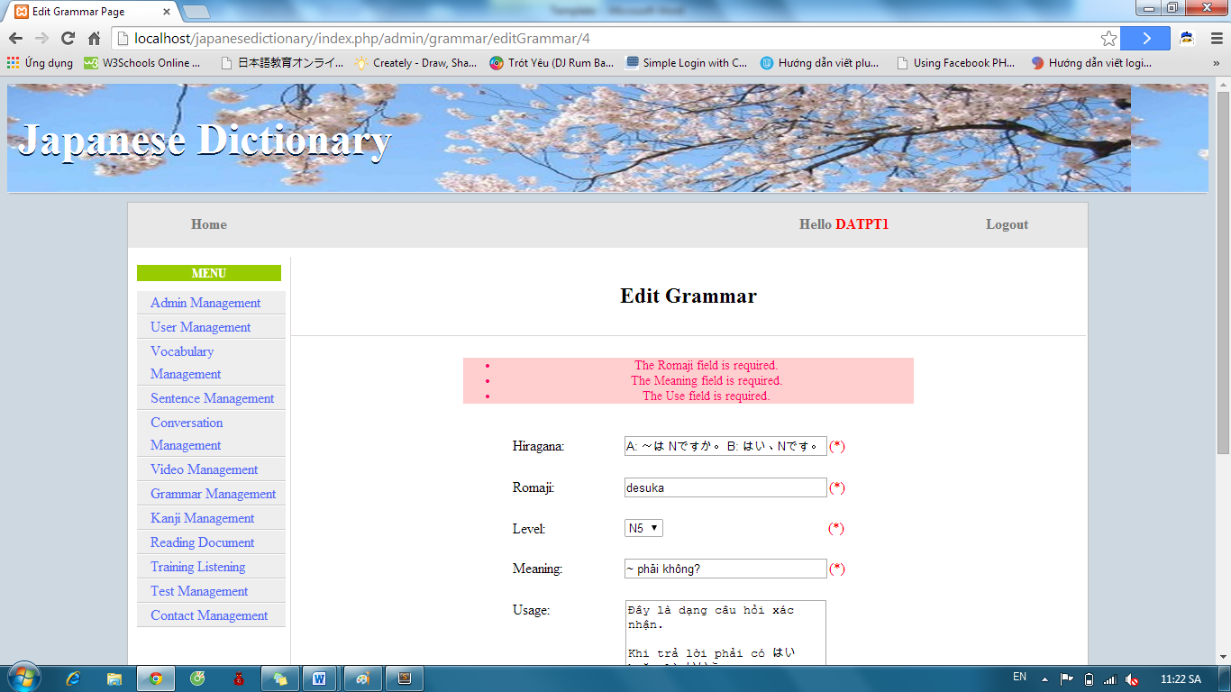

#### Delete Grammar

To use delete grammar function on website, the users do the steps below:

Step 1: Login with admin account as 4.2.19. System will display list User.

Step 2: Click “Grammar management” link. System will display list Vocabulary. After that, click “Delete” link with corresponding grammar.



### Conversation management

#### Search Conversation

To use search conversation function on website, the users do the steps below:

Step 1: Login with admin account as 4.2.19. System will display list User.

Step 2: Click “Conversation management” link. System will display list Conversation.

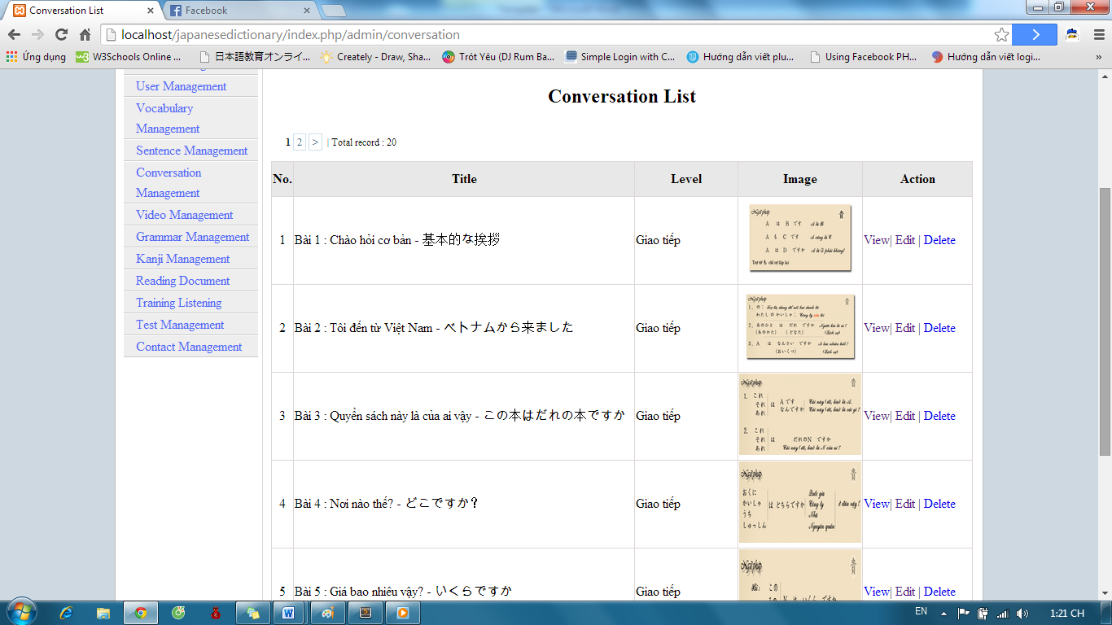

Step 3: Select option search and click “Search” button. Results search will be displayed.

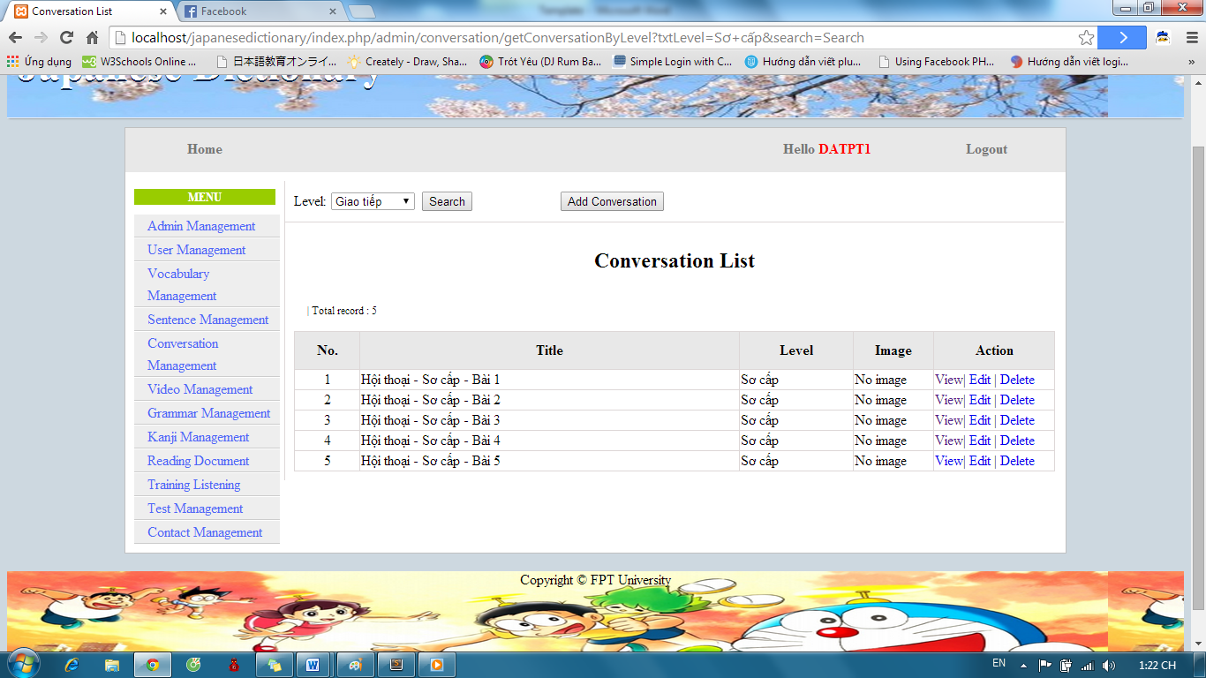

#### Add Conversation

To use add conversation function on website, the users do the steps below:

Step 1: Login with admin account as 4.2.19. System will display list User.

Step 2: Click “Conversation management” link. System will display list Conversation.

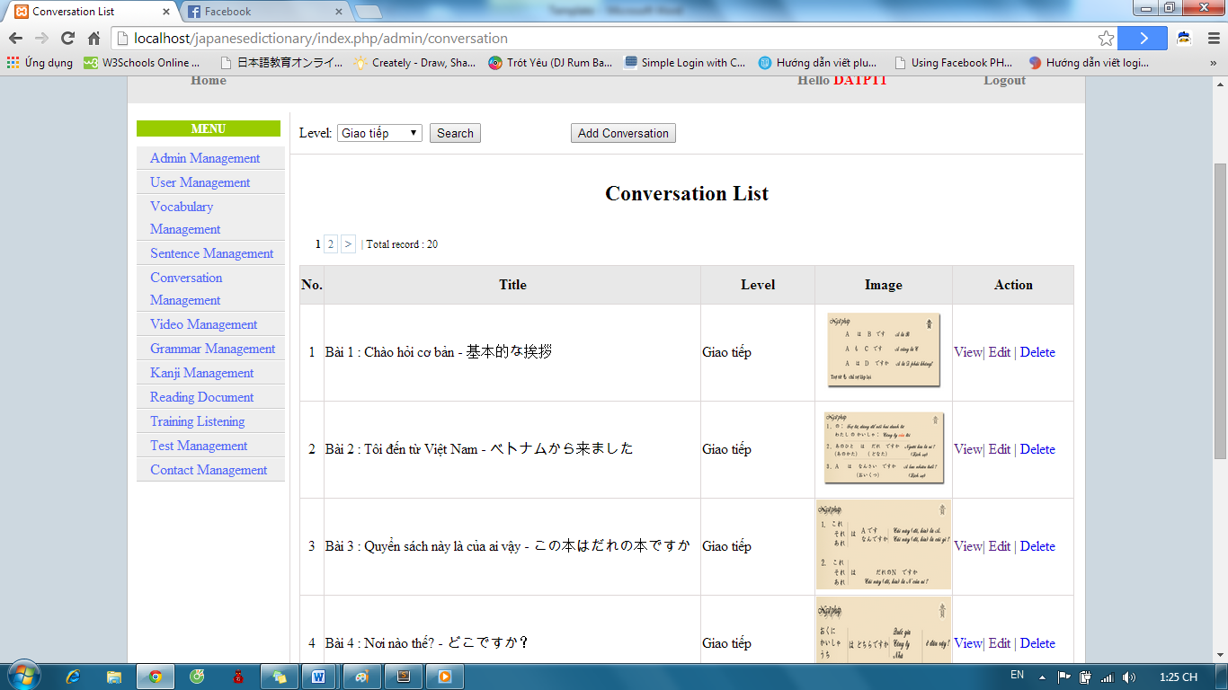

Step 3: Click “Add Conversation” button and input correct information of conversation that you want add.

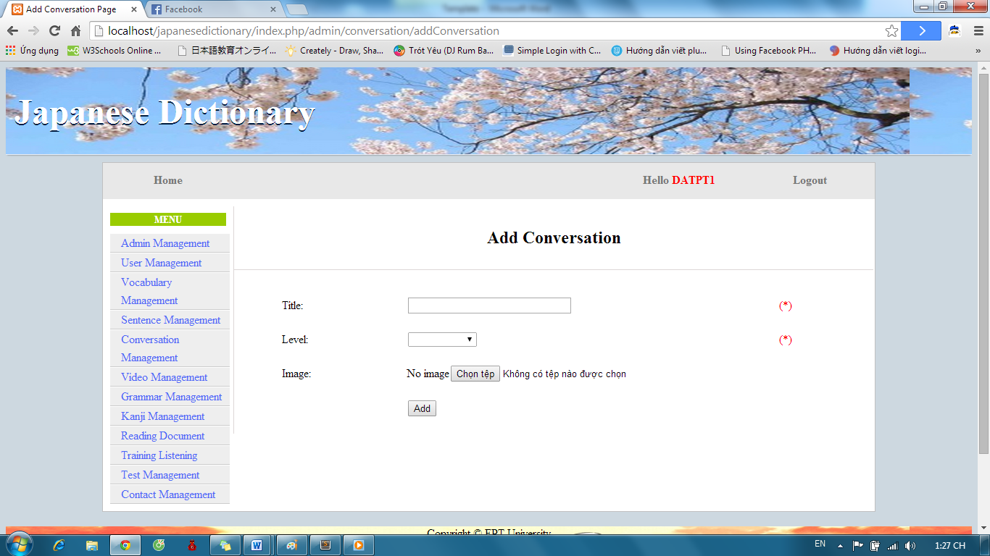

Step 4: After input, click “Add” button.

* Success: Display list conversation



* Fails: Error message will notify. You must try again.

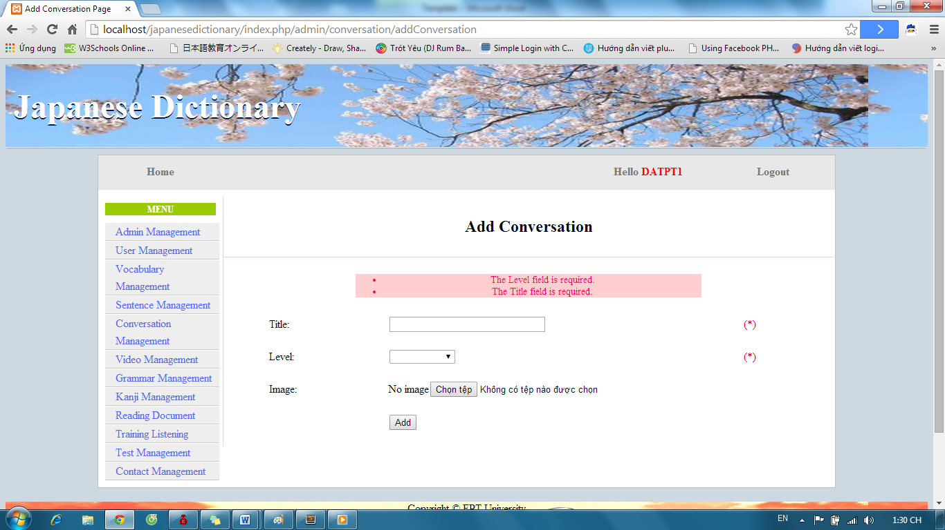

#### Add Content Conversation

To use add conversation function on website, the users do the steps below:

Step 1: Login with admin account as 4.2.19. System will display list User.

Step 2: Click “Conversation management” link. System will display list Conversation.



Step 3: If you want add content for a conversation, click “View” link with corresponding conversation.

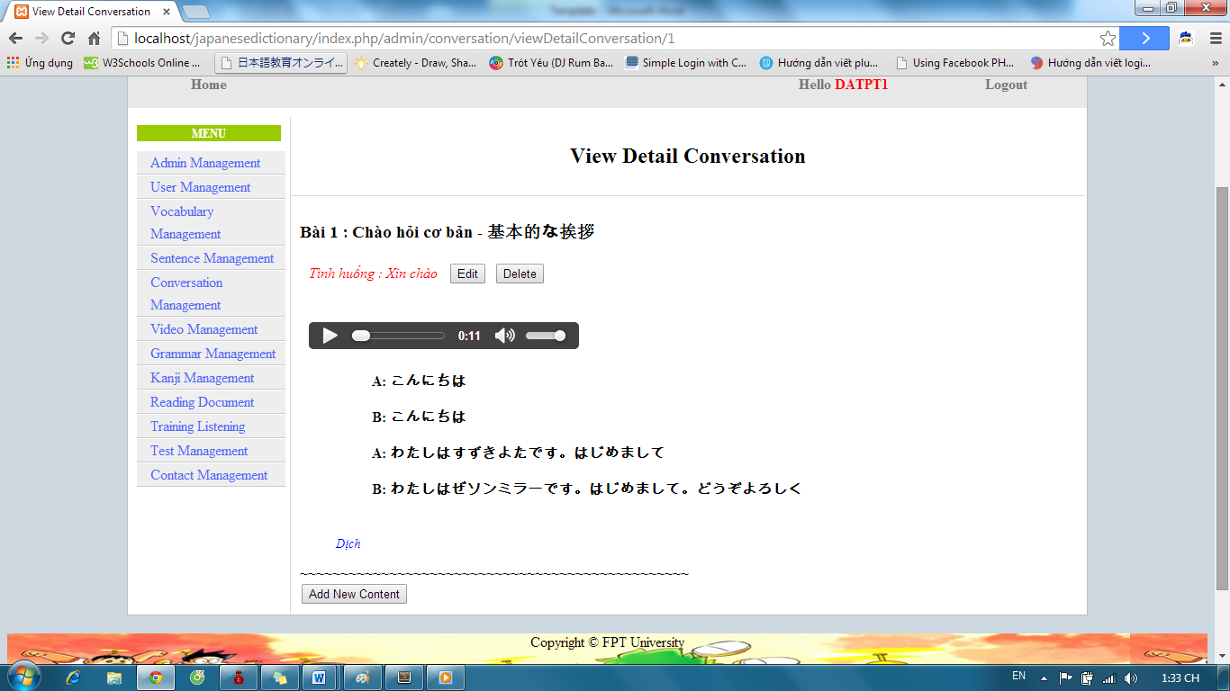

Step 4: Click “Add New Content” button and input correct information of conversation’s content.

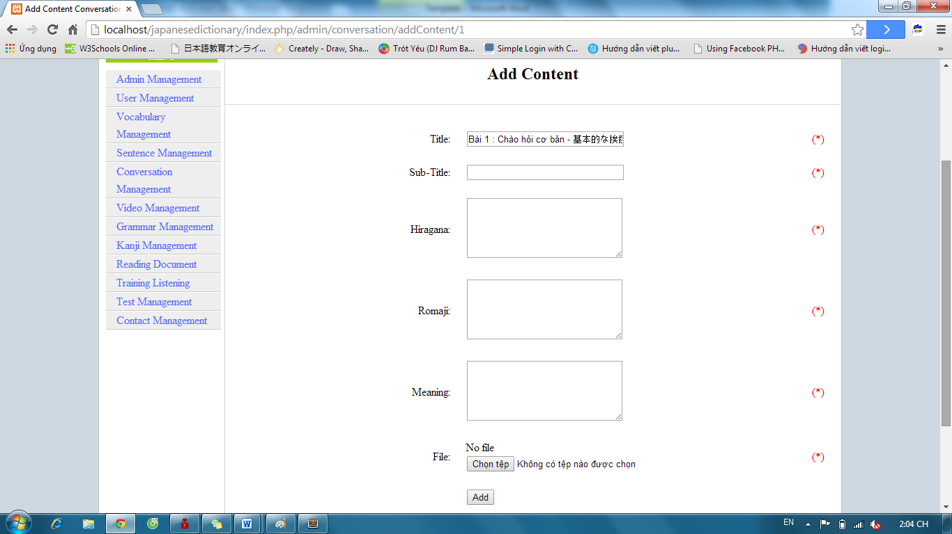

Step 5: Click “Add” button.

* Success : Display details conversation

#### Edit Conversation

#### Edit Content

#### Delete Conversation

# Appendix

List here all relevant references like error codes, functional code tables, FAQ (Frequently-asked-questions) or trouble-shooting guide...